Teacher Briefing



A Debate on European Union Values
The Rule of Law Debate
Debate Question
The question for your student debate is: “Does a European Arrest Warrant have to be automatically granted, or can a judge refuse to hand over someone to a fellow EU member state (country) if there is a risk of unfair trial there?” Through the debate, students explore a clash of two principles of the EU:
- Mutual Trust: EU member states (countries) rely on each other's courts without constantly second-guessing them.
- Rule of Law: Everyone has the right to be tried by an independent court, free from government pressure.

Debate Aim
That students consider the relevance of European Union values and explore the rights and responsibilities of citizens and member states under EU law. The debate question comes from a court case brought by Artur Celmer to the Court of Justice of the EU in 2018 [Artur Celmer v Minister for Justice and Equality].

- We want you and your students to explore the ideas and issues involved through a moral, social, and political debate, rather than a legal one.
- After the debate you can present the summary of the actual court case ruling to students (page 3) as a eureka moment for reflection.

Using the Debate
You can adapt the debate design and material to meet your teaching need, classroom dynamic, or student group. See this as a debate resource rather than a straitjacket.

Teacher Briefing

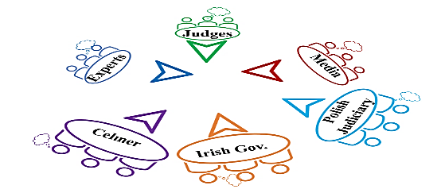

Debate Format

Pre-Debate
- Days Before: Provide the Student Briefing material to students (pages 7-9).
- Optional: Show student this very short AV clip about EU values
- Debate Day: Assign 3-5 students to a group for each debate role. Visually present the Debate Instructions (page 6) to students and distribute the relevant Role Cards (page 10-18) for their role. Give them approximately 20 minutes to analyse their Role Card and prepare for their role.

Debate Design
- Room Set-up: Each role group has a table, chairs, and a table title (page 19-24).

Debate Timeline
Debate Phase
- Opening: Debate Judges introduce debate question and ground rules. [3 mins]
- Presentation: Celmer outlines position. [3 mins]
- Presentation: Irish Government outlines position. [3 mins]
- Presentation: Polish Judiciary outlines position. [3 mins]
- Presentation: Judges ask Experts to contribute whenever relevant. [10 mins]
- Questioning: Judges can ask for clarity from anyone at any time. [15 mins]
- Reporting: Media deliver mid-debate report(s) on the debate. [5 mins]
- Responding: At any time in the debate, Celmer, Irish Government, Polish Judiciary or Experts can ask the Judges for time to respond to other points being made. [10 mins]

Interval Phase
- Drafting: Judges prepare a brief written ruling. [5 mins]

Outcome Phase
- Ruling: Judges present their ruling on the debate. [3 mins]
- Reporting: Media deliver final report(s) on the debate. [3 mins]

Post-Debate
- Case Ruling: Teacher interjects to present actual case ruling (page 3). [5 mins]
- Immediately or for Homework: Students complete any Reflective Activity that you choose (page 4).

Teacher Briefing

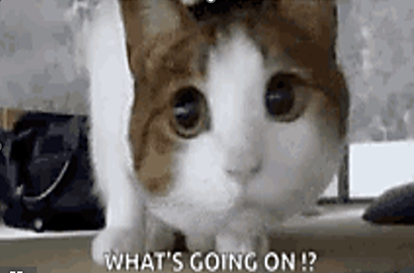


*Post-Debate* Teacher Intervention
Related Court Case
- This debate was based on a real situation. The related case, brought to the Court of Justice of the EU, was called ‘Artur Celmer v. Minister for Justice and Equality’ (2018). Here is a summary of the court’s ruling:

Ruling
- ‘European Arrest Warrants’: A member state’s national court can refuse to execute a European Arrest Warrant — but only if two conditions are met:
- This became known as the 'Two-Stage Test.'

- STAGE 1: There must be clear evidence of a systemic or generalised problem with judicial independence in the requesting country — not just political controversy, but real, documented evidence that the system as a whole is compromised.
- STAGE 2: There must also be a real risk to this specific individual — the court must assess the particular circumstances of the person's own case, not just the general situation.

- In Short: Mutual trust is not blind trust. But the bar for refusing a European Arrest Warrant is high in order to protect the system from abuse.

Did your judges reach the same conclusion?
If not, what do you think explains the difference? Was the ‘real’ court right?

Optional Follow-up
- Show students one or both of these AV clips about:
- 1) European Arrest Warrants (Utrecht University)
- 2) Rule of Law (euronews)
- 3) Rule of Law (EU Court of Justice)

Teacher Briefing


Post-Debate Student Activities
- Students can use this page or post-its to reflect on their content or skill learning. No right answers, just honesty….

Reflective Activities

The most convincing thing you heard from the other side was…

The weakest argument you heard was…

If YOU were wanted in another country and feared the trial wouldn’t be fair, what would you want the judge to do?

“Trusting other countries is important, but it should never mean sending someone to an unfair trial.” Do you agree? Where should the line be?

Exit Thoughts
If a court you’d never met was about to decide your future, what would you most want to be true about it?

One minute. Three things. Write the first thing that comes into your head.
ONE thing I’ll remember | ONE question I still have | ONE word to describe today

Use minute papers (or note cards) for students to reflect on their content or skill learnings from the debate. Here are some prompts:
Content
1. What was most interesting about the debate background or scenario?
2. What did you learn about the EU or EU law that was most interesting?

Participation
1. What was most interesting about your role in the debate?
2. What did you learn from participating in or watching others participate in the debate?

Debate Impact
1. On a scale of 1 (Not at all) to 5 (Very); are you curious to find out about other impacts of the EU on professional sports?
2. On a scale of 1 (Not at all) to 5 (A lot); has this debate impacted your interest in EU values, principles, or EU citizens’ rights?
3. On a scale of 1 (Not at all) to 5 (Very); how engaging or fun was this debate overall?
4. What changes would you make to the debate material or design to improve it for students of your age?
Research Activities 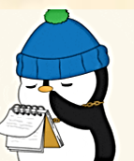
Assign a student or a group of students to research and report back on the following:

- Other high profile cases involving EU citizens’ freedom of movement or subsidiarity.
- The measures that UEFA and FIFA introduced after the ruling on transfers and compensation for player development.
- The impact of the Bosman rule on transfers, contracts, and globalisation in any other professional sport (e.g., rugby, basketball, Olympic handball or cycling).
- The effect of EU law on professional sports in Europe; such as tv rights deals, advertising, off-setting monopoly or breakaways in competitions.

Teacher Briefing



Student To-dos
1. Pre-debate: Read the debate scenario and background (pages 7-8).
2. Pre-debate: Read about EU Values and Principles (page 9).
3. Pre-debate: Work in assigned group to prepare debate role. Students can use the Student Briefing material and Role Cards as resources to prepare and develop their own arguments, in their own words.
4. During debate: Prepare and present their debate points, counterpoints, or information to perform their role.
5. Post-debate: Complete any Reflective Activity that you choose (page 4).



Glossary
- If you think that students do not know the following terms, these descriptions will help you in briefing them:
- EU Member States: The 27 European countries who pool decision-making power in some policy areas. This creates rights and responsibilities for national governments and citizens under EU law.
- EU Values: Beliefs or priorities that EU member states consider to be important. The EU has 6 common values (human dignity, freedom, equality, democracy, rule of law, and respect for human rights).
- Rule of Law: Decisions about guilt and punishment are made by independent courts, following clear rules, not by politicians. Governments in EU member states must respect a courts’ role to independently interpret laws and rights.

Printing (If Relevant)
You may be able to distribute debate material to students using your school’s virtual platform. However, if printing, this is a summary of advisable printing:
Days in Advance: Double-sided, 1 copy of Student Briefing (page 7-9) per student.
Days or hours in Advance: Single-sided, 1 or 2 copies of Role Cards (page 10-18 ).
Days or hours in Advance: Single-sided, 1 copy of table titles (page 19-24 ).

Debate Instructions [Teacher Presents (Visually) on Debate Day]

Preparation
You’re going to debate the question: Does a European Arrest Warrant have to be automatically granted, or can a judge refuse to hand over someone to a fellow EU member state (country) if there is a risk of unfair trial there?”
I’ll assign you to a group to perform one of these roles in the debate:
- Judges
- Mr Celmer
- The Irish Government
- The Polish Judiciary
- Experts
- Media
Use the Student Briefing material and the prompts on your Role Card to prepare for the debate. It is not about using big words. Present your points in your own words and prepare counterpoints to the points made by other debate players.
You may not agree with the opinions or beliefs of the role you’re playing. It’s a role-play, your job is to represent the role you’re playing, rather than your own opinion. To stand in their shoes for a little while.

Debate Timeline

Debate Phase
- Opening: Debate Judges introduce debate question and ground rules. [3 mins]
- Presentation: Celmer outlines position. [3 mins]
- Presentation: Irish Government outlines position. [3 mins]
- Presentation: Polish Judiciary outlines position. [3 mins]
- Presentation: Judges ask Experts to contribute whenever relevant. [10 mins]
- Questioning: Judges can ask for clarity from anyone at any time. [15 mins]
- Reporting: Media deliver mid-debate report(s) on the debate. [5 mins]
- Responding: At any time in the debate, Celmer, Irish Government, Polish Judiciary or Experts can ask the Judges for time to respond to other points being made. [10 mins]

Interval Phase
- Drafting: Judges prepare a brief written ruling. [5 mins]

Outcome Phase
- Ruling: Judges present their ruling on the debate. [3 mins]
- Reporting: Media deliver final report(s) on the debate. [3 mins]

Student Briefing


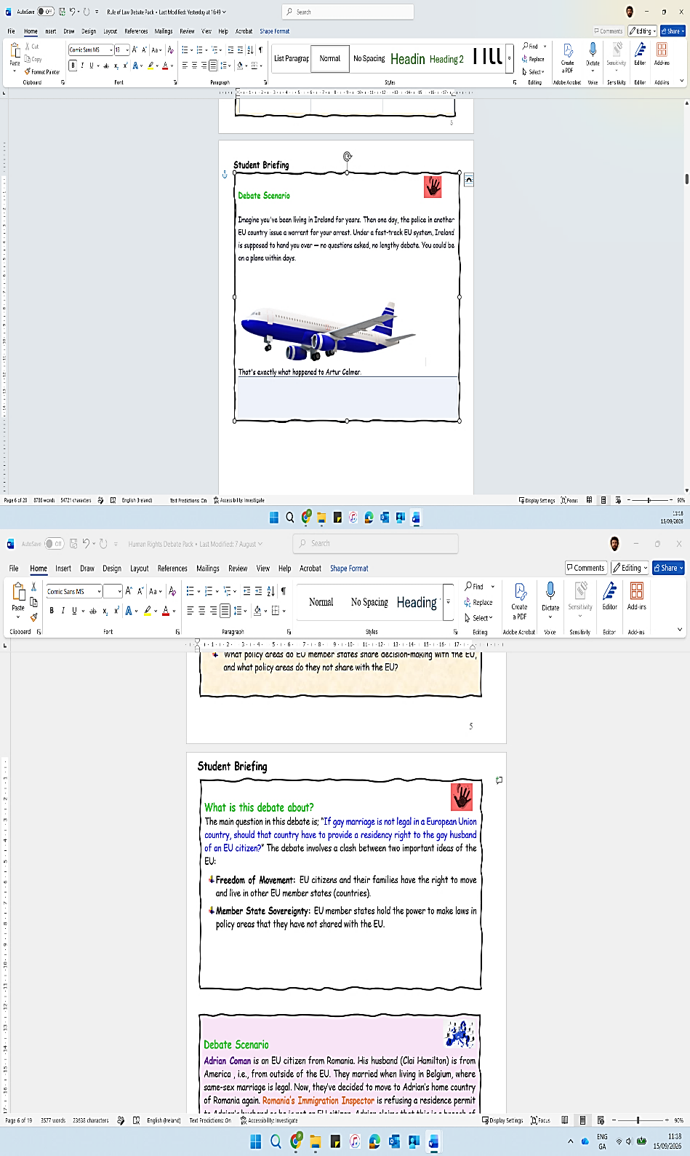
Debate Scenario
Imagine you've been living in Ireland for years. Then one day, the police in another EU member state (country) issue a warrant for your arrest. Under an fast-track system, Ireland is supposed to hand you over; no questions asked, no debate. You could be on a plane within days. That’s exactly what’s happening to Artur Celmer.
Artur’s Story  
Artur Celmer is a Polish man living in Ireland. He is accused by Polish authorities of serious drug trafficking offences. Poland has issued a European Arrest Warrant asking Ireland to hand him over for trial. Normally, that process is quick and automatic. EU countries are supposed to trust each other's courts without asking too many questions. But Artur's lawyers say: not so fast.
An important principle in a democracy is the rule of law — the idea that everyone, including the government, must follow the law, and that disputes are decided by independent judges, not by politicians. Independent means that judges make their decisions based on the law alone, without being pressured or controlled by those in power. Without independence, courts cannot be trusted to be fair.
At the time of Artur's warrant, Poland's government was changing the rules around how judges were appointed, disciplined, and removed. The European Commission has warned that this undermines judicial independence and, with it, the rule of law itself. Artur's argues that if he is sent back to Poland, he’ll appear before judges who are not truly independent — and therefore he cannot receive a fair trial.

What is this debate about?
- Can a country ever say no? EU countries are meant to trust each other and carry out arrest warrants almost automatically. But if there's evidence that the country's courts aren't fair, is a judge allowed to refuse, or does trust have to come first?
- How much proof is enough? Is it enough to show that a country's court system has general problems? Or do you also have to prove that this particular person would face a real risk of an unfair trial?
- Where does trust end? If judges can refuse warrants whenever they doubt another country's courts, could the whole system of cooperation fall apart? But if they can never refuse, does "mutual trust" just become blind trust?
- What happens to the individual? Poland's problems are systemic, affecting the whole system, but Artur's case is a drug charge, not a political one. Does a general problem with the courts automatically put this specific person at risk?
Student Briefing

Debate Background: EU Law 
- A court in one EU member state (country) can issue a European Arrest Warrant asking another EU member state to arrest a wanted person and send them back for trial. (EU Decision 2002)
- EU member states are supposed to trust each other's courts and carry out these warrants almost automatically, without re-checking the other country's justice system each time. 17,000 arrest warrants are sent between EU member states every year.
- A judge cannot refuse warrants from a country in one blanket move, just because that country's system has problems.



Debate Background: Artur’s Concerns

- Artur Celmer did not choose which courts would try him. If those courts are not truly independent, he cannot get a fair hearing or trial.
- Poland has changed its laws over how judges are appointed and dismissed, raising fears that judges were no longer independent of the government.
- Handing someone over to face an unfair trial would breach a basic right that the EU promises to everyone. (EU Charter of Fundamental Rights)
- Trust between countries does not automatically override the person’s rights standing in front of the judge, courts must find a fair balance

Student Briefing

Mutual Trust
- EU member states trust that each other's courts are fair, so they cooperate without constant re-checking.
- This trust helps the whole system of cross-border justice to work.
Rule of Law
- Decisions about guilt and punishment are made by independent courts, following clear rules, not by politicians.
- Everyone, including governments, must respect the courts and the law.
Judicial Independence
- Judges must be free to decide cases honestly, even against their own government.
- If independence is lost in one country, it puts pressure on other countries that have trusted it.
Right to Fair Trial
- Everyone is entitled to a hearing before an independent and impartial court.
- This right is protected; it cannot be set aside just to keep cooperation fast.
Primacy of EU Law
- EU law is applied in the same way across all member states.
- In policy areas where member states have given power to the EU, EU law comes before national law.

EU Principles 

These are guidelines for EU activity. They come from key EU values or ideas. They must be respected by EU institutions and member states when making decisions. Take time to read them carefully, they’ll help your debate points.

Role Card: Judges


Your Role
- You are Judges at the Court of Justice of the EU. Your role is to organise the debate and facilitate interactions. Listen to all sides neutrally and ask questions for clarity when you need. You are not on anyone’s side.
-------------------------------------------------------
Prepare
- Read the Student Briefing material (page 7-9). Use it to prepare an opening statement for the debate.
- Use the template provided to note and analyse the arguments made during the debate.
--------------------------------------------------------
Debate
- Opening: Briefly outline the debate question, and the rules of engagement for contributions and interactions between debate players.
- Facilitate: Invite debaters to present their arguments, roughly in line with the Debate Timeline in the Debate Instructions. Invite them to make counterpoints in response to points made by other debaters.
- Question: Be polite but ensure that debaters keep their points relevant to the question and issues involved.
- Invite: Experts to present information whenever relevant during the debate.
- Invite: Media groups to deliver mid-debate report.
- Ruling: Note relevant points made by Celmer, the Irish Government, Polish Judiciary, and Experts during the debate.
-------------------------------------------------------
Deliver
Ruling: Use the Interval Phase during the debate to consider whether Celmer’s or the Irish Government’s points were more convincing, given the debate background. Using your Ruling Sheet, write a few short notes of the most convincing points made, and possible wider impacts of the debate verdict.
- Presentation: Call all debaters attention and deliver your ruling to all present, outlining the points from your Ruling Sheet.
- Closing: Invite final reports from the Media groups that conclude the debate.

Role Card: Judges

Stage 2 — Real Risk to Artur (Yes / No)
- Does the general problem create a real risk for Artur in his specific case? Why or why not?

Our Decision
- State your ruling clearly. Can Ireland refuse the European Arrest Warrant?
- Give your answer, reasoning, and maybe some impacts of your decision.

Stage 1 — Systemic Problem (Yes / No)
- Is there clear evidence that Poland's courts in general are not independent? What convinced you?

Judges’ Ruling Sheet
- This sheet should help you in analysing the debate and forming your decision.
The Two-Stage Test
- Both stages must be met before you can refuse the European Arrest Warrant.

Role Card: Artur Celmer

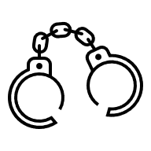

Your Role
- You represent Artur Celmer in the debate. You think that Ireland should refuse the European Arrest Warrant issue by Poland, because you would not get a fair trial there.
-------------------------------------------------------
Prepare
- Read the debate Student Briefing material. In your own words, develop moral, social, or political points to represent Mr Celmer. Here are some, but be confident to develop your own:
- Right to Fair Trial: The most basic promise in EU law is that you're judged by a fair, independent court. This can't be switched off just because handing people over quickly is easier. “Speed can't come before fairness. A fast trial is worthless if it isn't a fair one.” (EU Charter of Fundamental Rights).
- Poland’s Courts Compromised: Between 2015 and 2017 Poland changed its laws, so politicians have more power over who becomes a judge and who gets removed. When a government can pressure judges, courts stop being independent. This isn’t about helping you to escape justice; it’s about making sure that wherever you’re tried, the court is honest and independent.
- EU Raised the Alarm: This isn't just your opinion. In 2017, the EU officially warned that Poland's courts were under political control – and even named arrest warrants as something at risk.
- Trust Must Not Be Blind: Countries trusting each other keeps Europe working. But trust can't mean handing someone over no matter what. If it does, the rights written into EU law mean nothing in real life.
-------------------------------------------------------
Debate
- Present: Be clear in outlining relevant points to represent Mr Celmer’s position. Be confident to do this in your own words, without overly relying on prompts, big words, or a script.
- Interact: Consider the information introduced by other debate players. Be prepared to counter the points that they make. Try to keep the debate background and EU principles in mind (page 9) .

Role Card: Irish Government


Your Role
- You represent the Irish Government in the debate. You think that Ireland should carry out the European Arrest Warrant issued by Poland to hand over Mr Celmer to face drug-trafficking charges.
-------------------------------------------------------
Prepare
- Read the debate Student Briefing material. In your own words, develop moral, social, or political points to represent the Irish Government. Here are some, but be confident to develop your own:
- Mutual Trust: EU member states agreed to trust each other's courts so criminals can't escape justice by crossing borders. This trust keeps Europe safe. If every member second-guessed the others, the whole system of catching suspected criminals would collapse.
- Refusal as Exceptional: A judge can't refuse an arrest warrant just because they're worried; it’s only when there is a real proof of danger. Refusal is only for exceptional situations, and the person fighting it has to prove a real risk, not just point to news headlines.
- General Problem v Personal Risk: Even if Poland's courts have broad problems, that doesn't prove Mr Celmer would get an unfair trial. It is an ordinary drugs case, not a political one. Poland has followed the rules in issuing this warrant and asked Ireland to hand him over for a serious drugs case. There's no evidence that he'd be singled out for political reasons.
- Risk of a Safe Haven: If Ireland refuse the warrant because of a general worry, every Polish warrant could be blocked. Ireland could become a hiding place for criminal suspect. The law must be applied the same way every time.
--------------------------------------------------------
Debate
- Present: Be clear in outlining relevant points to represent the Irish Government’s position. Be confident to do this in your own words, without overly relying on prompts, big words, or a script.
- Interact: Consider the information introduced by other debate players. Be prepared to counter the points that they make. Try to keep the debate background and EU principles in mind (page 9) .

Role Card: Polish Judiciary


Your Role
- You represent the Polish Judiciary (i.e., court system) in the debate. You issued the arrest warrant for Mr Celmer to Ireland so that he can face drug-trafficking charges in Poland. You think that Poland's courts are working normally and will give Artur a fair trial
-------------------------------------------------------
Prepare
- Read the debate Student Briefing material. In your own words, develop moral, social, or political points to represent the Polish Judiciary. Here are some, but be confident to develop your own:
- Working Courts: Poland's 300 courts handle over 15 million cases a year. The vast majority are ordinary matters, decided fairly. A few headlines about big political fights don't change that reality.
- Ordinary v Political Trial: Mr Celmer is wanted for the ordinary crime of drug trafficking. He isn't a journalist, an activist, or a critic of the government. No one in power or political office gains anything by treating him unfairly.
- Polish Cooperation: Poland is happy to answer any questions that Irish authorities or courts have, to explain how Artur's trial would be run. A member state trying to be unfair would not cooperate in this way.
- Member State Status: Poland is a full EU member state, just like Ireland. Refusing our arrest warrant with no proof about Mr Celmer’s trial suggests distrust between equal partners and harms cooperation. That would let a criminal suspect walk free without trial and is dangerous for justice.
Debate
- Present: Be clear in outlining relevant points to represent the Polish Judiciary’s position. Be confident to do this in your own words, without overly relying on prompts, big words, or a script.
- Interact: Consider the information introduced by other debate players. Be prepared to counter the points that they make. Try to keep the debate background and EU principles in mind (page 9) .

Role Card: Experts

Your Role
- You are independent experts who provide information to enhance the debate. You are neutral, you do not represent either side in the debate. Your role is to explain a key concept or context to help the judges understand the debate.
--------------------------------------------------------
Prepare
- Read the debate Student Briefing material to be aware of the background.
- Divide the roles below within your group. If you like, work as sub-groups rather than individually. Develop related points in your own words.
- Rule of Law Researcher: Outline that ‘rule of law’ means courts have the power to interpret law, and to do this without political interference. The European Arrest Warrant is based on trust that EU countries respect the rule of law. Changes in Poland around judges’ appointment/removal raise concern about their independence. However, there’s a difference between a country breaking one rule and having a ‘system-level’ problem.
- Fair Trial Specialist: Outline that the right to fair trial means the right to an independent and impartial hearing (EU Charter of Fundamental Rights). The level of political involvement in appointing, removing, or disciplining judges is relevant. A 1st consideration here is whether there is a general problem in a country with judges’ independence? A 2nd consideration is whether a general problem of judges’ independence causes an evident risk in an individual case?
- EU Law Lecturer: Outline the legal setting for judges. There is a strong, almost automatic, inclination to recognise and grant arrest warrants coming from other EU countries. Arrest warrants cannot be refused by a member state because you disapprove of another member state’s reforms, there needs to be specific risk of the rule of law and realisation of rights.
- Human Rights Organisation: Outline the risk to an individual if surrendered to an unfair court system; i.e., an unfair conviction or the lack of fair procedure to appeal. That would compromise the quality of justice in the EU. On the other hand, European arrest warrants support justice for victims when crimes are committed. Dismissing arrest warrants, without specific evidence, would equally compromise the quality of justice in the EU.
--------------------------------------------------------
Debate
- Present: Be clear and brief in your contributions, with a neutral tone.
- Interaction: The Judges will invite you. But if a point made in the debate relates to your expertise, ask the Judges for the opportunity to clarify.

Role Card: Media


Your Role
- You are reporters for news organisations covering the debate. Your teenage audience is not familiar with the EU. Your reports need to make the debate issues meaningful for them. Bring a bit of drama or excitement to the debate.
--------------------------------------------------------
Prepare
- Divide into two news groups. Media organisations focus 1) informing in a neutral or formal way or 2) dramatising by using controversial angles and soundbites. Each media group can decide whether your report stye will be ‘Informing’ or ‘Dramatising’.
- You can also decide whether your reports are for Online (TikTok, Insta, X, etc) or Broadcast (TV or Radio) media.
- Think about and prepare relevant props (fake micro-phone, backdrop, sound effects, or imagery) for the type of report medium you select.
- Use the Student Briefing material to select angles that to focus on in your reports. Within your group, divide tasks to ensure relevant information is captured, and the design and presentation of the report(s) is prepared.
- Use the mid-debate and final report Preparation Templates to prepare.
--------------------------------------------------------
Debate
- Observe: Note relevant points, issues, and debate exchanges.
- Engage: At any time, you can ask other debate players for a comment or quotation to inform your reports.
--------------------------------------------------------
Deliver
- Mid-Debate Report: When called by the Judges, each media group delivers a short (2-3mins) and snappy update on the debate to that point. Be creative and add life to the debate for an external audience. Include relevant props depending on your type of report and start with a catchy headline.
- Final Report: When called by the Judges, each media group presents a short (2-3mins) and snappy final report on the debate. Try to keep your Informing or Dramatising style in mind. Be creative to engage or entertain your audience.

Role Card: Media

Other Notes:

Debater Quotes / Comments to include:

Hook/Angles to bring your ‘Informing’ or ‘Dramatising’ style:

Props to Animate Report Presentation:

Possible Headlines:

Main Debate Points/Issues/Events to include:

Report Style: Informing or Dramatising? ___________________

Report Type: TikTok, Insta,TV, Radio, X, or other? __________________

Hook/Angles to bring your ‘Informing’ or ‘Dramatising’ style:

Props to Animate Report Presentation:

Other Notes:

Preparation Template for Mid-Debate Report

Role Card: Media
Hook/Angles to bring your ‘Informing’ or ‘Dramatising’ style:

Props to Animate Report Presentation:

Other Notes:

Debater Quotes / Comments to include:

Hook/Angles to bring your ‘Informing’ or ‘Dramatising’ style:

Props to Animate Report Presentation:

Main Debate Points/Issues/Events to include:

Possible Headlines:

Report Type: TikTok, Insta,TV, Radio, X, or other? __________

Hook/Angles to bring your ‘Informing’ or ‘Dramatising’ style:

Other Notes:

Report Style: Informing or Dramatising? ___________

Preparation Template for Final Report

Judges

Celmer

Irish Government

Polish Judiciary

Experts

Media

