Debate Question:
“The Climate Crisis: Who should pay for Loss and Damage in the Global South?”

Introduction I: Loss and Damage Fund 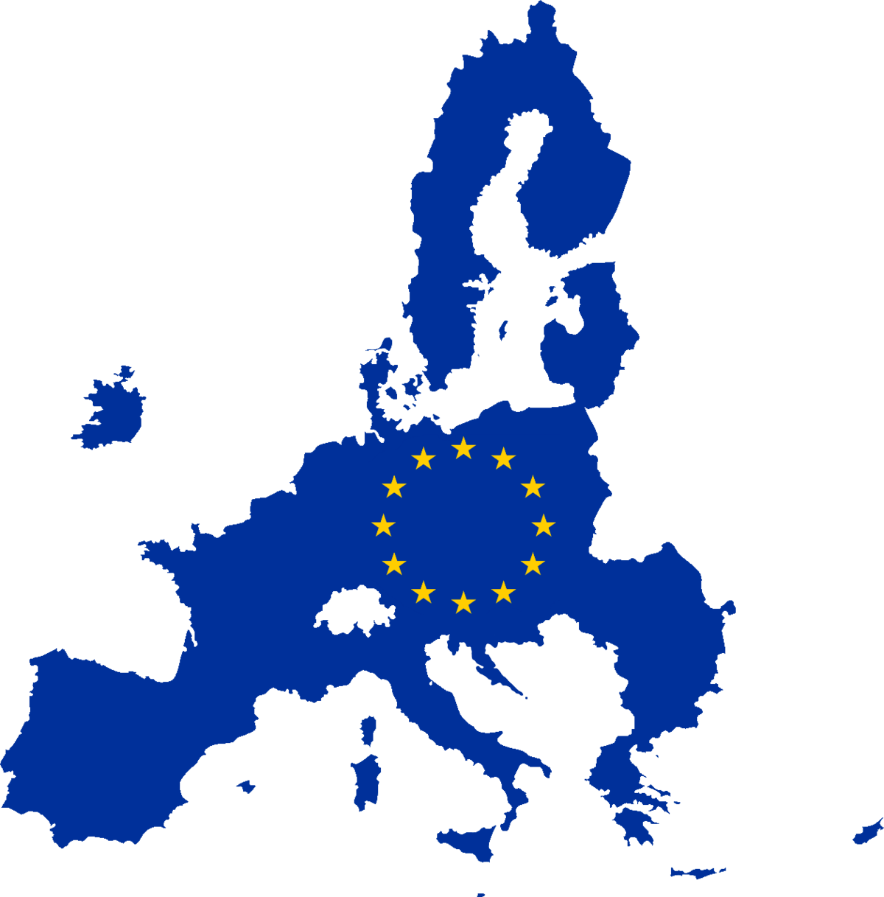
In 2022, the United Nations’ (UN) Climate Conference COP27 adopted a new climate fund to ensure financial support for poor countries that are vulnerable climate-related loss and damage. It took more than 30 years of discussion to reach the agreement on having the fund.
The fund’s logic is that countries which have historically emitted the most greenhouse gases have a major responsibility for the climate crisis. They also have a moral responsibility toward poorer countries who feel the effects in climate disasters. The fund is a recognition by the international community that there is a need for financial climate support for the countries in the global south. Several countries announced their intention to contribute financially to the Loss and Damage Fund.

Introduction II: Commitment Issues 
More agreement is needed on issues such as: ‘what can be categorised as losses and damages? and ‘who should pay what amount to the climate fund? A big challenge is turning countries’ political commitments into real financing. Less than half of the $790 million promised has been deposited in the fund. Several countries are being criticised that their financial contributions to the fund are not ‘new money’. For example, the money promised for the fund has been taken from an existing overseas development or aid budget.
There remains disagreement among UN members states about who should pay more to the climate fund. Is it the countries that have historically emitted the most per person, such as the United States of America and rich European Union member states? Or should the heavy emitting countries in recent years also contribute even though they are less economically developed, such as China and India?

Debate Instructions (for reading to students) 
We are going to debate the question: “The Climate Crisis: Who should pay for Loss and Damage in the Global South?” The players in this debate are:
- the Business Europe
- the Chinese Government
- the Danish Government
- the Slovakian Government
- the Alliance of Small Island States (AOSIS)
Your task is to prepare and represent the position of one of these debate players.

What do you have to do? (for reading to students) 
1. Use your Role sheet and Factsheet provided to prepare short points to support your position in the debate [10–15 mins on your own]
2. Then, work with others assigned to play the same role. Work on the phrasing and examples/evidence to be used [10-15 mins with others given the same role]
3. Now, you’ll see floor markings (or chairs) marking positions in a debate circle. You and others given the same role rotate into position to speak in the debate. When not in a speaking position, listen to the debate and prepare points to add information to the debate and to support your position [20 mins in debate circle]

Debate Prompts (optional aid for teachers) 
1. Should China (a large developing country but also the world’s largest carbon dioxide (CO₂) emitter) receive money from or contribute to the Loss and Damage fund?
- Looking at Factsheet 1, should China’s current CO₂ emissions carry more weight in the discussion than its total historical emissions? It is a greater current emitter (12 billion tons compared to 3 billion tons for the EU). However, it’s total over time is lower (273 billion tonnes compared to 298 billion tonnes for the EU).
- Should contributions to the fund factor-in the CO₂ emissions per person? Emissions per person are 8 tons for China, 11 tons for the EU, and 14 tons for the USA.
- Should contributions to the fund factor-in the level of economic development of a country? China has a Gross Domestic Product (GDP) per person of €11440, the EU’s is €37072 per person, and the USA’s is €73792.
2. Should the money for the loss and damage fund be “new money” that increases the budget, or money from already adapted budgets that are reallocated from other areas?
- Should the historically higher emitters such as the USA and the EU have to contribute ‘new money’ to the fund, to amend for their impact on global warming over time and the economic wealth they have derived from it?
- If wealthier EU member states redirect funding to the Loss and Damage Fund, instead of investing in EU’s regional development and cohesion funds, will that unfairly impact poorer EU members such as Slovakia?
3. How do we categorize which loss and damage that entitles developing country to receive money from the fund? And what if the loss is your entire country?
- Looking at Factsheet 1, you see small islands such as Tuvalu (26km² ) have tiny CO₂ emissions. Should any loss of land in such places automatically trigger access to the fund?
- Should the Loss and Damage Fund also cover non-economic losses, such as the loss of biodiversity and cultures?

Role Sheet: Business Europe
You represent Business Europe in this debate. 
Business Europe represents business associations from 36 countries in Europe. It focusses on economic growth and competitiveness. You argue that there must be a good business case for rule changes. You think that the money for the Loss and Damage Fund should come from existing EU budget resources. The priority should be investment in innovative European companies that optimise the green transition and tackle climate change impacts.

Position Prompts 
In this debate, you (as Business Europe) want:
- Major emitters outside of Europe (China, Russia, USA) to finance the Loss & Damage Fund.
  - Hint: European companies are regulated to reduce emissions, much more than companies in countries outside of Europe.
- The EU’s contribution to the Fund to come from existing budget resources.
  - Hint: European companies should be supported to develop green technologies, which will strengthen the transition in European and in developing countries.
- Recognition of European companies’ existing contribution to offset climate change.
  - Hint: European businesses have been market leaders in investing in sustainably technology and transport, eco-efficient products, and in promoting healthier lifestyles.


Outline Of Other Debate Players
Chinese  Government  | Danish  Government  | Slovakian  Government  |  | Alliance of Small  Island States  (AOSIS) 
Developing country, now one of the largest CO₂ emitters. Not contributing to the Loss and Damage fund. | Rich EU member state. Heavily invested in green transition but historically a heavy CO₂ emitter per capita. | Less rich EU member state. Has experienced many climate-related disasters, but imports much oil from Russia. |  | A coalition of 39 low-lying and small islands. Particularly vulnerable to a rise in sea-levels.

Role Sheet: Chinese Government
You represent the Chinese Government in this debate. 
You govern the most populated country in the world. Strong demand from Western markets has grown your economy rapidly in recent decades. Economic growth now positions you as highest carbon dioxide (CO₂) emitter globally. You remind Western countries, who criticize your pollution, that their consumption drives your pollution.
You think it unfair to expect China, as a developing country with significant poverty, to contribute to the Loss and Damage Fund. Western countries, who have been developed for much longer, and with larger historical emissions, should be the ones supporting those less developed in facing climate change effects

Position Prompts
In this debate, you (as the Chinese Government) want:
- To NOT contribute to the Loss and Damage fund.
- Hint: Pollution in China is due to product manufacturing for Western markets.
- Hint: China accounts for a small amount of CO₂ emissions over time (Factsheet 2).
- Western countries to invest in China’s green transition.
- Hint: China accounts for 40% of global renewable energy capacity. The $818 bn invested is more than double any other country. Western states should support China to develop rare minerals which are central to renewable battery capacity.
- Recognition of China’s climate vulnerable status.
- Hint: China has felt climate change impacts with heat waves and storms. 650 million of its citizens live in coastal provinces, vulnerable to small sea level rises.
- Hint: With nearly 20% of its population on less than $6.85 a day, China needs time for recent economic growth to translate into socio-economic development before being hit with punitive green transition costs by western states.

Outline Of Other Debate Players
Business Europe | Danish  Government | Slovakian Government |  | Alliance of Small Island States  (AOSIS)
Association of European businesses. Wants support to innovate green rather than curb economic progress. | Rich EU member state. Heavily invested in green transition but historically a heavy CO₂ emitter per capita. | Less rich EU member state. Has experienced many climate-related disasters, but imports much oil from Russia. |  | A coalition of 39 low-lying and small islands. Particularly vulnerable sea-level rises.

Role Sheet: Danish Government
You represent the Danish Government in this debate. 
Denmark is one of one the wealthiest countries in Europe. It has one of the highest levels of carbon dioxide (CO₂) emissions per person in the world. You believe that climate justice is important; wealthy countries should support poorer ones facing climate challenges. You have been the first country to pledge money for the Loss and Damage Fund. However, like other EU member states, you currently face rising defence, competitivity, and green transition costs. Therefore, you want countries like China to contribute, before over-committing yourself.

Position Prompts
In this debate, you (as the Danish Government) want:
- Countries with high CO₂ emission levels to contribute to the fund.
- Hint: As an economically developed emitter, you accept your responsibility to contribute $50million to the fund. However, you want large countries (USA & China) to contribute more to the fund. The USA has only contributed $15million so far.
- An inclusive approach to defining what is Loss and Damage.
- Hint: You want the loss of rare and unique ecosystems, and biodiversity, to be considered eligible for support through the fund. You want other countries to agree with this wider definition, and to react with more funding.

Outline Of Other Debate Players
Business Europe | Chinese  Government | Slovakian Government |  | Alliance of Small Island States  (AOSIS)
Association of European businesses. Wants support to innovate green rather than curb economic progress. | Developing country, now one of the largest CO₂ emitters. Not contributing to the Loss and Damage fund. | Less rich EU member state. Has experienced many climate-related disasters, but imports much oil from Russia. |  | A coalition of 39 low-lying and small islands. Particularly vulnerable sea-level rises.

Role Sheet: Slovakian Government
You represent the Slovakian Government in this debate.
You have made efforts to accelerate the green transition since joining the EU. You have been a major beneficiary of EU regional development and cohesion funds, to modernise infrastructure, industry, and public services.
A history of heavy industry and oil and coal consumption see you with high CO₂ emissions and an energy dependency on Russian fuel imports. In theory, you see the importance of supporting vulnerable non-EU countries through mechanisms like the Loss and Damage Fund.

Position Prompts
In this debate, you (as the Slovakian Government) want:
- EU finance of the Loss and Damage Fund to not jeopardise internal EU transfers.
- Hint: You want poorer EU member states to receive support through EU regional and cohesion funds to develop their energy and environmental infrastructures. This should not be lowered by commitments to the Loss and Damage Fund beyond EU borders.
- Climate justice in the green transition, inside and outside Europe.
- Hint: Richer countries should close the gap between their moral obligation and what they have contributed to the Loss and Damage Fund.
- Hint: Protection for EU member states such as Slovakia who have been hit with major flooding events in recent years (2024).
- Hint: More time for poorer EU member states to adjust their energy imports and infrastructure for competitiveness, before being hit with punitive emissions costs.

Outline Of Other Debate Players
Business Europe | Chinese  Government | Danish Government |  | Alliance of Small Island States  (AOSIS)
Association of European businesses. Wants support to innovate green rather than curb economic progress. | Developing country, now one of the largest CO₂ emitters. Not contributing to the Loss and Damage fund. | Rich EU member state. Heavily invested in green transition but historically a heavy CO₂ emitter per capita. |  | A coalition of 39 low-lying and small islands. Particularly vulnerable sea-level rises.

Role Sheet: Alliance of Small Island States (AOSIS)
You represent the Alliance of Small Island States (AOSIS) in this debate.
You are a coalition of 39 low-lying and small island countries (e.g., Jamaica, Tuvalu and Papua New Guinea) that are particularly vulnerable to sea-level rise. Your land and your culture are valued as assets. You are united by the threat that climate change poses to your islands’ survival, with temperature increase projections remaining above 1.5 degrees. You want major emitters, as polluters, to accept their responsibility for historical and contemporary impacts on climate change.

Position Prompts
In this debate, you (as AOSIS) want:
- Major polluters to reduce emissions and meet global agreement commitments.
- Hint: If the long-term global average temperature increase of 1.5 degrees is breached many AOSIS states will be submerged.
- EU member states, the USA, and China to accept responsibility for the climate crisis due to emissions.
- Hint: They must commit to separate Loss and Damage funding for poorer states to tackle and offset the impacts of climate change. This does not mean repurposing global aid funding, it means contributing both types of funding.
- Recognition of AOSIS as places of biodiversity.
- Hint: Support for education and research programmes which widen the understanding and appreciation of biodiversity wealth in these areas.

Outline Of Other Debate Players
Business Europe | Chinese  Government | Danish Government |  | Slovakian Government
Association of European businesses. Wants support to innovate green rather than curb economic progress. | Developing country, now one of the largest CO2 emitters. Not contributing to the Loss and Damage fund. | Rich EU member state. Heavily invested in green transition but historically a heavy CO₂ emitter per capita. |  | Less rich EU member state. Has experienced many climate-related disasters, but imports much oil from Russia.

Loss and Damage Fund Debate Factsheets
Factsheet1: Countries’ Parameters of Wealth, Greenhouse Gas Emissions, and Size
Country | GDP (€ bn) | GDP per person (€) | Annual CO₂  (bn ton) | Annual CO₂ per person (ton) | Cumulative CO₂ since 1750  (bn ton) | Population  (million) | Size  (km²)
China | 16120 | 11440 | 12 | 8 | 273 | 1400 | 9.7 million
India | 3360 | 2318 | 3 | 2 | 63 | 1500 | 3.3 million
USA | 25100 | 73792 | 4 | 14 | 432 | 347 | 9.4 million
EU | 16700 | 37072 | 3 | 11 | 298 | 450 | 4 million
Denmark | 369 | 61780 | 0.03 | 5 | 4 | 6 | 42,955
Slovakia | 122 | 22482 | 0.04 | 6 | 4 | 5 | 49,035
Tuvalu (AOSIS) | 0.05 | 5450 | 0.00001 | 1 | 0.0003 | 0.01 | 26

Source: Democracy In Europe Organisation (2025)
Note: Gross Domestic Product is an indicator of a country’s economic output or wealth.
Note: Carbon dioxide (CO₂) is a greenhouse gas. Ton is used as a standard measure of its size.
Note: KM² is a square kilometer. It is used as a standard measure of the size of an area or a country.

Factsheet 2: Relative Carbon Dioxide (CO₂) Emissions By Region (1750-2024)
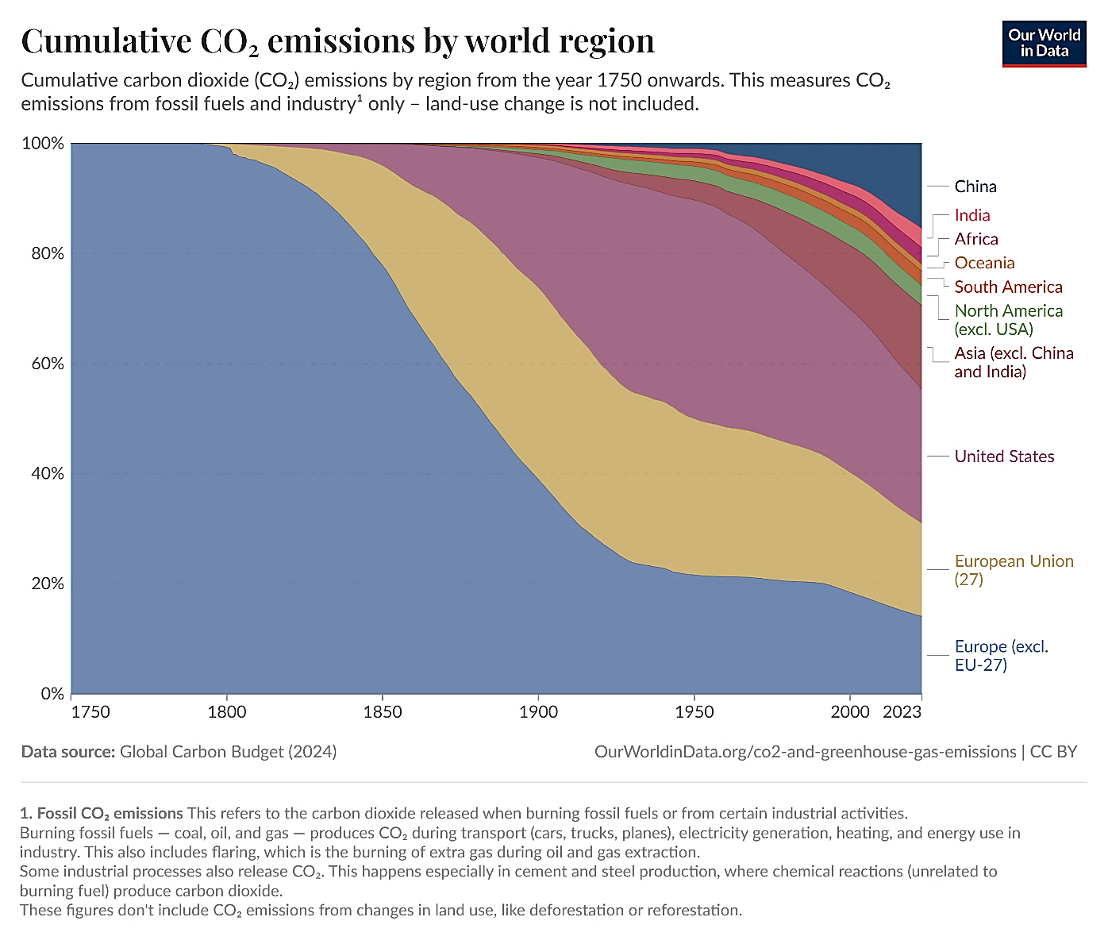
Source: Our World In Data (Global Carbon Budget, 2024)
Note: Measure is based on CO₂ emissions from fossil fuels and industry. The thickness of each band of colour indicates porportion at a point in time.

