Teacher Briefing




A Debate on European Union Values
The Human Rights Debate

Debate Question
The question for your student debate is; “If gay marriage is not legal in a European Union country, should that country still have to provide a residency right to the gay husband of an EU citizen?” Through the debate, students explore a clash of two principles of the EU:
- Freedom of Movement: EU citizens and their families have the right to move and live in other EU member states (countries).
- Member State Sovereignty: EU member states (countries) hold the power to make laws in policy areas that they have not shared with the EU.

Debate Aim
That students consider the relevance of European Union values and explore the rights and responsibilities of citizens and member states under EU law. The debate question comes from a court case brought by Adrian Coman to the Court of Justice of the EU in 2018 [Coman v Romania’s Immigration Inspector].
- We want you and your students to explore the ideas and issues involved through a moral, social, and political debate, rather than a legal one.
- After the debate you can present the summary of the actual court case ruling to students (page 3) as a eureka moment for reflection.

Using the Debate
You can adapt the debate design and material to meet your teaching need, classroom dynamic, or student group. See this as a debate resource rather than a straitjacket.

Teacher Briefing


Debate Format
Pre-Debate
- Days Before: Provide the Student Briefing material to students (pages 7-9).
- Optional: Show student this very short AV clip about EU values
- Debate Day: Assign 3-5 students to a group for each debate role. Visually present the Debate Instructions (page 6) to students and distribute the relevant Role Cards (page 10-17) for their role. Give them approximately 20 minutes to analyse their Role Card and prepare for their role.

Debate Design
- Room Set-up: Each role group has a table, chairs, and a table title (page 19-23).
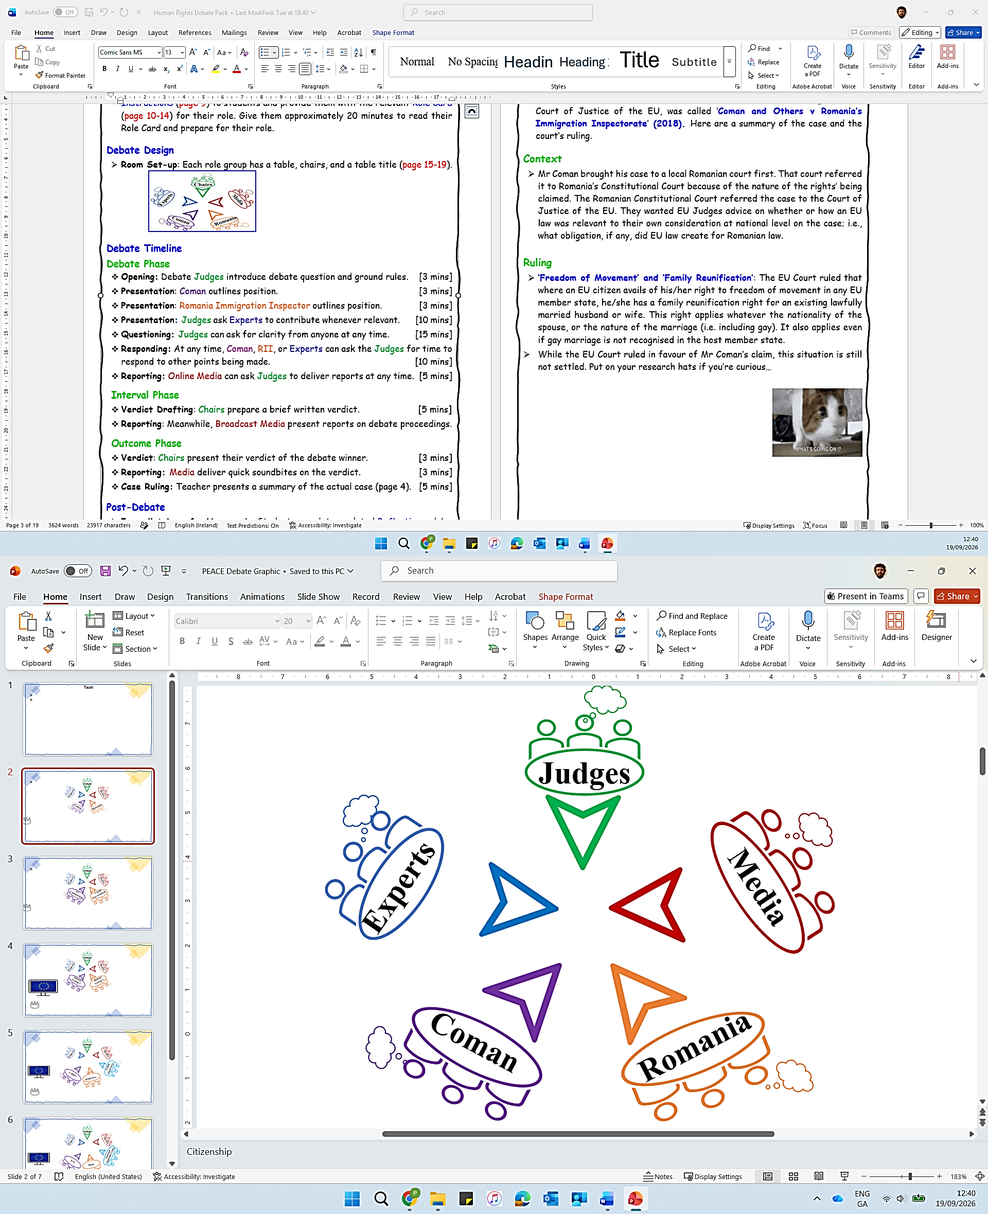

Debate Timeline
Debate Phase
- Opening: Debate Judges introduce debate question and ground rules. [3 mins]
- Presentation: Coman outlines position. [3 mins]
- Presentation: Romania Immigration Inspector outlines position. [3 mins]
- Presentation: Judges ask Experts to contribute whenever relevant. [10 mins]
- Questioning: Judges can ask for clarity from anyone at any time. [15 mins]
- Reporting: Media deliver mid-debate report(s) on the debate. [5 mins]
- Responding: At any time in the debate, Coman, RII, or Experts can ask the Judges for time to respond to other points being made. [10 mins]

Interval Phase
- Drafting: Judges prepare a brief written ruling. [5 mins]

Outcome Phase
- Ruling: Judges present their ruling on the debate. [3 mins]
- Reporting: Media deliver final report(s) on the debate. [3 mins]

Post-Debate
- Case Ruling: Teacher interjects to present actual case ruling (page 3). [5 mins]
- Immediately or for Homework: Students complete any Reflective or Research Activity that you choose (page 4).

Teacher Briefing



*Post-Debate* Teacher Intervention
Court Case
- This debate was based on a real situation. The related case, brought to the Court of Justice of the EU, was called ‘Coman and Others v Romania’s Immigration Inspectorate’ (2018). Here are a summary of the case and the court’s ruling.

Context
- Mr Coman brought his case to a local Romanian court first. That court referred it to Romania’s Constitutional Court because of the type of rights’ he claimed. The Romanian Constitutional Court referred the case to the Court of Justice of the EU. They wanted EU Judges to advise on whether or how EU law was relevant for their consideration of the case at national level; i.e., what obligation, if any, did EU law create for Romanian law.

Ruling
- ‘Freedom of Movement’ and ‘Family Reunification’: The EU Court ruled that where an EU citizen avails of ‘his’ right to freedom of movement in any EU member state, ‘he’ has a family reunification right with an existing lawfully married husband or wife.
- This right applies whatever the nationality of the spouse, or the nature of the marriage (i.e., including gay marriage). It also applies even if gay marriage is not recognised in the host member state.
- Romania still does not need to legislate for or legalise gay marriage. This ruling applies only to the rights of mobile EU citizens (and their legal spouses) who live in or move to Romania.
- While the EU Court ruled in favour of Mr Coman’s claim, this situation is still not settled in Romania. Put on your research hats if you’re curious…

Optional Follow-up
- Show students one or both of these AV clips about:
- 1) Coman Case Verdict (DWNews)
- 2) Coman Case (euronews)

Teacher Briefing



Post-Debate Student Activities
Reflective Activities
Students can use a page or post-its to reflect on their content or skill learning. No right answers, just honesty….
Content
1. What was most interesting about the debate scenario?
2. What was most interesting about EU law?

Participation
1. What was most interesting about your role in the debate?
2. What did you learn about your debating skills or watching others debate?

Debate Impact
1. On a scale of 1 (Not at all) to 5 (Very); are you curious to find out what happened to Mr Coman after the case?
2. On a scale of 1 (Not at all) to 5 (Very); has this debate impacted your interest in EU values, principles, or EU citizens’ rights?
3. On a scale of 1 (Not at all) to 5 (Very); how engaging or fun was this debate overall?
4. What changes would you make to the debate design or content to improve it for students of your age?

Research Activities
Assign a student or a group of students to research and report back on the following:

- Why Mr Coman later took a case to the Council of Europe’s European Court of Human Rights (i.e., outside the EU) in 2020 to implement this decision?
- The European Parliament’s Committee on Petitions’ (2021) discussion of Romania’s failure to implement the ruling in this case.
- Other court cases about EU citizens’ right to ‘freedom of movement’ across the EU (e.g., there is an interesting professional football/soccer one)
- What policy areas do EU member states share decision-making with the EU, and what policy areas do member states not share with the EU?

Teacher Briefing



Student To-dos
1. Pre-debate: Read the debate scenario and background (pages 7-8).
2. Pre-debate: Read about EU Values and Principles (page 9).
3. Pre-debate: Work in assigned group to prepare debate role. Students can use the Student Briefing material and Role Cards as resources to prepare and develop their own arguments, in their own words.
4. During debate: Prepare and present their debate points, counterpoints, or information to perform their role.
5. Post-debate: Complete any Reflective or Research Activity that you choose (page 4).


Glossary
- If you think that students do not know the following terms, these descriptions will help you in briefing them:
- EU Member States: The 27 European countries who pool decision-making power in some policy areas. This creates rights and responsibilities for their governments and citizens under EU law.
- EU Values: Beliefs or priorities that EU member states consider to be important. The EU has 6 common values (human dignity, freedom, equality, democracy, rule of law, and respect for human rights).
- Freedom of Movement: Citizens of EU member states can live in any other EU member state for up to 3 months. If employed, studying, or self-funded, EU citizens have the right to live there for longer. An EU citizen’s family (husband, wife, or children) are entitled to move and live with them, even if the husband or wife is from outside of the EU. This right is not absolute; it can be limited by a country for policy reasons.

Printing (If Relevant)
You may be able to distribute debate material to students using your school’s virtual platform. However, if printing, this is a summary of advisable printing:
Days in Advance: Double-sided, 1 copy of Student Briefing (page 7-9) per student.
Days or hours in Advance: Single-sided, 1 or 2 copies of Role Cards (page 10-17).
Days or hours in Advance: Single-sided, 1 copy of table titles (page 19-23).

Debate Instructions [Teacher Presents (Visually) on Debate Day]


Preparation
You’re going to debate the question: If gay marriage is not legal in a European Union country, should that country still have to provide a residency right to the gay husband of an EU citizen?
I’ll assign you to a group to perform one of these roles in the debate:
- Judges
- Mr Coman
- Romania’s Immigration Inspector
- Experts
- Media
Use the Student Briefing material and the prompts on your Role Card to prepare for the debate. It is not about using big words. Present your points in your own words and prepare counterpoints to the points made by other debate players.
You may not agree with the opinions or beliefs of the role you’re playing. It’s a role-play, your job is to represent the role you’re playing, rather than your own opinion. To stand in their shoes for a little while.

Debate Timeline

Debate Phase
- Opening: Debate Judges introduce debate question and ground rules. [3 mins]
- Presentation: Coman outlines position. [3 mins]
- Presentation: Romania Immigration Inspector outlines position. [3 mins]
- Presentation: Judges ask Experts to contribute whenever relevant. [10 mins]
- Questioning: Judges can ask for clarity from anyone at any time. [15 mins]
- Reporting: Media groups deliver mid-debate report(s) on the debate. [5 mins]
- Responding: At any time in the debate, Coman, RII, or Experts can ask the Judges for time to respond to other points being made. [10 mins]

Interval Phase
- Drafting: Judges prepare a brief written ruling. [5 mins]

Outcome Phase
- Ruling: Judges present their ruling on the debate. [3 mins]
- Reporting: Media groups deliver final report(s) on the debate. [3 mins]

Student Briefing

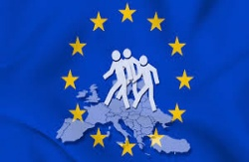

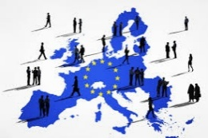

Debate Scenario

Adrian Coman is an EU citizen from Romania. His husband (Clai Hamilton) is from America , i.e., from outside of the EU. They married when living in Belgium, where same-sex marriage is legal.
Now, they’ve decided to move to Adrian’s home country of Romania. Romania’s Immigration Inspector is refusing to provide a residence permit to Adrian’s husband as he is not an EU citizen. Adrian claims that refusal breaches his right, as an EU citizen, to live with his family in any EU member state.

What is this debate about?
The main question in this debate is; “If gay marriage is not legal in a European Union country, should that country still have to provide a residency right to the gay husband of an EU citizen?” The debate involves a clash between two important ideas of the EU:

- Freedom of Movement: EU citizens and their families have the right to move and live in other EU member states (countries).
- Member State Sovereignty: EU member states (countries) hold the power to make laws in policy areas that they have not shared with the EU.

Student Briefing



Debate Background: EU Law

- EU citizens have a right to move and live (‘freedom of movement’) within the EU. (EU Directive 2004)
- EU member states must respect this right without discrimination based on sex, race, colour, disability, age or sexual orientation. (EU Charter of Fundamental Rights)
- EU member states must provide a right to move and reside to family members of EU citizens. This includes legal spouses (husbands/wives), regardless of their nationality.

Debate Background: Romanian Law 
- Romania accepts EU citizens right to ‘freedom of movement’ in its territory.
- In Romania, legal marriage is a union between a man and a woman. (Romanian Civil Code)
- Marriage between persons of the same sex is prohibited or illegal. (Romanian Civil Code)
- The same-sex marriage of a Romanian citizen abroad is not legally recognised in Romania. (Romanian Civil Code)

Student Briefing


Charter of Fundamental
Rights of the EU
- Identifies civil, political, social, and economic rights of EU citizens and residents.

Primacy of EU Law
- In policy areas where member states have given the EU competence, EU law trumps national law.
- The aim is that EU law is applied consistently across member states.
Freedom of Movement
- EU citizens have a right to live, work, study, and retire in any other member state.
- Family members have the right to accompany EU citizens.

Member State Sovereignty
- An EU member state shares decision-making power with EU institutions in some policy areas.
- In other policy areas, a member state holds full power to make law.

EU Citizenship
- Is automatically granted to all nationals of EU member states.
- Provides rights and opportunities, such as freedom of movement and some political rights.

EU Principles 

These are guidelines for EU activity. They come from key EU values or ideas. They must be respected by EU institutions and member states when making decisions. Take time to read them carefully, they’ll help your debate points.

Role Card: Judges


Your Role
- You are Judges at the Court of Justice of the EU. Your role is to organise the debate and facilitate interactions. Listen to all sides neutrally and ask questions for clarity when you need. You are not on anyone’s side.
-------------------------------------------------------
Prepare
- Read the Student Briefing material (page 7-9). Use it to prepare an opening statement for the debate.
- Use the template provided to note and analyse the arguments made during the debate.
--------------------------------------------------------
Debate
- Opening: Briefly outline the debate question, and the rules of engagement for contributions and interactions between debate players.
- Facilitate: Invite debaters to present their arguments, roughly in line with the Debate Timeline in the Debate Instructions. Invite them to make counterpoints in response to points made by other debaters.
- Question: Be polite but ensure that debaters keep their points relevant to the question and issues involved.
- Invite: Experts to present information whenever relevant during the debate.
- Invite: Media groups to deliver mid-debate report.
- Ruling: Note relevant points made by Coman, Romania’s Immigration Inspector, and Experts during the debate.
-------------------------------------------------------
Deliver
Ruling: Use the Interval Phase during the debate to consider whether Coman’s or the Romania’s Immigration Inspector’s points were more convincing, given the debate background. Using your Ruling Sheet, write a few short notes of the most convincing points made, and possible wider impacts of the debate verdict.
- Presentation: Call all debaters attention and deliver your ruling to all present, outlining the points from your Ruling Sheet.
- Closing: Invite final reports from the Media groups that conclude the debate.

Role Card: Judges

Our Decision
- State your ruling clearly. Can Romania continue to refuse a residence permit to Mr Coman’s husband? Or does the breach his rights as a mobile EU citizen?
- Give your answer, reasoning, and maybe some impacts of your decision.

What are the most convincing/relevant points in support of the Romanian Immigration Inspectors’ claim?

What are the most convincing/relevant points in support of Mr Coman’s claim?

Judges’ Ruling Sheet
- This sheet should help you in analysing the debate and forming your decision.

Role Card: Mr Coman



Your Role
- You represent Adrian Coman in the debate. You think that the refusal by Romania of a residence permit to your husband breaches your right as an EU citizen.
-------------------------------------------------------
Prepare
- Read the debate Student Briefing material. In your own words, develop moral, social, or political points to represent Mr Coman. Here are some, but be confident to develop your own:
- Freedom of Movement: Your husband has the right to live with you in Romania or any EU member state. This comes from a family reunification right (even though he is from outside the EU), as you are an EU citizen.
- EU Fundamental Rights: Denying you this right is discrimination on the grounds of sexual orientation, as you have a right to freedom of movement in the EU.
- Primacy of EU Law: Romania agreed to the EU law (Directive) on free movement and to the EU Charter of Fundamental Rights when joining as a member state. You think that these are relevant for your scenario and should prevail over Romania’s national law that sees same-sex marriage as illegal or irrelevant.
-------------------------------------------------------
Debate
- Present: Be clear in outlining relevant points to represent Mr Coman’s position. Be confident to do this in your own words, without overly relying on prompts, big words, or a script.
- Interact: Consider the information introduced by other debate players. Be prepared to counter the points that they make. Try to keep the debate background and EU principles in mind (page 9) .

Role Card: Romania’s Immigration Inspector



Your Role
- You represent Romania’s Immigration Inspector in the debate. You think that as gay marriage is not legal in Romania, Mr Coman’s husband does not have a right to permanently live in Romania.
-------------------------------------------------------
Prepare
- Read the debate Student Briefing material. In your own words, develop moral, social, or political points to represent Romania’s Immigration Inspector. Here are some, but be confident to develop your own:
- Freedom of Movement: Mr Coman’s husband, as a non-EU national (American), is not entitled to an EU citizen’s right to reside in any EU member state.
- Member State Sovereignty: As the legalisation of marriage is not an area of shared EU decision-making, Romania does not have to recognise gay marriage. Your current law does not recognise gay marriages conducted in other countries. Therefore, Mr Coman’s husband is not entitled to a residence permit through the family reunification right of an EU citizen.
- EU Fundamental Rights: As Mr Coman’s husband is not recognised as a legal spouse in Romanian law, denying him a residence permit in this instance is not discrimination.
--------------------------------------------------------
Debate
- Present: Be clear in outlining relevant points to represent the Immigration Inspector’s position. Be confident to do this in your own words, without overly relying on prompts, big words, or a script.
- Interact: Consider the information introduced by other debate players. Be prepared to counter the points that they make. Try to keep the debate background and EU principles in mind (page 9) .

Role Card: Experts


Your Role
- You are independent experts who provide information to enhance the debate. You are neutral, you do not represent either side. Your role is to explain a key concept or context to help the judges understand the debate.
--------------------------------------------------------
Prepare
- Read the debate Student Briefing material to be aware of the background.
- Divide the roles below within your group. If you like, work as sub-groups rather than individually. Develop related points in your own words.

- EU Politics Teacher: Outline the aim of the EU’s Free Movement Directive. As a key part of EU citizenship, it gives citizens the right to live in any other EU member state. It comes from the idea of a single EU market for workers. However, mobile EU citizens cannot be a burden on the social system of that state. To stay longer than 3 months, they must be employed, studying, or funded.
- EU Legal Expert: Outline what is meant by ‘the primacy of EU law’. EU countries pool decision-making in some policy areas. In these, the European Commission (representing the EU), the European Parliament (representing EU citizens), and the Council of the EU (representing EU member governments) make laws that member states must implement. A member state cannot use it existing national law to avoid EU obligations that it has agreed to.
- Romanian Political Researcher: Outline developments around gay marriage in Romania. Legalising gay marriage is not a policy competence of the EU, each country decides for itself. Only one Romanian political party supports gay marriage. In 2018, its government tried to strengthen the banning of gay marriage through a referendum.
- Political Scientist: Outline that public opinion polls indicate slight increases over time in support for gay rights and marriage in Romania. However, this is still minority support. In a 2023 public opinion poll across EU member states, Romania had the 2nd lowest level of public support for gay marriage, at only 37% in favour.
- Romanian LGBT Organisation: Outline moves to expand gay rights in Romania. The 2018 government referendum to strengthen the ban on gay marriage did not pass. Only 20% turned out to vote, below a 30% threshold. Civil groups led its boycott. Romania has been brought to other European Courts over LGBT rights.
--------------------------------------------------------
Debate
- Present: Be clear and brief in your contributions, with a neutral tone.
- Interaction: The Judges will invite you. But if a point made in the debate relates to your expertise, ask the Judges for an opportunity to clarify.

Role Card: Media



Your Role
- You are reporters for news organisations covering the debate. Your teenage audience is not familiar with the EU. Your reports need to make the debate issues meaningful for them. Bring a bit of drama or excitement to the debate.
--------------------------------------------------------
Prepare
- Divide into two news groups. Media organisations focus 1) informing in a neutral or formal way or 2) dramatising by using controversial angles and soundbites. Each media group can decide whether your report stye will be ‘Informing’ or ‘Dramatising’.
- You can also decide whether your reports are for Online (TikTok, Insta, X, etc) or Broadcast (TV or Radio) media.
- Think about and prepare relevant props (fake micro-phone, backdrop, sound effects, or imagery) for the type of report medium you select.
- Use the Student Briefing material to select angles that to focus on in your reports. Within your group, divide tasks to ensure relevant information is captured, and the design and presentation of the report(s) is prepared.
- Use the mid-debate and final report Preparation Templates to prepare.
--------------------------------------------------------
Debate
- Observe: Note relevant points, issues, and debate exchanges.
- Engage: At any time, you can ask other debate players for a comment or quotation to inform your reports.
--------------------------------------------------------
Deliver
- Mid-Debate Report: When called by the Judges, each media group delivers a short (2-3mins) and snappy update on the debate to that point. Be creative and add life to the debate for an external audience. Include relevant props depending on your type of report and start with a catchy headline.
- Final Report: When called by the Judges, each media group presents a short (2-3mins) and snappy final report on the debate. Try to keep your Informing or Dramatising style in mind. Be creative to engage or entertain your audience.

Role Card: Media

Main Debate Points/Issues/Events to include:

Debater Quotes / Comments to include:

Hook/Angles to bring your ‘Informing’ or ‘Dramatising’ style:

Other Notes:

Props to Animate Report Presentation:

Possible Headlines:

Report Type: TikTok, Insta,TV, Radio, X, or other? __________________

Report Style: Informing or Dramatising? ___________________

Preparation Template for Mid-Debate Report

Role Card: Media

Report Type: TikTok, Insta,TV, Radio, X, or other? __________________

Possible Headlines:

Main Debate Points/Issues/Events to include:

Debater Quotes / Comments to include:

Hook/Angles to bring your ‘Informing’ or ‘Dramatising’ style:

Other Notes:

Props to Animate Report Presentation:

Report Style: Informing or Dramatising? ___________________

Preparation Template for Final Report

Judges

Coman

Immigration Inspector (Romania)

Experts

Media

