Teacher Briefing



A Debate on European Union Values
The Human Dignity Debate
Debate Question
The debate question is: “Can a court in one country order a worldwide takedown of false social media content and what responsibility does that put on a social media platform?” Through the debate, students explore a clash of two principles of the EU:

- Human Dignity: Every person's worth and reputation deserve to be protected.
- Freedom of Expression: Everyone has the right to hold opinions and to share and receive information.
Debate Aim
That students consider the relevance of European Union values and explore the rights and responsibilities of citizens and member states under EU law. The debate question comes from a court case brought by Eva Glawischnig-Piesczek to the Court of Justice of the EU in 2018 [Eva Glawischnig-Piesczek v Facebook Ireland].

- We want you and your students to explore the ideas and issues involved through a moral, social, and political debate, rather than a legal one.
- After the debate you can present the summary of the actual court case ruling to students (page 3) as a eureka moment for reflection.

Using the Debate
You can adapt the debate design and material to meet your teaching need, classroom dynamic, or student group. See this as a debate resource rather than a straitjacket.

Teacher Briefing

Debate Format
Pre-Debate
- Days Before: Provide the Student Briefing material to students (pages 7-9).
- Optional: Show student this very short AV clip about EU values
- Debate Day: Assign 3-5 students to a group for each debate role. Visually present the Debate Instructions (page 6) to students and distribute the relevant Role Cards (page 10-18) for their role. Give them approximately 20 minutes to analyse their Role Card and prepare for their role.

Debate Design
- Room Set-up: Each role group has a table, chairs, and table titles (page 19-24).
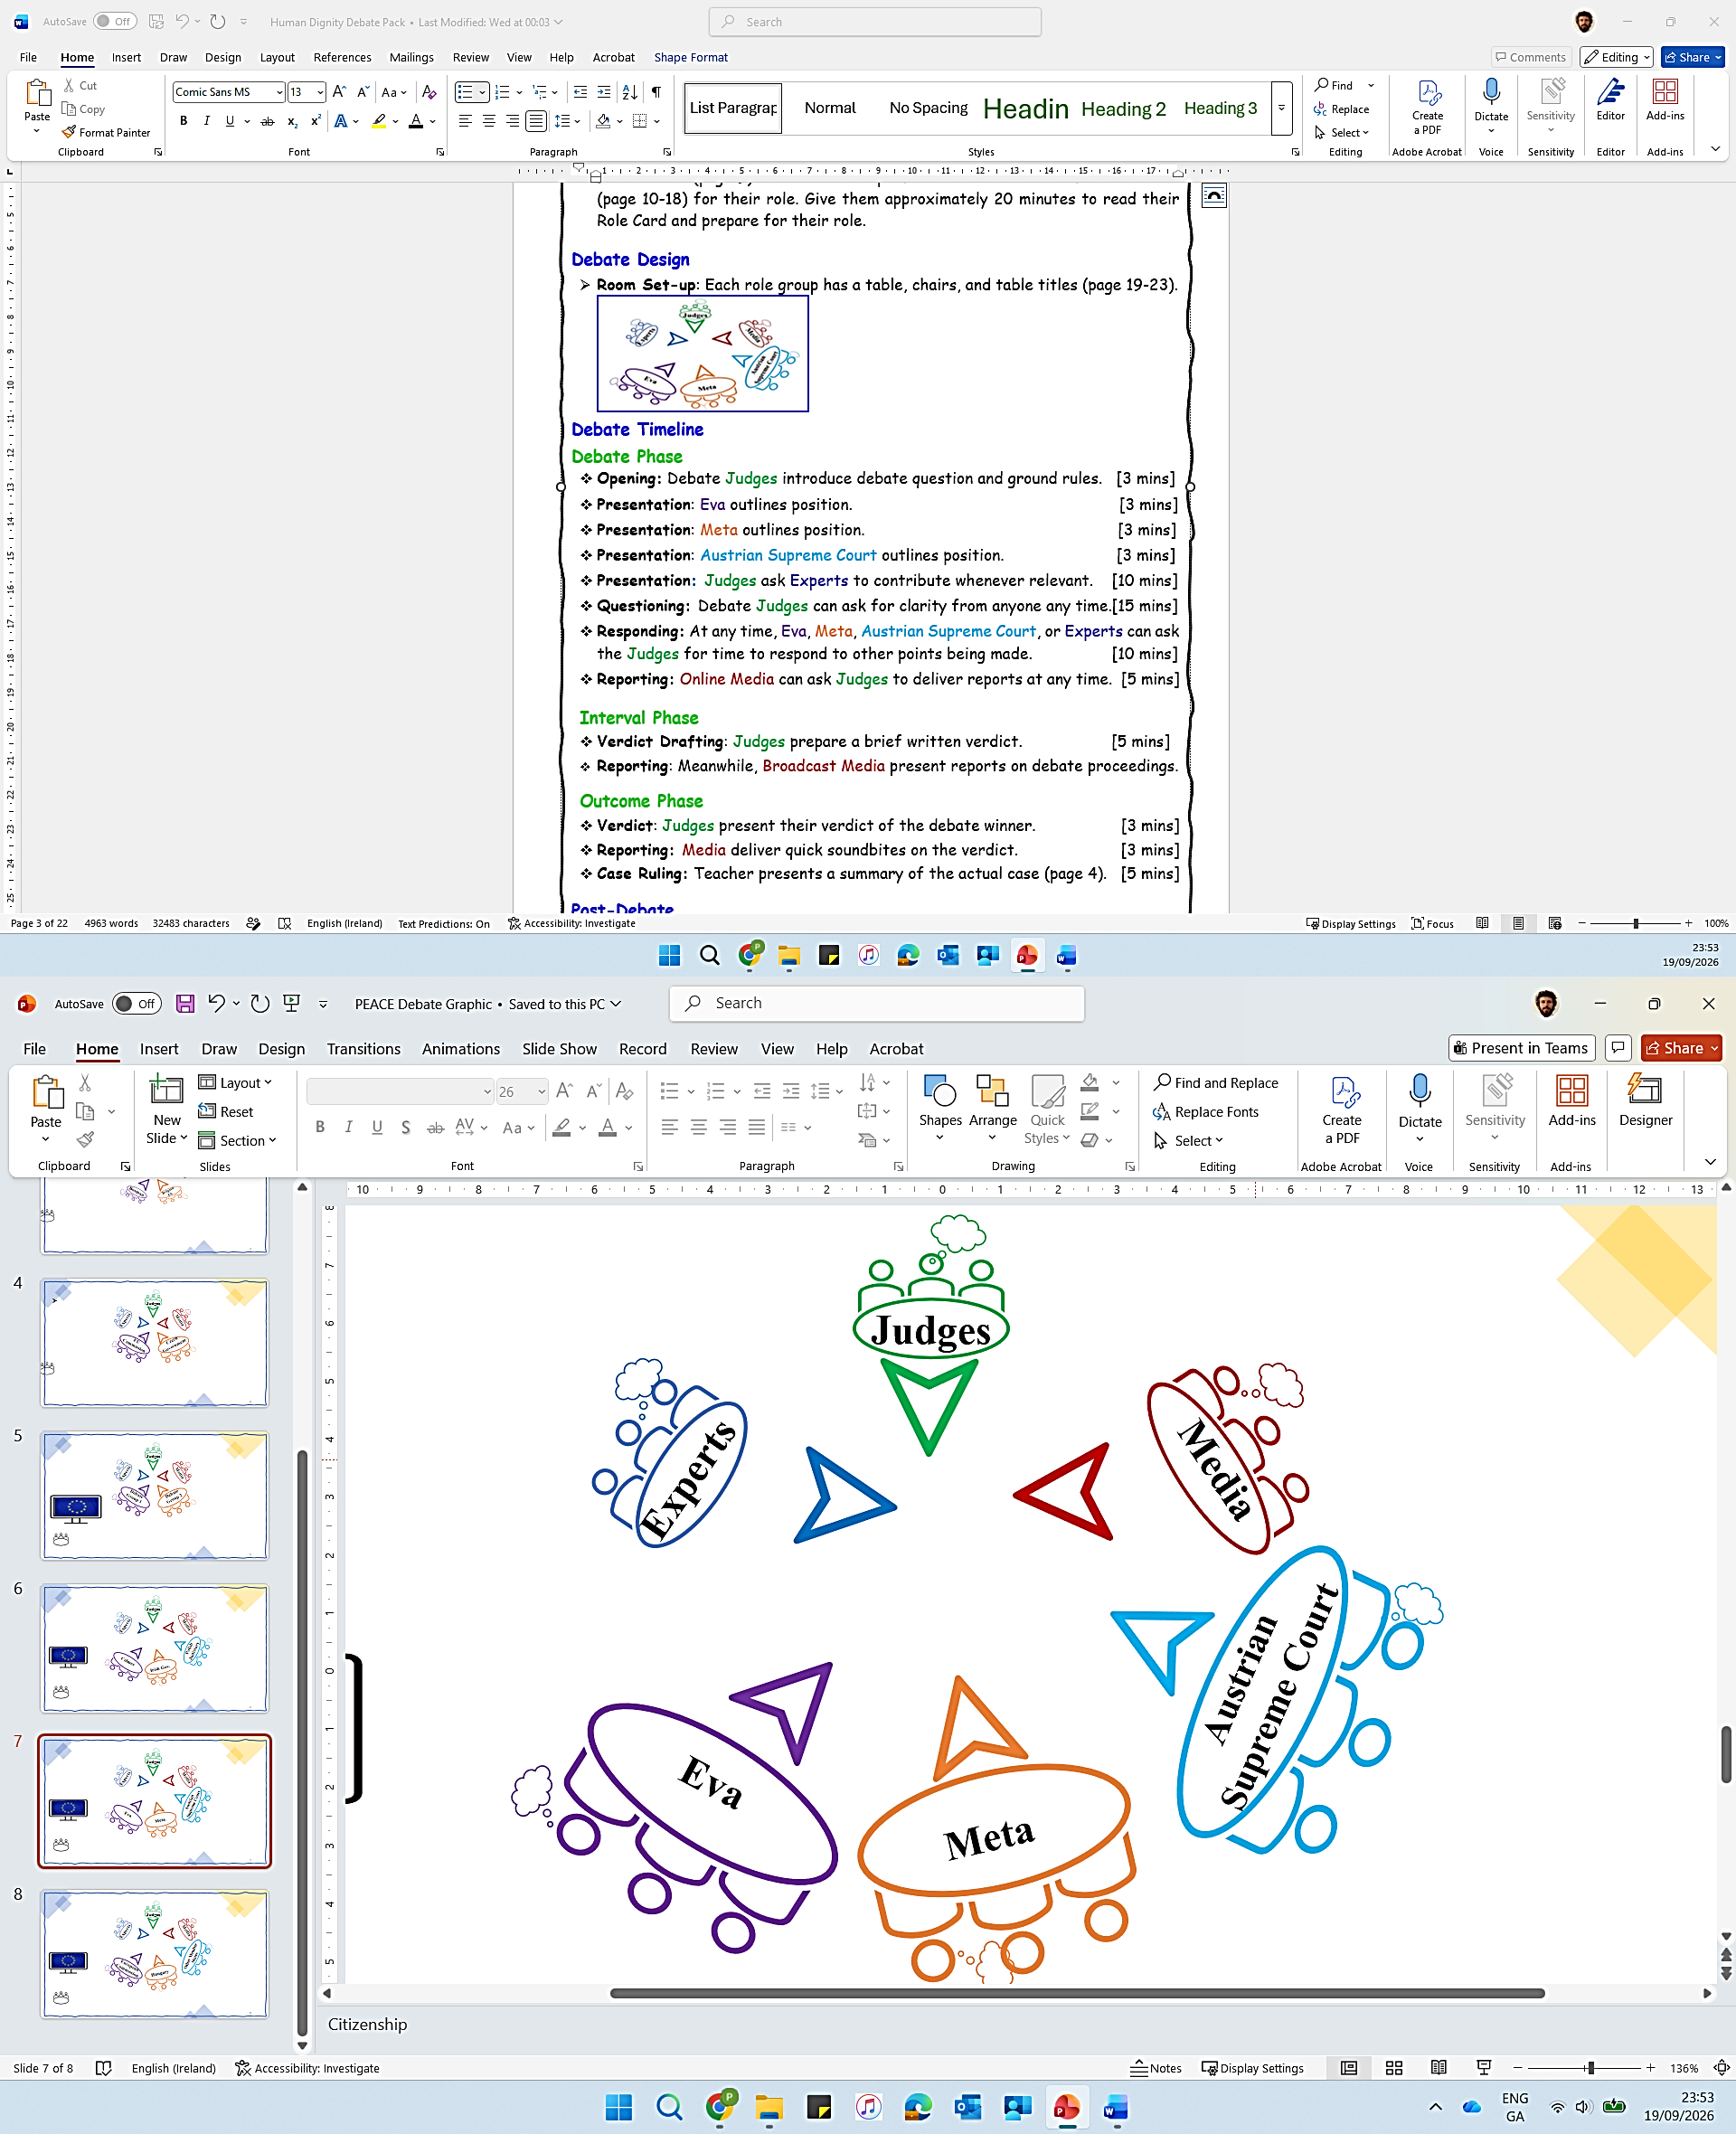

Debate Timeline
Debate Phase
- Opening: Debate Judges introduce debate question and ground rules. [3 mins]
- Presentation: Eva outlines position. [3 mins]
- Presentation: Meta outlines position. [3 mins]
- Presentation: Austrian Supreme Court outlines position. [3 mins]
- Presentation: Judges ask Experts to contribute whenever relevant. [10 mins]
- Questioning: Judges can ask for clarity from anyone at any time. [15 mins]
- Reporting: Media deliver mid-debate report(s) on the debate. [5 mins]
- Responding: At any time in the debate, Eva, Meta, Austrian Supreme Court, or Experts can ask Judges for time to respond to other points being made. [10 mins]

Interval Phase
- Drafting: Judges prepare a brief written ruling. [5 mins]

Outcome Phase
- Ruling: Judges present their ruling on the debate. [3 mins]
- Reporting: Media deliver final report(s) on the debate. [3 mins]

Post-Debate
- Case Ruling: Teacher interjects to present actual case ruling (page 3). [5 mins]
- Immediately or for Homework: Students complete any Reflective that you choose (page 4).

Teacher Briefing


*Post-Debate* Teacher Intervention
Related Court Case 
- This debate was based on a real situation. The related case, brought to the Court of Justice of the EU, was called ‘Eva Glawischnig-Piesczek v Facebook Ireland’ (2018). Here is a summary of the court’s ruling in 2019:

Ruling
- Human Dignity: A national court can order a platform to remove illegal content worldwide. One country’s court can reach beyond its own borders.
- Online Platform Moderation: Facebook can be ordered to remove not just the original post, but any post with the exact same wording — anywhere on its platform, worldwide.
- Automatic Moderation: A court can also order removal of posts with similar meaning — but only if the search can be done automatically. Facebook can’t be expected to personally read and judge every post.
- Censorship: Platforms still can’t be forced to monitor everything all the time. This ruling is about specific, identified illegal content — not a blank cheque for censorship.

- In Short: Free speech is protected — but only for speech that’s legal. When content is genuinely illegal, dignity wins. How far the remedy can go was left for national courts to work out case by case…

Did your judges reach the same conclusion?
If not, what do you think explains the difference? Was the ‘real’ court right?

Optional Follow-up
- Show students one or both of these AV clips about:
- 1) Case Significance and Reaction (euronews – clip in article)
- 2) Mark Zuckerberg on Freedom of Expression v Censorship (Instagram)

Teacher Briefing


Post-Debate Student Activities
- Students can use this page or post-its to reflect on their content or skill learning. No right answers, just honesty….

Reflective Activities

The most convincing thing you heard from the other side was…

The weakest argument you heard was…

If someone posted lies about you online, what would you want to happen?

If you posted something harsh about a politician and it got removed worldwide, how would you feel about that?

Exit Thoughts
“Having the right to free speech doesn’t mean having the right to destroy someone with lies.” Do you agree? Where should the line be??
One minute. Three things. Write the first thing that comes into your head.
ONE thing I’ll remember | ONE question I still have | ONE word to describe today

Use minute papers (or note cards) for students to reflect on their content or skill learnings from the debate. Here are some prompts:
Content
1. What was most interesting about the debate background or scenario?
2. What did you learn about the EU or EU law that was most interesting?

Participation
1. What was most interesting about your role in the debate?
2. What did you learn from participating in or watching others participate in the debate?

Debate Impact
1. On a scale of 1 (Not at all) to 5 (Very); are you curious to find out about other impacts of the EU on professional sports?
2. On a scale of 1 (Not at all) to 5 (A lot); has this debate impacted your interest in EU values, principles, or EU citizens’ rights?
3. On a scale of 1 (Not at all) to 5 (Very); how engaging or fun was this debate overall?
4. What changes would you make to the debate material or design to improve it for students of your age?
Research Activities 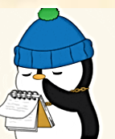
Assign a student or a group of students to research and report back on the following:

- Other high profile cases involving EU citizens’ freedom of movement or subsidiarity.
- The measures that UEFA and FIFA introduced after the ruling on transfers and compensation for player development.
- The impact of the Bosman rule on transfers, contracts, and globalisation in any other professional sport (e.g., rugby, basketball, Olympic handball or cycling).
- The effect of EU law on professional sports in Europe; such as tv rights deals, advertising, off-setting monopoly or breakaways in competitions.

Teacher Briefing



Student To-dos
1. Pre-debate: Read the debate scenario and background (pages 7-8).
2. Pre-debate: Read about EU Values and Principles (page 9).
3. Pre-debate: Work in assigned group to prepare debate role. Students can use the Student Briefing material and Role Cards as resources to prepare and develop their own arguments, in their own words.
4. During debate: Prepare and present their debate points, counterpoints, or information to perform their role.
5. Post-debate: Complete any Reflective Activity that you choose (page 4).

Glossary 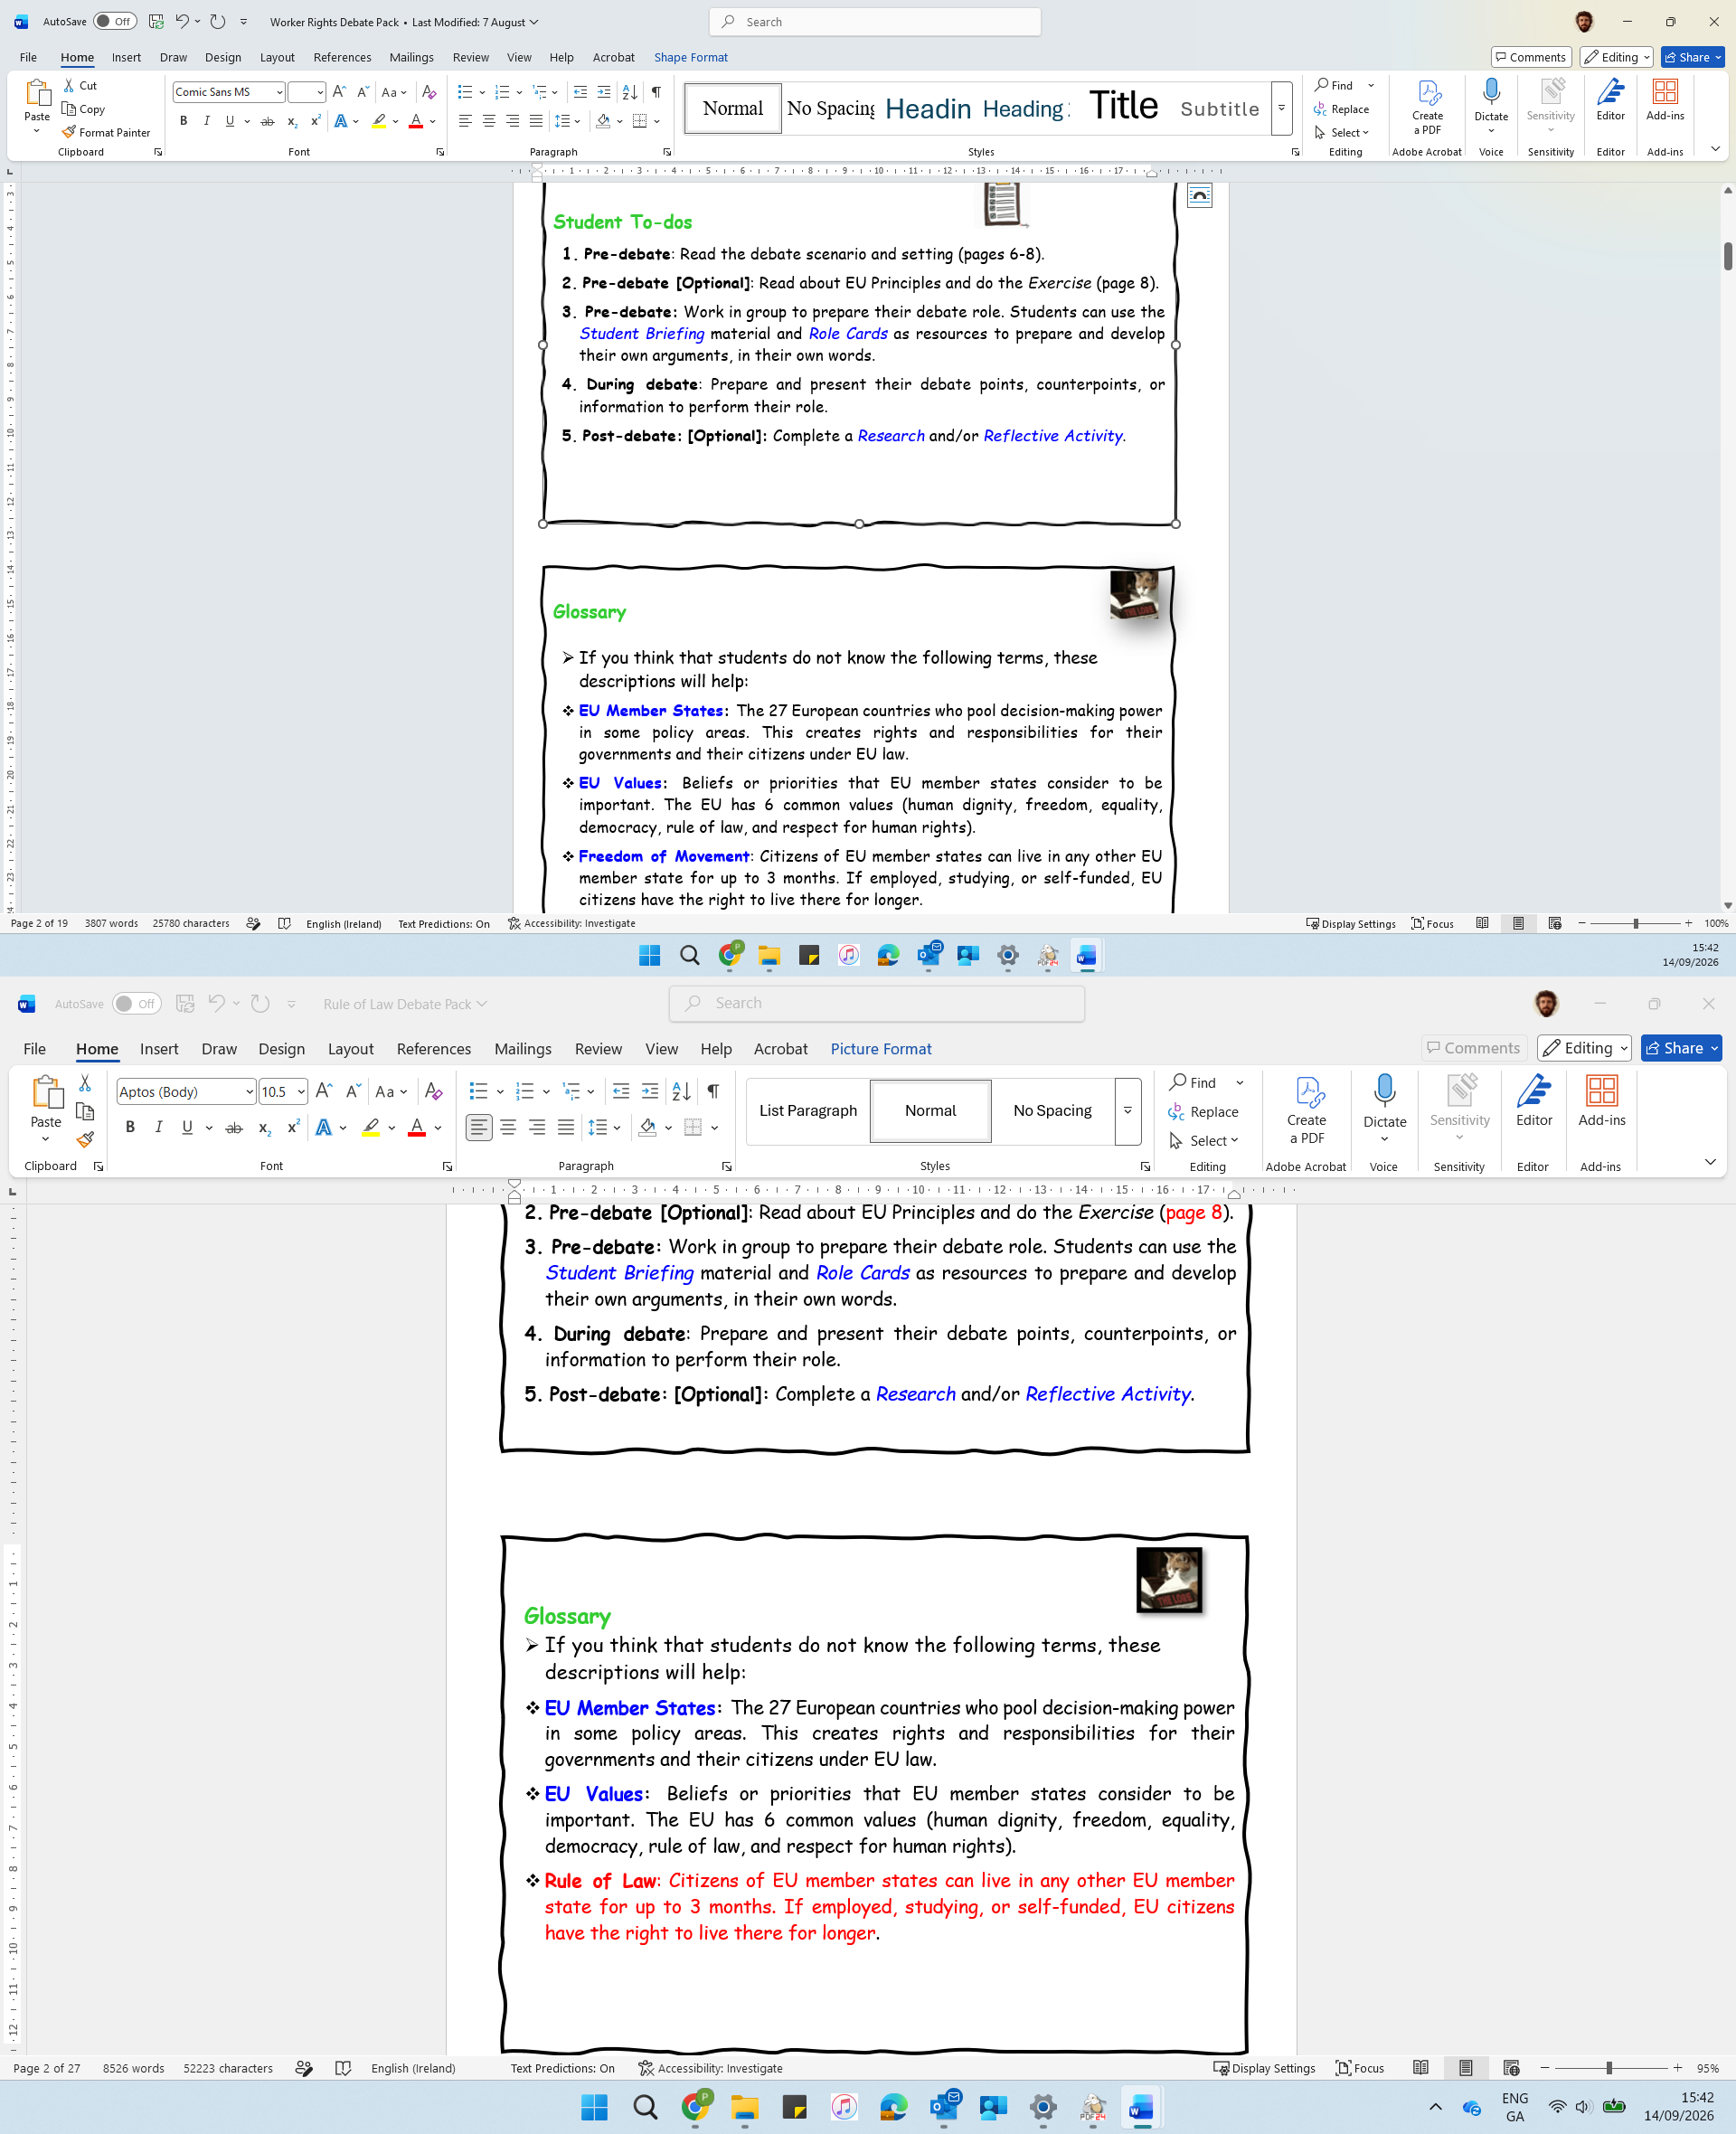
- If you think that students do not know the following terms, these descriptions will help you in briefing them:
- EU Member States: The 27 European countries who pool decision-making power in some policy areas. This creates rights and responsibilities for their governments and their citizens under EU law.
- EU Values: Beliefs or priorities that EU member states consider to be important. The EU has 6 common values (human dignity, freedom, equality, democracy, rule of law, and respect for human rights).
- Human Dignity: Every person's worth and reputation deserve respect. Attacks that are untrue and damaging (i.e., defamation) are not protected as free speech.

Printing (If Relevant)
You may be able to distribute debate material to students using your school’s virtual platform. However, if printing, this is a summary of advisable printing:
Days in Advance: Double-sided, 1 copy of Student Briefing (page 7-9) per student.
Days or hours in Advance: Single-sided, 1 or 2 copies of Role Cards (page 10-18).
Days or hours in Advance: Single-sided, 1 copy of table titles (page 19-24 ).

Debate Instructions [Teacher Presents (Visually) on Debate Day]


Preparation
You’re going to debate the question: Can a court in one country order a worldwide takedown of false social media content and what responsibility does that put on a social media platform?
I’ll assign you to a group to perform one of these roles in the debate:
- Judges
- Eva
- Meta
- The Austrian Supreme Court
- Experts
- Media
Use the Student Briefing material and the prompts on your Role Card to prepare for the debate. It is not about using big words. Present your points in your own words and prepare counterpoints to the points made by other debate players.
You may not agree with the opinions or beliefs of the role you’re playing. It’s a role-play, your job is to represent the role you’re playing, rather than your own opinion. To stand in their shoes for a little while.

Debate Timeline

Debate Phase
- Opening: Debate Judges introduce debate question and ground rules. [3 mins]
- Presentation: Eva outlines position. [3 mins]
- Presentation: Meta outlines position. [3 mins]
- Presentation: Austrian Supreme Court outlines position. [3 mins]
- Presentation: Judges ask Experts to contribute whenever relevant. [10 mins]
- Questioning: Judges can ask for clarity from anyone at any time. [15 mins]
- Reporting: Media deliver mid-debate report(s) on the debate. [5 mins]
- Responding: At any time in the debate, Eva, Meta, Austrian Supreme Court, or Experts can ask Judges for time to respond to other points being made. [10 mins]

Interval Phase
- Drafting: Judges prepare a brief written ruling. [5 mins]

Outcome Phase
- Ruling: Judges present their ruling on the debate. [3 mins]
- Reporting: Media deliver final report(s) on the debate. [3 mins]

Student Briefing
Debate Scenario
Imagine waking up one morning and finding that someone has posted lies about you online — calling you corrupt, a traitor, a fascist. Your photo is right there next to the words. Thousands of people have already seen it. You ask the platform to take it down. They say no. That’s exactly what happened to Eva Glawischnig-Piesczek.
Eva’s Story
Eva was the leader of the Austrian Green Party and a member of parliament. She campaigned on climate change and human rights. An anonymous Facebook user has shared a news article about her and added comments underneath calling her a “corrupt oaf,” a “lousy traitor,” and claimed she belonged to a “fascist party.”
Eva has asked an Austrian court to give a ruling on whether these comments were opinions or lies. The Austrian court decided the comment was defamatory, which means it was untrue and damaged her reputation.
Eva contacted Meta directly and asked them to remove the post. Meta refused. Eventually, after a court order, they blocked it in Austria but left it visible to the rest of the world. Eva has asked the Austrian court to make Facebook take the comment down. But she also wants more: she wants Facebook to remove any copy of the same comment, and any comment that says the same thing in slightly different words, so it could not simply be posted again. Facebook is based in Ireland, so the question of how far this order could reach ended up at the EU's top court.

What is this debate about?
- Online Borders: If a post is removed in one country but people can still see it elsewhere, has the person really been protected?
- Similar Content? If Facebook is told to remove posts like an illegal one, who decides which other posts are too similar? Could this lead to innocent posts being removed?
- Censorship and Free Speech? If one country's court can order posts to be removed everywhere in the world, could governments with less respect for free speech use the same power to silence journalists or critics?
- Platform Moderation? Online platforms aren't expected to check every post before it's published. But if they are told that something is illegal and do nothing, should they still avoid responsibility?


Pre-Debate
- One Week Out: Students are provided access to the preparatory debate material (Pages 3-4).
- Class Before Debate: Students allocated to debate roles as are presented with the Debate Instructions (Page 5) and relevant Role Sheet (Page 6-10) for their group. They work to prepare the debate within their group.

Debate Session and Timeline
- The debate environment is structured like a court room, with role-specific positions.
- Opening: The Judges’ Panel introduces the case and the legal question [5 mins]
- Presentation: Eva Legal Team [5 mins]
- Presentation: Facebook Legal Team [5 mins]

- Media mid-way report: Reporters summarise the case, the key questions, what is at stake and how parties have been behaving as well as what is to come. [3 mins]
- Presentation: Austria’s Supreme Court [3 mins]
- Invited Expert Presentations [6 mins]
- Judges Questioning/Clarifications [5 mins]
- Interval: Judges consult and draft a written judgement. Media groups prepare their final reports on the case. [7 mins]
- Judgment: Judges recall the session and orally deliver a written judgement [5 mins]

- Media Reports: Each media group delivers a 3-minute case report [7 mins]
- Real Case Ruling: Teacher reads out synopsis of actual ruling in the case. Calss discussion on how your decision differs from real EU court decided [5 mins]
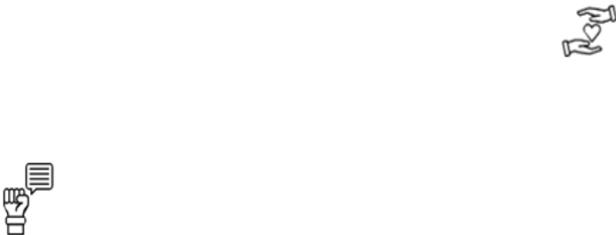
Post-Debate
- Immediately or Homework: Students complete the Reflective Activity.

- Subsequent class or session: Teacher can use students’ reflections as a resource to discuss whichever thematic (content) or experiential (skills) learning points align with other aspects of their module or curriculum.
- Project Videos: Based on their observation, a teacher selects two small groups of students to prepare a video each on their experience of the debate.

Student Briefing

Debate Background: EU Law 
- A court in an EU country can order a platform like Facebook to remove a comment that has been judged illegal. (EU Directive, 2000)
- That order can also cover comments that are identical, and ones that are equivalent, meaning they say the same harmful thing in slightly different words.
- A platform cannot be told to watch everything everyone posts. It only has to look for the specific illegal comment already identified.
- The removal can be extended worldwide, within the limits of international law.

Debate Background: Meta’s Concerns 
- People have a right to express opinions and share information freely. (EU Charter of Fundamental Rights)
- Facebook does not write the comments. Its users do. It only stores and shows them.
- Deciding whether a new comment is equivalent to a banned one is hard. A machine or a worker must judge each case, which risks removing lawful speech by mistake.
- A worldwide takedown of content or comment means that one country's court could decide what people see everywhere, even where the comment is legal.

Student Briefing


Balancing Rights
- When two rights clash, such as human dignity and freedom of expression, courts must find a fair balance.
- No single right automatically wins over the others.

Primacy of EU Law
- EU law is applied in the same way across all member states.
- In policy areas where member states have given power to the EU, EU law comes before national law.
Rule of Law
- Decisions about guilt and punishment are made by independent courts, following clear rules, not by politicians.
- Everyone, including governments, must respect the courts and the law.

Freedom of Expression
- Everyone has the right to hold opinions and to share and receive information.
- This right is protected but not unlimited: it can be restricted to protect other people's rights, such as their reputation.
Human Dignity
- Every person's worth and reputation deserve respect.
- Attacks that are untrue and damaging (defamation) are not protected as free speech.

EU Principles 

These are guidelines for EU activity. They come from key EU values or ideas. They must be respected by EU institutions and member states when making decisions. Take time to read them carefully, they’ll help your debate points

Role Card: Judges


Your Role
- You are Judges at the Court of Justice of the EU. Your role is to organise the debate and facilitate interactions. Listen to all sides neutrally and ask questions for clarity when you need. You are not on anyone’s side.
-------------------------------------------------------
Prepare
- Read the Student Briefing material (page 7-9). Use it to prepare an opening statement for the debate.
- Use the template provided to note and analyse the arguments made during the debate.
--------------------------------------------------------
Debate
- Opening: Briefly outline the debate question, and the rules of engagement for contributions and interactions between debate players.
- Facilitate: Invite debaters to present their arguments, roughly in line with the Debate Timeline in the Debate Instructions. Invite them to make counterpoints in response to points made by other debaters.
- Question: Be polite but ensure that debaters keep their points relevant to the question and issues involved.
- Invite: Experts to present information whenever relevant during the debate.
- Invite: Media groups to deliver mid-debate report.
- Ruling: Note relevant points made by Eva, Meta, Austrian Supreme Court, and Experts during the debate.
-------------------------------------------------------
Deliver
Ruling: Use the Interval Phase during the debate to consider whether Eva’s or the Meta’s points were more convincing, given the debate background. Using your Ruling Sheet, write a few short notes of the most convincing points made, and possible wider impacts of the debate verdict.
- Presentation: Call all debaters attention and deliver your ruling to all present, outlining the points from your Ruling Sheet.
Closing: Invite final reports from the Media groups that conclude the debate

Role Card: Judges
Our Decision
- State your ruling clearly. What can a court order? How far can it reach?
- Give your answer, reasoning, and maybe some impacts of your decision.

Bonus Question — What about similar content?
Should Facebook also remove posts saying the same thing in different words — or is that too vague and risky?

Q2 — If yes, should that removal be worldwide or only in Austria? (Worldwide / Austria only)
The internet has no borders — but should one country's court control what billions of people see? Why or why not??

Q1 — Should Meta be ordered to remove the content? (Yes / No)
Was the content illegal? Did Facebook's refusal to act cause real harm to Eva? What convinced you??

Judges’ Ruling Sheet
- This sheet should help you in analysing the debate and forming your decision.
Two Questions For Consideration

Role Card: Eva


Your Role
- You represent Eva Glawischnig-Piesczek, an Austrian politician and former leader of the Green Party, in the debate. A Facebook user shared a news article about you and added insulting and dishonest comments. You think this content is an unlawful lie that damages your reputation. You want the court to order Facebook to take it down, along with similar content online, around the world.
-------------------------------------------------------
Prepare
- Read the debate Student Briefing material. In your own words, develop moral, social, or political points to represent Eva. Here are some, but be confident to develop your own:
- Expression v Defamation: This isn’t about silencing criticism. An Austrian court already deemed the comment illegal. Free speech protects opinions and even harsh criticism (“her policies are terrible”), but NOT false statements or untrue facts that wreck a reputation, such as “Corrupt” and “traitor”.
- Platform Moderation: Once told a specific post is illegal, Meta should be ordered to remove it and identical copies. This is NOT ‘general monitoring’ (banned by Article 15) – it's targeted removal of a known illegal post. Meta removes 16 million hate-speech items per quarter and can clearly operate at scale to remove illegal comments.
- Similar Content: A takedown is pointless if the same lie is reposted with a word changed. The court can order removal of ‘equivalent’ content with the same meaning – as long as the wording is clear enough for Facebook to find it automatically.
- Worldwide Scope: On a platform of 3+ billion people, a lie posted anywhere reaches Austria. Facebook geo-blocked the comment inside Austria only, leaving it visible everywhere else, and continuing the damage to reputation. EU law allows a national court to order worldwide removal.
-------------------------------------------------------
Debate
- Present: Be clear in outlining relevant points to represent Eva’s position. Be confident to do this in your own words, without overly relying on prompts, big words, or a script.
- Interact: Consider the information introduced by other debate players. Be prepared to counter the points that they make. Try to keep the debate background and EU principles in mind (page 9) .

Role Card: Meta
Our Decision
- State your ruling clearly. Can Ireland refuse the European Arrest Warrant?
- Give your answer, reasoning, and maybe some impacts of your decision.



Your Role
- You represent Meta in the debate, the company that runs Facebook in Europe. You think that a court should not force Facebook to hunt for and delete ‘similar’ comments across the whole platform and definitely should not order this to apply worldwide.
-------------------------------------------------------
Prepare
- Read the debate Student Briefing material. In your own words, develop moral, social, or political points to represent Meta. Here are some, but be confident to develop your own:
- Monitoring Platforms: EU law bans forcing a platform to actively watch everything every user posts. If you make us hunt for all ‘equivalent’ versions of a comment, across billions of posts for all time, is basically the same thing.
- Equivalent Content: Deciding whether a new comment means the same thing as an existing comment is a judgement call that software can't make. You admit that about 2 of every 10 takedowns may be mistakes. Automated scanning, with mistakes, would cause unnecessary censoring of content.
- Free Expression: People whose posts get caught by an over-cautious filter are not part of this case and did nothing wrong. Deleting their lawful posts ‘just to be safe’ tramples on their right to free expression and causes too much collateral damage.
- Overreach: Facebook operates in over 100 countries. Defamation law is not the same everywhere – it isn't even the same across EU member states. Calling a politician a ‘corrupt oaf’ is illegal in Austria but protected free speech in the USA for example. Ordering worldwide takedowns means that the strictest country decides what everyone on earth can see. That risks dangerous censorship of free expression by authoritarian states who don’t like criticism.
--------------------------------------------------------
Debate
- Present: Be clear in outlining relevant points to represent the Immigration Inspector’s position. Be confident to do this in your own words, without overly relying on prompts, big words, or a script.
- Interact: Consider the information introduced by other debate players. Be prepared to counter the points that they make. Try to keep the debate background and EU principles in mind (page 9) .

Role Card: Austrian Supreme Court


Your Role
- You represent the Austrian Supreme Court. Rather than argue for one side or other, your job is to explain why you want this debated in an EU court. You have already granted Eva an injunction against Facebook, but Facebook only geo-blocked the post in Austria. The case has now reached you at the Austrian Supreme Court and you want to some advice from the EU court.
-------------------------------------------------------
How the case moved along the judicial system
Vienna Commercial Court  Grants Eva an injunction. Facebook blocks the post – but only in Austria. | Higher Regional Court, Vienna  Mostly upholds it, but limits how far ‘equivalent’ posts must go. | Austrian Supreme Court (You)  Both sides appeal. You're unsure how far EU law lets the order reach. | Pause & Refer  You PAUSE your case and ask the CJEU to explain EU rules. | CJEU answers → you decide  The CJEU interprets the law; you apply it and give the final ruling.

Prepare
In your own words, explain why you have brought this case for debate at EU level, and what you would like from the debate. Here are some prompts:
- Preliminary Reference: Outline that national courts in member states must follow EU law. When they are unsure how an EU rule applies, they can pause and ask the EU Court of Justice for a ruling before deciding themselves.
- Identical Content: Outline that Facebook accepted taking down the original comment. Your question is can the injunction also require Facebook to remove copies of it – posted by anyone, not just the original user? Or would that require Facebook to monitor too much?
- Equivalent Content: Can you make an order about posts that mean the same thing but use different words? How precisely is ‘equivalent’ to be defined so Facebook can find it automatically – without having to judge each new post for itself? If too vague, that may risk over-removal and censorship.
- Territorial Scope: Facebook blocked the post only inside Austria. You question if the removal should stop at Austria's borders, or can you order it removed everywhere in the world? Austrian defamation law isn't the same as other countries' speech laws, so this question of scope matters.
Debate
- Present: Make you points succinctly. Be confident to do this in your own words, without overly relying on prompts, big words, or a script.
- Interact: Consider information introduced by other debate players. Be prepared to clarify when necessary.

Role Card: Experts

Your Role
- You are independent experts who provide information to enhance the debate. You are neutral, you do not represent either side in the debate. Your role is to explain a key concept or context to help the judges understand the debate.
--------------------------------------------------------
Prepare
- Read the debate Student Briefing material to be aware of the debate background.
- Divide the roles below within your group. If you like, work as sub-groups rather than individually. Develop related points in your own words.
- Free Speech Specialist: Outline that free speech includes protection for ideas that shock or disturb. Democracies need room for disagreement and criticism. Emphasise the dividing line between opinion and fact. Free speech cannot incite violence against others. A limit on free speech must be based on law, have a legitimate goal (e.g., protecting reputation), and be proportionate.
- Defamation Researcher: Outline that defamation is a false statement of fact, presented as true, that damages someone’s reputation. Harsh criticism and rude opinions are only defamation if provably untrue. Defamation law steps in when there is a ‘false-fact’ claim, and when real damage is done to reputation.
- Digital Rights Campaigner: Outline that worldwide takedown orders may be misused by governments to silence journalists and activists. While such an order in this case may be well-intended, there is a risk that it is misused in more censoring countries and autocratic countries
- Software Technician: Outline that online platforms cannot have humans monitoring billions of posts. The software used for automatic filtering works by word matches, rather than understanding meaning. It therefore has some difficulty with ‘equivalent’ meaning. If the threshold or expectation is set high, there is a risk of over-removal to be considered or factored in.
- Reputation Expert: Outline the damage of an online lie on reputation. A false claim can impact one’s job, relationships, safety, and wellness. If unregulated, a lie exists on the internet indefinitely. While public criticism of politicians is an important freedom in a democracy, they should also be entitled to their good name, safe from lies, for the good of democracy.
--------------------------------------------------------
Debate
- Present: Be clear and brief in your contributions, with a neutral tone.
- Interaction: The Judges will invite you. But if a point made in the debate relates to your expertise, ask the Judges for the opportunity to clarify.

Role Card: Media

Your Role
- You are reporters for news organisations covering the debate. Your teenage audience is not familiar with the EU. Your reports need to make the debate issues meaningful for them. Bring a bit of drama or excitement to the debate.
--------------------------------------------------------
Prepare
- Divide into two news groups. Media organisations focus 1) informing in a neutral or formal way or 2) dramatising by using controversial angles and soundbites. Each media group can decide whether your report stye will be ‘Informing’ or ‘Dramatising’.
- You can also decide whether your reports are for Online (TikTok, Insta, X, etc) or Broadcast (TV or Radio) media.
- Think about and prepare relevant props (fake micro-phone, backdrop, sound effects, or imagery) for the type of report medium you select.
- Use the Student Briefing material to select angles that to focus on in your reports. Within your group, divide tasks to ensure relevant information is captured, and the design and presentation of the report(s) is prepared.
- Use the mid-debate and final report Preparation Templates to prepare.
--------------------------------------------------------
Debate
- Observe: Note relevant points, issues, and debate exchanges.
- Engage: At any time, you can ask other debate players for a comment or quotation to inform your reports.
--------------------------------------------------------
Deliver
- Mid-Debate Report: When called by the Judges, each media group delivers a short (2-3mins) and snappy update on the debate to that point. Be creative and add life to the debate for an external audience. Include relevant props depending on your type of report and start with a catchy headline.
- Final Report: When called by the Judges, each media group presents a short (2-3mins) and snappy final report on the debate. Try to keep your Informing or Dramatising style in mind. Be creative to engage or entertain your audience.


Role Card: Media

Props to Animate Report Presentation:

Other Notes:

Hook/Angles to bring your ‘Informing’ or ‘Dramatising’ style:

Debater Quotes / Comments to include:

Main Debate Points/Issues/Events to include:

Possible Headlines:

Report Style: Informing or Dramatising? ___________________

Report Type: TikTok, Insta,TV, Radio, X, or other? __________________

Preparation Template for Mid-Debate Report

Role Card: Media

Props to Animate Report Presentation:

Other Notes:

Hook/Angles to bring your ‘Informing’ or ‘Dramatising’ style:

Debater Quotes / Comments to include:

Main Debate Points/Issues/Events to include:

Report Type: TikTok, Insta,TV, Radio, X, or other? __________________

Report Style: Informing or Dramatising? ___________________

Possible Headlines:

Preparation Template for Final Report

Judges

Eva

Meta

Austrian Supreme Court

Experts

Media

