Teacher Briefing



A Debate on European Union Values
The Freedom Debate

Debate Question
The question for your student debate is; “Should sport professionals be able to move club within the European Union without compensation for their current club?” Through the debate, students explore a clash of two principles of the EU:
- Freedom of Movement: EU citizens have the right to move, live, and work in other EU member states (countries).
- Subsidiarity: Decision-making power should be located close to the level of those affected by a decision. That the EU should limit its interventions on the organisation and rules of private organisations at member state level as much as possible.

Debate Aim
That students consider the relevance of European Union values and explore the rights and responsibilities of citizens and member states under EU law. The debate question comes from a court case brought by Jean-Marc Bosman to the Court of Justice of the EU in 1993 [Union Royale Belge des Sociétés de Football Association (ASBL) v Bosman].

- We want you and your students to explore the ideas and issues involved through a moral, social, and political debate, rather than a legal one.
- After the debate you can present the summary of the actual court case ruling to students (page 3) as a eureka moment for reflection.
Using the Debate
You can adapt the debate design and material to meet your teaching need, classroom dynamic, or student group. See this as a debate resource rather than a straitjacket.

Teacher Briefing

Debate Format
Pre-Debate 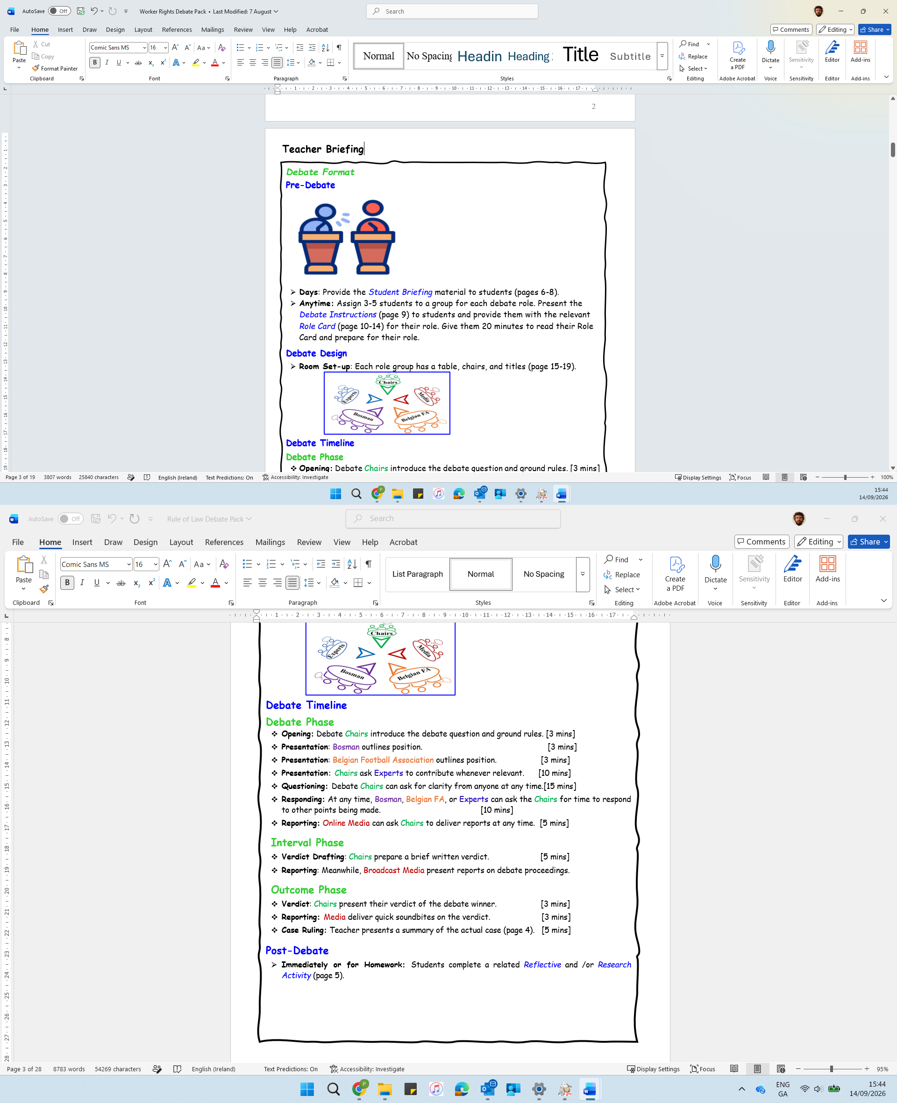
- Days Before: Provide the Student Briefing material to students (pages 7-9).
- Optional: Show student this very short AV clip about EU values
- Debate Day: Assign 3-5 students to a group for each debate role. Visually present the Debate Instructions (page 6) to students and distribute the relevant Role Cards (page 10-17) for their role. Give them approximately 20 minutes to analyse their Role Card and prepare for their role.

Debate Design
- Room Set-up: Each role group has a table, chairs, and a table title (page 19-23).
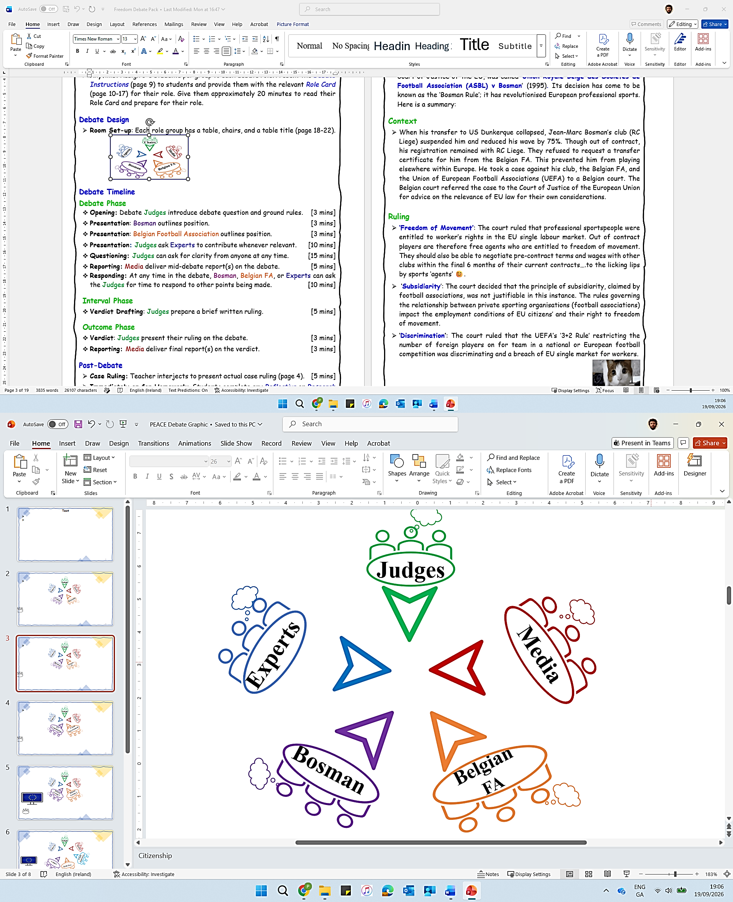

Debate Timeline
Debate Phase
- Opening: Debate Judges introduce debate question and ground rules. [3 mins]
- Presentation: Bosman outlines position. [3 mins]
- Presentation: Belgian Football Association outlines position. [3 mins]
- Presentation: Judges ask Experts to contribute whenever relevant. [10 mins]
- Questioning: Judges can ask for clarity from anyone at any time. [15 mins]
- Reporting: Media deliver mid-debate report(s) on the debate. [5 mins]
- Responding: At any time in the debate, Bosman, Belgian FA, or Experts can ask the Judges for time to respond to other points being made. [10 mins]

Interval Phase
- Drafting: Judges prepare a brief written ruling. [5 mins]

Outcome Phase
- Ruling: Judges present their ruling on the debate. [3 mins]
- Reporting: Media deliver final report(s) on the verdict. [3 mins]

Post-Debate
- Case Ruling: Teacher interjects to present actual case ruling (page 3). [5 mins]
- Immediately or for Homework: Students complete any Reflective or Research Activity that you choose (page 4).

Teacher Briefing



*Post-Debate* Teacher Intervention
Related Court Case
- This debate was based on a real situation. The related case, brought to the Court of Justice of the EU, was called ‘Union Royale Belge des Sociétés de Football Association (ASBL) v Bosman’ (1995). Its decision has come to be known as the ‘Bosman Rule’; it has revolutionised European professional sports. Here is a summary:

Context
- When his transfer to US Dunkerque collapsed, Jean-Marc Bosman’s club (RC Liege) suspended him and reduced his wave by 75%. Though out of contract, his registration remained with RC Liege. They refused to request a transfer certificate for him from the Belgian FA. This prevented him from playing elsewhere in Europe. He took a case against his club, the Belgian FA, and the Union of European Football Associations (UEFA) to a Belgian court. The Belgian court referred it to the Court of Justice of the European Union for advice.

Ruling
- ‘Freedom of Movement’: The court ruled that professional sportspeople were entitled to worker’s rights in the EU’s single labour market. Out of contract players are therefore free agents who are entitled to freedom of movement. They should also be able to negotiate pre-contract terms and wages with other clubs within the final 6 months of their current contracts….to the sound of licking lips by sports agents .
- ‘Subsidiarity’: The court decided that the principle of subsidiarity, claimed by football associations, was not justifiable in this instance. The rules governing the relationship between private sporting organisations (football associations) impact the employment conditions of EU citizens’ and their right to freedom of movement.
- ‘Discrimination’: The court ruled that the UEFA’s ‘3+2 Rule’ restricting the number of foreign players for teams in national or European football competition was discriminating and a breach of EU single market for workers. This forced the opening up of football leagues to international transfers.

Optional Follow-up
- Show student this AV clip about:
- 1) Bosman Ruling Significance (SportStoriez)

Teacher Briefing

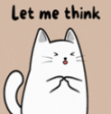
Post-Debate Student Activities
Reflective Activities
Students can use a page or post-its to reflect on their content or skill learning. No right answers, just honesty….
Content
1. What was most interesting about the debate scenario?
2. What was most interesting about EU law?

Participation
1. What was most interesting about your role in the debate?
2. What did you learn about your debating skills or watching others debate?

Debate Impact
1. On a scale of 1 (Not at all) to 5 (Very); are you curious to find out about other EU impacts on professional sports?
2. On a scale of 1 (Not at all) to 5 (Very); has this debate impacted your interest in EU values, principles, or EU citizens’ rights?
3. On a scale of 1 (Not at all) to 5 (Very); how engaging or fun was this debate overall?
4. What changes would you make to the debate design or content to improve it for students of your age?
Research Activities 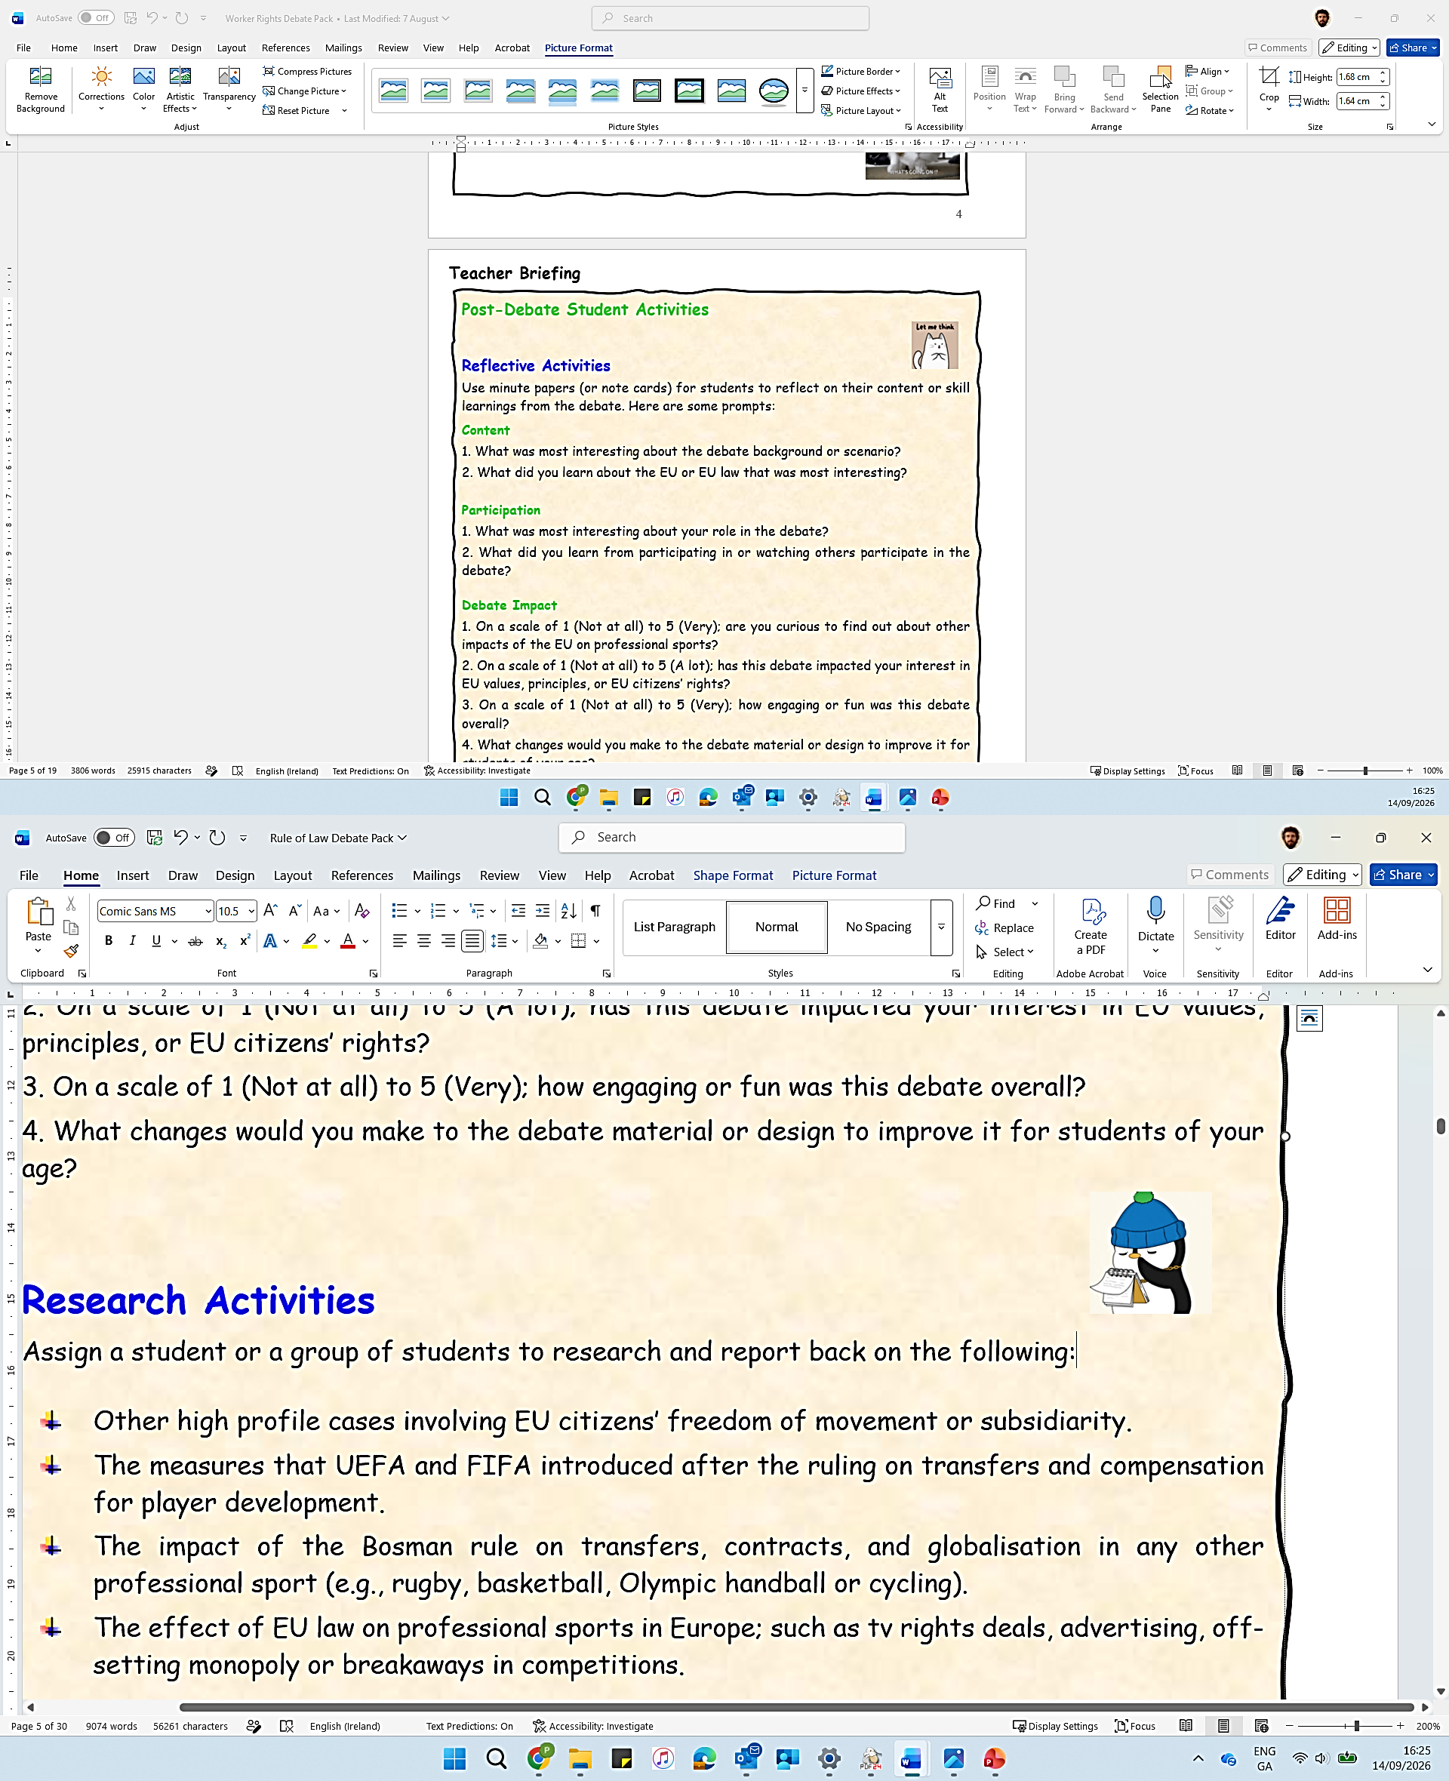
Assign a student or a group of students to research and report back on the following:

- Other court cases about EU citizens’ right to ‘freedom of movement’ across the EU.
- The measures that UEFA and FIFA introduced after the ruling on transfers and compensation for player development.
- The impact of the Bosman rule on transfers, contracts, and globalisation in any other professional sport (e.g., rugby, basketball, Olympic handball or cycling).
- The effect of EU law on professional sports in Europe; such as tv rights deals, advertising, preventing monopolies or breakaways in sports leagues.

Teacher Briefing



Student To-dos
1. Pre-debate: Read the debate scenario and background (pages 7-8).
2. Pre-debate: Read about EU Values and Principles (page 9).
3. Pre-debate: Work in assigned group to prepare debate role. Students can use the Student Briefing material and Role Cards as resources to prepare and develop their own arguments, in their own words.
4. During debate: Prepare and present their debate points, counterpoints, or information to perform their role.
5. Post-debate: Complete any Reflective or Research Activity that you choose (page 4).

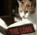

Glossary
- If you think that students do not know the following terms, these descriptions will help you in briefing them:
- EU Member States: The 27 European countries who pool decision-making power in some policy areas. This creates rights and responsibilities for national governments and citizens under EU law.
- EU Values: Beliefs or priorities that EU member states consider to be important. The EU has 6 common values (human dignity, freedom, equality, democracy, rule of law, and respect for human rights).
- Freedom of Movement: Citizens of EU member states can live in any other EU member state for up to 3 months. If employed, studying, or self-funded, EU citizens have the right to live there for longer. This right is not absolute; it can be limited by a member state for policy reasons.

Printing (If Relevant)
You may be able to distribute debate material to students using your school’s virtual platform. However, if printing, this is a summary of advisable printing:
Days in Advance: Double-sided, 1 copy of Student Briefing (page 7-9) per student.
Days or hours in Advance: Single-sided, 1 or 2 copies of Role Cards (page 10-17).
Days or hours in Advance: Single-sided, 1 copy of table titles (page 19-23).

Debate Instructions [Teacher Presents (Visually) on Debate Day]


Preparation
You’re going to debate the question: “Should sports professionals be able to move club within the European Union without compensation for their current club?”
I’ll assign you to a group to perform one of these roles in the debate:
- Judges
- Mr Bosman
- Belgian Football Association
- Experts
- Media
Use the Student Briefing material and the prompts on your Role Card to prepare for the debate. It is not about using big words. Present your points in your own words and prepare counterpoints to the points made by other debate players.
You may not agree with the opinions or beliefs of the role you’re playing. It’s a role-play, your job is to represent the role you’re playing, rather than your own opinion. To stand in their shoes for a little while.

Debate Timeline

Debate Phase
- Opening: Debate Judges introduce debate question and ground rules. [3 mins]
- Presentation: Bosman outlines position. [3 mins]
- Presentation: Belgian Football Association outlines position. [3 mins]
- Presentation: Judges ask Experts to contribute whenever relevant. [10 mins]
- Questioning: Judges can ask for clarity from anyone at any time. [15 mins]
- Reporting: Media groups deliver mid-debate report(s) on the debate. [5 mins]
- Responding: At any time in the debate, Bosman, Belgian FA, or Experts can ask the Judges for time to respond to other points being made. [10 mins]

Interval Phase
- Drafting: Judges prepare a brief written ruling. [5 mins]

Outcome Phase
- Ruling: Judges present their ruling on the debate. [3 mins]
- Reporting: Media groups deliver final report(s) on the debate. [3 mins]

Student Briefing


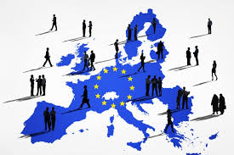

Debate Scenario

Jean-Marc Bosman is a professional footballer. His contract with RC Liege (Belgium) has just expired. A move to a new club (US Dunkerque in France) has collapsed due the transfer fee requested by RC Liege. Current Belgian Football Association rules mean that he is registered with (i.e., owned by) RC Liege, even though he has turned town a new contract with them.

Jean-Marc thinks that this transfer fee system unduly restricts his freedom of movement as a worker in the EU. He also thinks that the rule limiting the number of foreign players on a team in European football leagues amounts to discrimination in what is supposed to be a single EU market for workers.

What is this debate about?
The main question in this debate is; “Should sports professionals be able to move club within the European Union without compensation for their current club?” The debate involves a clash between two important ideas of the EU:

- Freedom of Movement: EU citizens have the right to move, live, and work in other EU member states (countries).
- Subsidiarity: Decision-making power should be located close to the level of those affected by a decision. That the EU should limit its interventions on the organisation and rules of private organisations at member state level as much as possible.

Student Briefing

Debate Background: EU Law 
- EU citizens have a right to move for work and live across the EU (European Community Treaty, 1957).
- EU member states must respect this right without discrimination based on nationality, sex, race, colour, disability, age or sexual orientation. (EU Charter of Fundamental Rights)
- Under the principle of subsidiarity, the European Union wants member states and non-state actors to regulate their own affairs as much as possible. Intervention by EU institutions is limited to instances where competences have been shared by member states with the EU, or where EU citizens’ rights under EU law are affected.

Debate Background: Football Law 
- Professional football is regulated by national, European (UEFA) and global (FIFA) associations. They operate as private ‘self-regulators’ of the profession, including the rules on player transfers.
- Players are considered as assets of the clubs they are registered with, even after their contract expires.
- A UEFA ‘3+2 Rule’ limits the number of foreign EU players that a club team can field in European matches; i.e. a maximum of 3 from other EU countries and a maximum of 2 ‘assimilated’ players who have 5 years playing in the club’s country.

Student Briefing


Freedom of Movement
- EU citizens have a right to live, work, study, and retire in any other member state.
- This right can be limited by member states for policy or security reasons.
Subsidiarity
- Decision-making takes place at the level closest to those impacted where possible.
- EU law and institutions are limited to policies where member states have agreed to pool decision-making power with them.

Member State Sovereignty
- An EU member state shares decision-making power with EU institutions in some policy areas.
- In other policy areas, a member state holds full power to make law.

EU Citizenship
- Is automatically granted to all nationals of EU member states.
- Provides rights and opportunities, such as freedom of movement and some political rights.

Charter of Fundamental
Rights of the EU
- Identifies civil, political, social, and economic rights of EU citizens and residents.

EU Principles 

These are guidelines for EU activity. They come from key EU values or ideas. They must be respected by EU institutions and member states when making decisions. Take time to read them carefully, they’ll help your debate points.

Role Card: Judges


Your Role
- You are Judges at the Court of Justice of the EU. Your role is to organise the debate and facilitate interactions. Listen to all sides neutrally and ask questions for clarity when you need. You are not on anyone’s side.

-------------------------------------------------------
Prepare
- Read the Student Briefing material (page 7-9). Use it to prepare an opening statement for the debate.
- Use the template provided to note and analyse the arguments made during the debate.
--------------------------------------------------------
Debate
- Opening: Briefly outline the debate question, and the rules of engagement for contributions and interactions between debate players.
- Facilitate: Invite debaters to present their arguments, roughly in line with the Debate Timeline in the Debate Instructions). Invite them to make counterpoints in response to points made by other debaters.
- Question: Be polite but ensure that debaters keep their points relevant to the question and issues involved.
- Invite: Experts to present information whenever relevant during the debate.
- Invite: Media groups to deliver mid-debate report.
- Ruling: Note relevant points made by Bosman, Belgian Football Association, and Experts during the debate.
-------------------------------------------------------
Deliver
Ruling: Use the Interval Phase during the debate to consider whether Bosman’s or the Belgian Football Associations’ points were more convincing, given the debate background. Using your Ruling Sheet, write a few short notes of the most convincing points made, and possible wider impacts of the debate verdict.
- Presentation: Call all debaters attention and deliver your ruling to all present, outlining the points from your Ruling Sheet.
- Closing: Invite final reports from the Media groups that conclude the debate.

Role Card: Judges
Our Decision
- State your ruling clearly. Is Mr Bosman free to transfer without any compensation to his current club? Does the rule limiting the number of foreign EU players on a team in a league in EU member states break workers’ rights in the EU’s single market?
- Give your answer, reasoning, and maybe some impacts of your decision.

What are the most convincing/relevant points in support of the Belgian Football Association’s claim?

What are the most convincing/relevant points in support of Mr Bosman’s claim?

Judges’ Ruling Sheet
- This sheet should help you in analysing the debate and forming your decision.

Role Card: Mr Bosman



Your Role
- You represent Jean-Marc Bosman in the debate. You think that transfer fees and foreign player quotas in professional football breach your right to freedom of movement as a worker in the EU.
-------------------------------------------------------
Prepare
- Read the debate Student Briefing material. In your own words, develop moral, social, or political points to represent Mr Bosman. Here are some, but be confident to develop your own:
- Freedom of Movement: Professional footballers should be regarded as workers under EU law. If so, they are entitled to move freely for work across member states in the EU single market.
- Employment Barriers: The transfer system, where a club puts a fee on a player’s transfer after their contract expires, is a financial barrier to possible employment in other clubs across the EU. It is an unjustified economic restriction on the free movement and labour rights of workers in the EU.
- Discrimination: UEFA’s ‘3+2 Rule’ limits the number of foreign players that a club can play in national and European leagues. This restriction on foreign players equates to discrimination based on nationality for citizens in EU member states where a single labour market is supposed to exist.
- Primacy of EU Law: Member states have agreed to the EU law on free movement and to the EU Charter of Fundamental Rights. You think that these are relevant in your situation and should prevail over football associations’ claims for an exemption and subsidiarity as private regulators of a sport.
-------------------------------------------------------
Debate
- Present: Be clear in outlining relevant points to represent Mr Bosman’s position. Be confident to do this in your own words, without overly relying on prompts, big words, or a script.
- Interact: Consider the information introduced by other debate players. Be prepared to counter the points that they make. Try to keep the debate background and EU principles in mind (page 9) .

Role Card: Belgian Football Association


Your Role
- You represent the Belgian Football Association in the debate. You think that as private regulators of a sport you are entitled to protect the interest of clubs and national football through mechanisms including transfer fees and foreign player quotas.
-------------------------------------------------------
Prepare
- Read the debate Student Briefing material. In your own words, develop moral, social, or political points to represent the Belgian FA. Here are some, but be confident to develop your own:
- Subsidiarity and Sporting Exception: Football has unique characteristics which need protection by national football associations. These associations, as private self-regulators, should have the freedom to make decisions that protect the national culture and integrity of sports competitions at national level, without interference by EU law that only prioritises European economic interest.
- Competition: The EU wants competition in industries. The transfer fees for out-of-contract players are the instrument used by football associations to prevent wealthier clubs from monopolising talent in the player market. These fees redistribute finance across clubs and retain talent in smaller clubs who have invested in a talented player, who is their asset.
- Development and Culture: Transfer fees and quotas limiting foreign players encourage clubs to invest in youth development. This helps to keep the football market stable. It protects the culture and shared interests of clubs and competitions at national level which have developed that talent.
--------------------------------------------------------
Debate
- Present: Be clear in outlining relevant points to represent the Belgian FA’s position. Be confident to do this in your own words, without overly relying on prompts, big words, or a script.
- Interact: Consider the information introduced by other debate players. Be prepared to counter the points that they make. Try to keep the debate background and EU principles in mind (page 9) .

Role Card: Experts


Your Role
- You are independent experts who provide information to enhance the debate. You are neutral, you do not represent either side. Your role is to explain a key concept or context to help the judges understand the debate.
--------------------------------------------------------
Prepare
- Read the debate Student Briefing material to be aware of the background.
- Divide the roles below within your group. If you like, work as sub-groups rather than individually. Develop related points in your own words.

- EU Analyst: Outline the EU’s freedom of movement. EU citizenship gives a right to live in other EU member states. It comes from the idea of a single EU labour market. To stay longer than 3 months, you must be employed, a student, or self-funded. Member states can apply restrictions for policy or security reasons.
- Employment Expert: Outline what a ‘worker’ is under EU law. To be considered, you have to be; engaged in gainful employment with responsibility to an employer, in remunerated (i.e., paid) service, and have agreed conditions of work.
- Football Agent: Outlines that the transfer system aims to keep power in the hands of clubs and associations rather than players or agents. It frames footballers as assets rather than as empowered employees. Transfer fees on out-of-contract players are seen as compensation for clubs’ investment who developed those assets.
- Sports Economist: Outline football association and UEFA’s ideas in regulating transfers. If players moved freely across club or country on the expiry of a contract; bigger clubs could skew competition by offering inflated wages, smaller clubs would face increased wage demands or not be adequately compensated for players developed. European football competition and talent could become imbalanced and centralised. However, alternatives to ensure redistribution to smaller clubs such as solidarity payments and compensation mechanisms exist.
- Football Analyst: Outline that quotas on fielding foreign players in European football competitions are common. UEFA has a ‘3+2 Rule’, La Liga’s is 3, Ligue 1 is 2, and the top English league uses UEFA’s rule. This is seen as protecting national identity in competitions and ensuring that clubs develop ‘home-grown’ talent. The focus is on national social and cultural values and identity, not on diversity, European identity, or opening clubs and leagues to the fortunes of globalisation.
--------------------------------------------------------
Debate
- Present: Be clear and brief in your contributions, with a neutral tone.
- Interaction: The Judges will invite you. But if a point made in the debate relates to your expertise, ask the Judges for the opportunity to clarify.

Role Card: Media



Your Role
You are reporters for news organisations covering the debate. Your teenage audience is not familiar with the EU. Your reports need to make the debate issues meaningful for them. Bring a bit of drama or excitement to the debate
--------------------------------------------------------
Prepare
- Divide into two news groups. Media organisations focus 1) informing in a neutral or formal way or 2) dramatising by using controversial angles and soundbites. Each media group can decide whether your report stye will be ‘Informing’ or ‘Dramatising’.
- You can also decide whether your reports are for Online (TikTok, Insta, X, etc) or Broadcast (TV or Radio) media.
- Think about and prepare relevant props (fake micro-phone, backdrop, sound effects, or imagery) for the type of report medium you select.
- Use the Student Briefing material to select angles that to focus on in your reports. Within your group, divide tasks to ensure relevant information is captured, and the design and presentation of the report(s) is prepared.
- Use the mid-debate and final report Preparation Templates to prepare.
--------------------------------------------------------
Debate
- Observe: Note relevant points, issues, and debate exchanges.
- Engage: At any time, you can ask other debate players for a comment or quotation to inform your reports.
--------------------------------------------------------
Deliver
- Mid-Debate Report: When called by the Judges, each media group delivers a short (2-3mins) and snappy update on the debate to that point. Be creative and add life to the debate for an external audience. Include relevant props depending on your type of report and start with a catchy headline.
- Final Report: When called by the Judges, each media group s a short (2-3mins) and snappy final report on the debate. Try to keep your Informing or Dramatising style in mind. Be creative to engage or entertain your audience.

Role Card: Media

Other Notes:

Props to Animate Report Presentation:

Hook/Angles to bring your ‘Informing’ or ‘Dramatising’ style:

Debater Quotes / Comments to include:

Possible Headlines:

Main Debate Points/Issues/Events to include:

Report Style: Informing or Dramatising? ___________________

Report Type: TikTok, Insta,TV, Radio, X, or other? __________________

Preparation Template for Mid-Debate Report

Role Card: Media
Other Notes:

Hook/Angles to bring your ‘Informing’ or ‘Dramatising’ style:

Possible Headlines:

Debater Quotes / Comments to include:

Main Debate Points/Issues/Events to include:

Props to Animate Report Presentation:

Report Style: Informing or Dramatising? ___________________

Report Type: TikTok, Insta,TV, Radio, X, or other? __________________

Preparation Template for Final Report

Judges

Bosman

Belgian FA

Experts

Media

