Debate Question:
“Is the European Union’s Emissions Trading System fair, or does it need reform?”

Introduction I: EU Emissions Trading System (ETS) 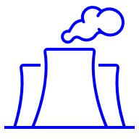
The European Union (EU) has set ambitious climate targets; a 55% reduction in greenhouse gas emissions by 2030 and climate neutrality by 2050. Achieving these targets will require many industries to reduce their emissions.
The EU’s Emissions Trading System (ETS) is one of the EU’s main tools for reducing greenhouse gas emissions. The system sets a limit on carbon dioxide emission for each company. It covers more than 10,000 companies in the energy sector and energy-intensive industries, such as oil refineries, the steel industry, commercial aviation, and shipping.
If a company emits more carbon dioxide (CO₂) than its limit, they must buy an emissions allowance for the excess. The system operates on the principle of supply and demand. Over time, the limit decreases, with fewer allowances available. Companies that fail to reduce their emissions will therefore face rising costs.

Introduction II: Benefits and Criticisms 
Benefits
The ETS encourages companies to invest in cleaner technology because polluting becomes expensive. Over time, it helps reduce emissions across Europe as the total number of carbon allowances available gradually decreases. The system also raises money that can be used for climate projects and renewable energy. By creating a clear financial incentive, the ETS motivates polluters to change their behaviour and innovate, making it a practical tool to fight climate change.
Criticisms
Some countries argue that the ETS raises energy prices and puts a heavy burden on households and businesses, especially in countries that rely heavily on coal. Some industries, such as aviation, claim that the system is unfair because it affects short-length flights more than long-length flights or wealthier airlines. Some environmental organisations say the ETS does not go far enough, because too many free permits are still given to polluting industries
Some non-EU countries argue that the ETS allows Europe to outsource part of its emissions reductions, making developing countries pay for Europe’s climate goals.

Debate Instructions (for reading to students) 
We are going to debate the question: “Is the European Union’s Emission Trading System fair, or does it need reform?” The players in this debate are:
- the Danish Government
- the Polish Government
- Bryan Airways
- the European Climate Defence Alliance
- the Turkish Government
Your task is to prepare and represent the position of one of these debate players.

What do you have to do? (for reading to students) 
1. Use your Role sheet and Factsheet to prepare short points to support your position in the debate [10-15 mins on your own]
2. Then, work with others assigned to play the same role. Work on the phrasing and the examples/evidence to be used [10-15 mins with others given the same role]
3. Now, you’ll see floor markings (or chairs) marking positions in a debate circle. You and others given the same role rotate into position to speak in the debate. When you’re not in a speaking position, listen to the debate and prepare points to add information to the debate and to support your position [20 mins in debate circle]

Debate Prompts (optional aid for teachers) 
1. Fairness v Costs
- Should industries continue receiving free emissions allowances, or should all polluters pay the full price for their carbon dioxide (CO₂) emissions?

2. Speed of Reform
- Should the Emissions Trading System limit be reduced quickly to reach climate targets faster, or should reductions be gradual to protect jobs and competitiveness?

3. Industries Covered
- Should more sectors, such as transport, be included in the Emissions Trading System, or is it fair to focus only on energy-intensive industries and aviation?

Role Sheet: Danish Government
You represent the Danish Government in this debate. 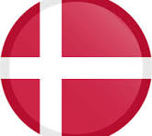
You are a climate-ambitious EU member state. You support strengthening the Emissions Trading System (ETS) for faster carbon dioxide reductions as a ‘polluter pays’ approach. You think the ETS creates a clear and common carbon cost across Europe, which is important for fairness in climate action. You think the ETS drives innovation toward green as fuel-heavy industries are encouraged to switch to low-carbon energy (wind, solar, and hydrogen). Revenues collected from ETS excess emitting can also be used to support green technologies.

Position Prompts
In this debate, you (as the Danish Government) want: 
- Stricter emissions limits.
  - Hint: You advocate for faster reductions in the emissions allowed under ETS to push industries toward meaningful carbon dioxide reductions.
- Fair allocation of ETS allowances.
  - Hint: You want fewer free allowances and believe that polluting industries should bear more responsibility, ensuring fairness across sectors and countries.
- Expansion to more industries.
  - Hint: You support including sectors like transport and shipping more fully in the ETS to cover all major sources of emissions.

Further Information (titles hyperlinked or use QR codes) 
ETS Explainer  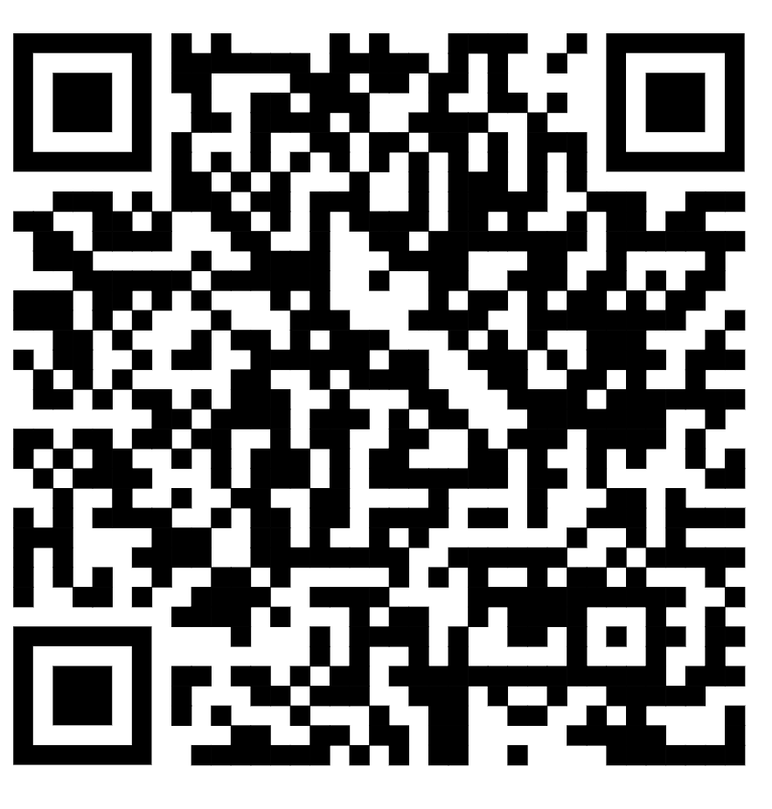 | Denmark & Green Deal  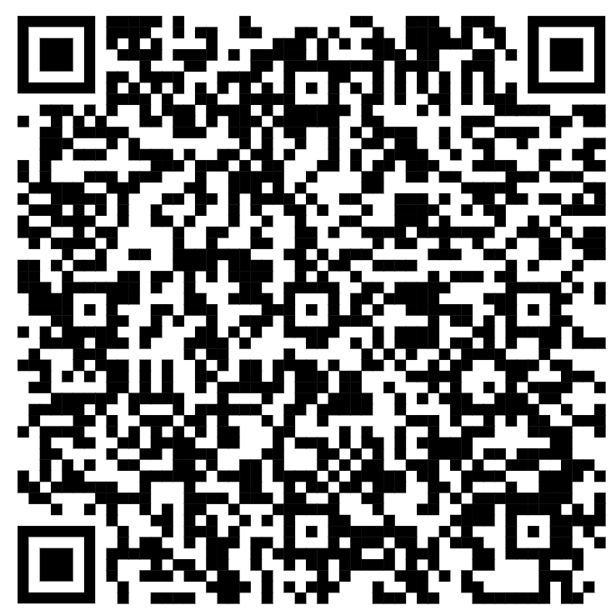
Source: European Commission | Source: DIIS


Outline Of Other Debate Players
Polish   Government | Bryan  Airways | European Climate Defence Alliance | Indian   Government
EU member state. Advocates for a gradual, flexible ETS reform to protect industries and jobs. | A multinational company Calls for fair treatment, gradual pricing, and international coordination to protect competitiveness. | A civic society organisation. Pushes for stronger ETS, higher CO₂ prices, elimination of free allowances, and coverage of more sectors. | A trading country with the EU. India sees the EU ETS as unfair because it forces developing countries to pay for Europe’s emissions cuts.

Role Sheet: Polish Government
You represent the Polish Government in this debate.
You argue that the Emissions Trading System (ETS) pushed up energy prices during the 2021 energy crisis. As your power plants rely heavily on coal, they must buy ETS allowances. This cost is transferred to electricity and heating prices for households and bills. You think that the ETS does not take account of the different starting points of EU member states. The EU does not provide enough tools to help member states which are decarbonising but are coming from a higher emissions and fossil fuel base.

Position Prompts
In this debate, you (as the Polish Government) want:
- Economic protection for industry.
- Hint: You want to ensure that energy-intensive industries are not unduly burdened. It is vital to preserve competitiveness at this time of energy insecurity in Europe. Otherwise, it threatens energy development in the EU as they move away from Russian fuel imports.
- Gradual ETS reform.
- Hint: You advocate for the slower reduction of emission allowances and continued transitional support for high-emission sectors. Industries and consumers are already struggling to pay for the power they use.
- National Flexibility.
- Hint: You emphasise the need for EU rules to allow flexibility for member states with higher reliance on fossil fuels and less developed green infrastructure. The ETS does not account for wider shocks that affect fuel/power costs on industry.

Further Information (titles hyperlinked or use QR codes) 
ETS Explainer | Poland Energy Transition | EU Polluters
 | 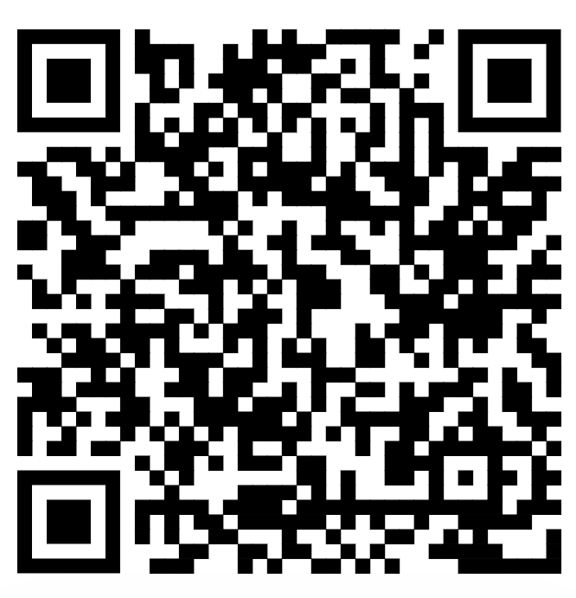 | 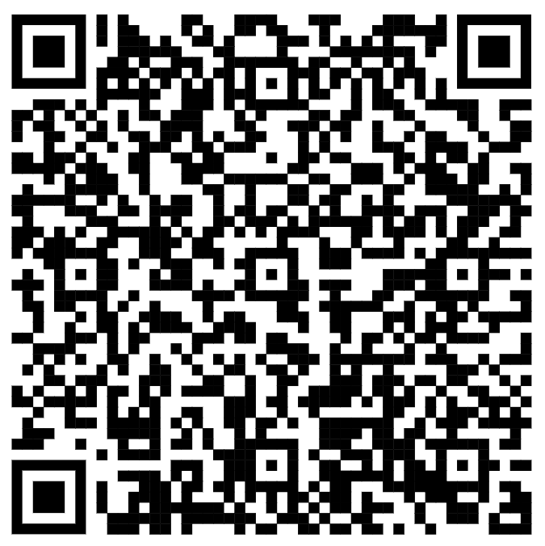
Source: European Commission | Source: euronews | Source: CCPI

Outline Of Other Debate Players
Danish   Government | Bryan  Airways | European Climate Defence Alliance | Indian  Government
EU member state. Supports ambitious ETS reform to drive emissions. reductions & fairness. | A multinational company Calls for fair treatment, gradual pricing, and international coordination to protect competitiveness. | A civic society organisation. Pushes for stronger ETS, higher CO₂ prices, elimination of free allowances, and coverage of more sectors. | A trading country with the EU. India sees the EU ETS as unfair because it forces developing countries to pay for Europe’s emissions cuts.

Role Sheet: Bryan Airways
You represent Bryan Airways in this debate.
As a major European airline you are concerned about costs and fair competition under the Emissions Trading System (ETS). You think the ETS places a disproportional burden on short-haul carriers. Long-haul flights, that produce much more CO₂, are exempt from the ETS, which is deeply unfair and hinders airline growth. European families who make use of cheap air fares for short distances will end up having to pay more.

Position Prompts
In this debate, you (as the Bryan Airways) want:
- Fair treatment for the airline industry.
- Hint: You want ETS rules to reflect the aviation industry’s unique challenges, avoiding excessive penalties that may harm competitiveness.
- Gradual implementation of ETS.
- Hint: You support phased increases in CO₂ pricing to allow time for investment in cleaner technologies and sustainable fuels.
- Hint: The EU must do more to ensure revenue from ETS goes to climate action budgets.
- Sustainable competition.
- Hint: You argue that EU-only measures risk disadvantaging European airlines versus non-EU competitors unless international coordination is ensured.
- Hint: Short-haul carriers shouldn’t carry the burden while long-haul carriers are exempt.

Further Information (titles hyperlinked or use QR codes) 
ETS Explainer | ETS and Aviation
 | 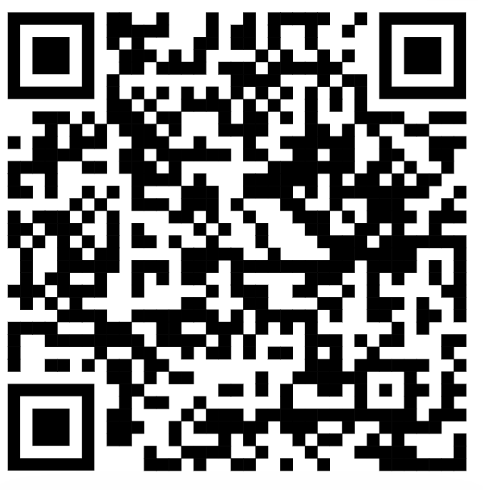
Source: European Commission | Source: Carbon Market Watch

Outline Of Other Debate Players
Danish  Government | Polish  Government | European Climate Defence Alliance | Indian  Government
EU member state. Supports ambitious ETS reform to drive emissions reductions and fairness. | EU member state. Advocates for a gradual, flexible ETS reform to protect industries and jobs. | A civic society organisation. Pushes for stronger ETS, higher CO₂ prices, elimination of free allowances, and coverage of more sectors. | A trading country with the EU. India sees the EU ETS as unfair because it forces developing countries to pay for Europe’s emissions cuts.

Role Sheet: European Climate Defence Alliance
You represent the European Climate Defence Alliance in this debate.
You think that the Emissions Trading System (ETS) doesn’t cut emissions fast enough to keep global warming under 1.5 degrees. Under ETS big industries (steel, cement & chemicals) still get a lot of free pollution allowances and therefore don’t feel the full financial pressure to pollute less or to invest in clean technologies urgently.

Position Prompts
In this debate, you (as European Climate Defence Alliance) want:
- More ambitious carbon dioxide emission reduction.
- Hint: You want companies’ ETS limits to be reduced quicker to ensure that emissions decline in line with EU 2030 and 2050 climate emissions targets.
- Elimination of free allowances.
- Hint: You argue that polluting industries should pay for all emissions to ensure fairness and to incentivise innovation and investment in green technologies and energies.
- Hint: You do not want polluters to be able to buy carbon credits by investing in green projects abroad, which allows them to produce more emissions at home. This is green-washing.
- Expanding the ETS across industries.
- Hint: You support extending the ETS to more business sectors, such as different transport sectors to cover all major sources of emissions.

Further Information (titles hyperlinked or use QR codes) 
ETS Explainer | ETS Criticism
 | 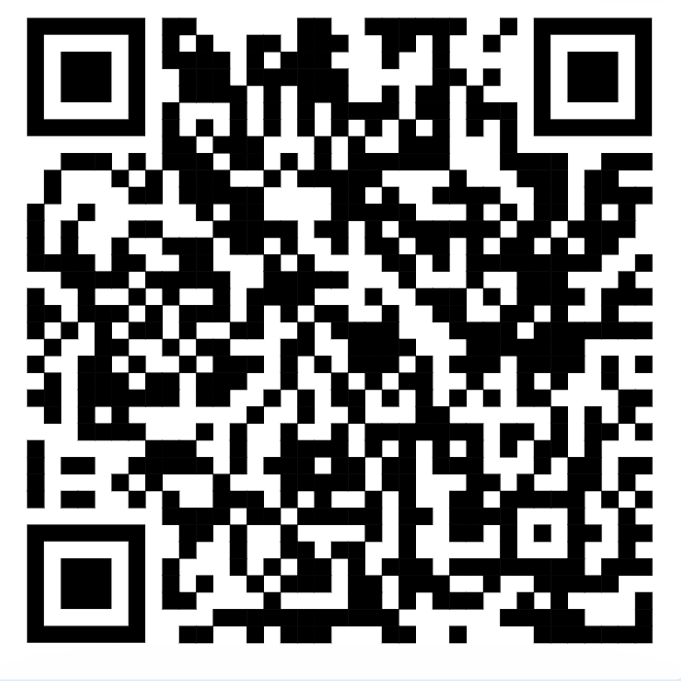
Source: European Commission | Source: Carbon Market Watch

Outline Of Other Debate Players
Danish  Government | Polish  Government | Bryan  Airways | Indian  Government
EU member state. Supports ambitious ETS reform to drive emissions reductions and fairness. | EU member state. Advocates for a gradual, flexible ETS reform to protect industries and jobs. | A multinational company Calls for fair treatment, gradual pricing, and international coordination to protect competitiveness. | A trading country with the EU. India sees the EU ETS as unfair because it forces developing countries to pay for Europe’s emissions cuts.

Role Sheet: Indian Government
You represent the Indian Government in this debate.
You argue that the EU’s Emissions Trading Scheme (ETS) is unfair because it forces you to pay for Europe’s pollution. If wealthy European companies offset their emissions by investing in projects in India, they are treating you a cheap source of emissions. It’s a form of modern carbon colonialism as Indian local governments feel pressure to prioritise projects that reduce emissions for Europe companies and member states rather than projects that are more urgent for Indian communities, such as education, medical or reliable energy infrastructure. It makes it harder for India to pursue its own sustainable development goals.

Position Prompts
In this debate, you (as the Indian Government) want:
- Fair treatment for developing countries.
- Hint: You want to ensure that developing countries are not unfairly burdened by the ETS, as you have contributed far less historically to global emissions than wealthy EU countries.
- Support for sustainable development.
- Hint: You emphasise that EU carbon markets and credits should support local development projects (renewable energy) rather than focusing on supporting European companies to offset their climate commitments.
- Recognition of historical responsibility and equality.
- Hint: You argue that wealthy EU nations should take the lead in reducing emissions. This includes flexibility for developing countries to develop their green energy capacity.

Further Information (titles hyperlinked or use QR codes) 
ETS Explainer | Carbon Credits
 | 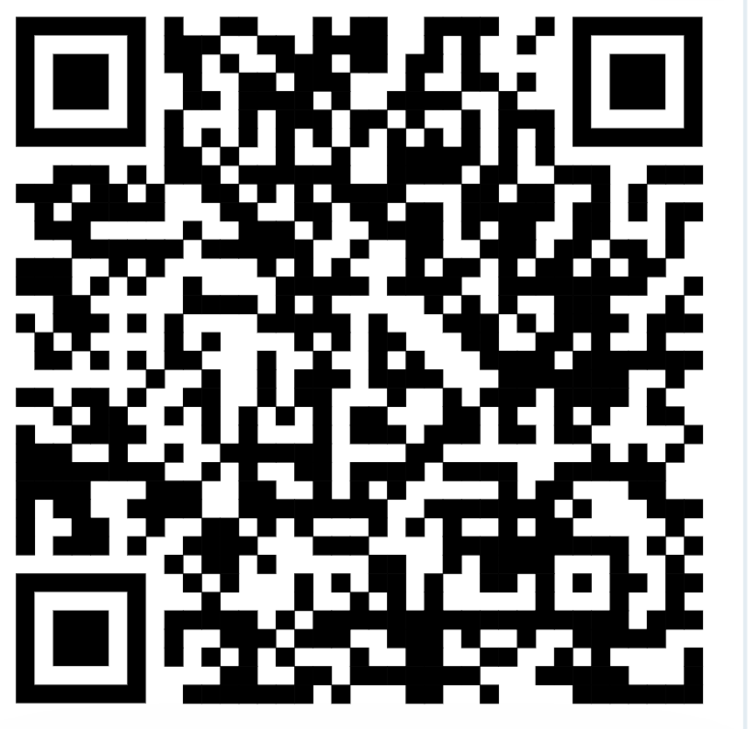
Source: European Commission | Source: CNBCTV

Outline Of Other Debate Players
Danish  Government | Polish  Government | Bryan  Airways | European Climate Defence Alliance
EU member state. Supports ambitious ETS reform to drive emissions reductions and fairness. | EU member state. Advocates for a gradual, flexible ETS reform to protect industries and jobs. | A multinational company Calls for fair treatment, gradual pricing, and international coordination to protect competitiveness. | A civic society organisation. Pushes for stronger ETS, higher CO₂ prices, elimination of free allowances, and coverage of more sectors.

Emissions Trading System Factsheets
Greenhouse Gas Emissions by Sector (2024) 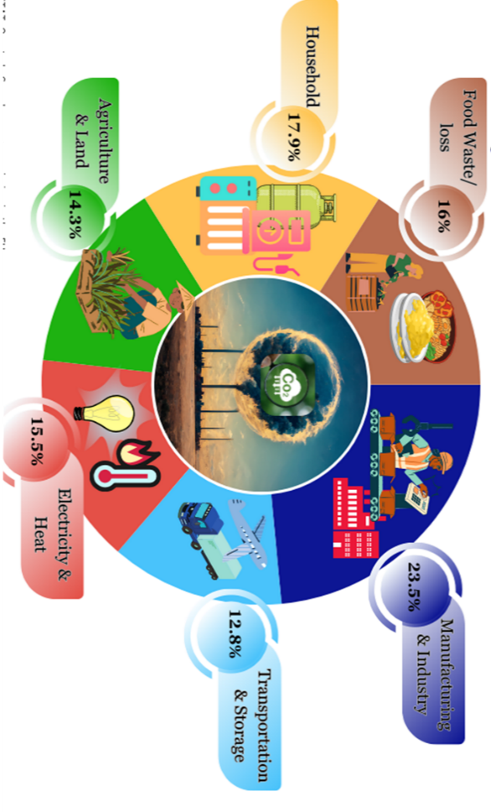
Source: Europahuis
----------------------------------------------------------------------------------------------
Sources of Electricity in Europe
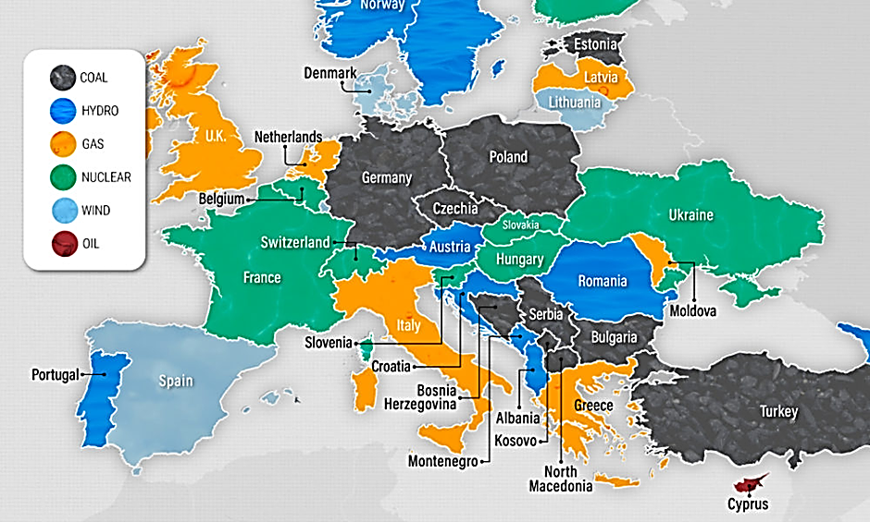
Source: Europahuis (2024)
Note: Colours indicate the main source rather than portion.

Carbon Dioxide Emissions from Energy Use in EU (2022)
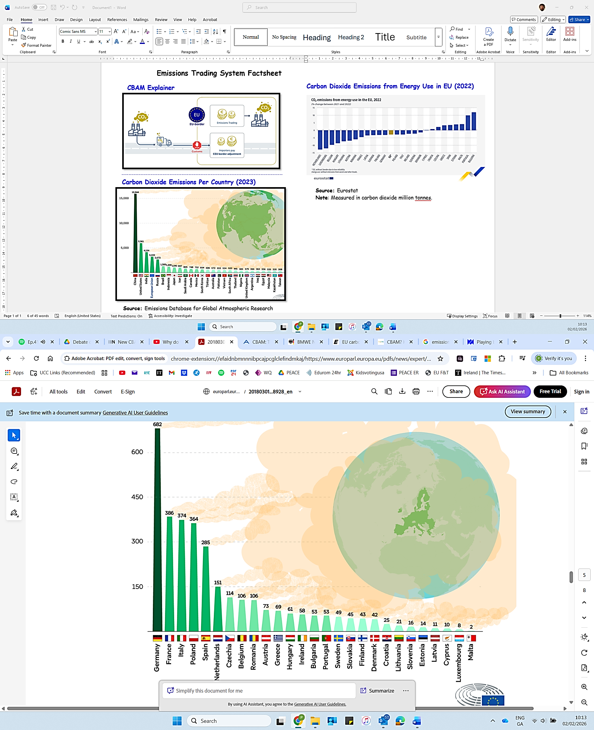
Source: Emissions Database for Global Atmospheric Research
Note: Measured in carbon dioxide million tonnes.

----------------------------------------------------------------------------------------------

EU Carbon Allowance Price (2005-2024)
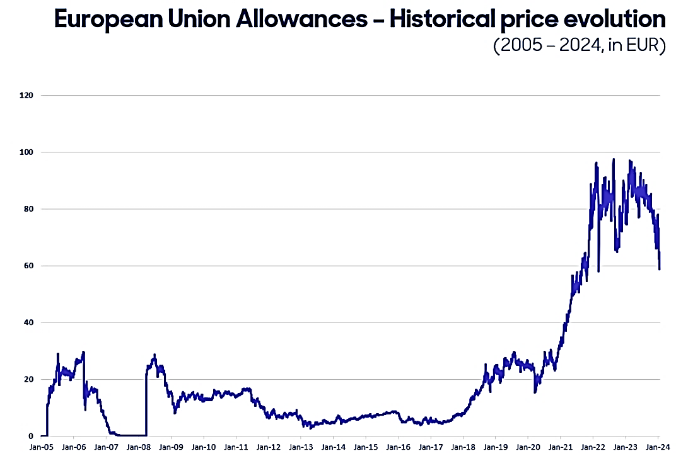
[Source: Homaio (2026) | Note: Price in € per tonne of carbon dioxide]
-------------------------------------------------------------------------------------------------------------------------------------------------------------------------------------------------------------------

Emissions Explainer
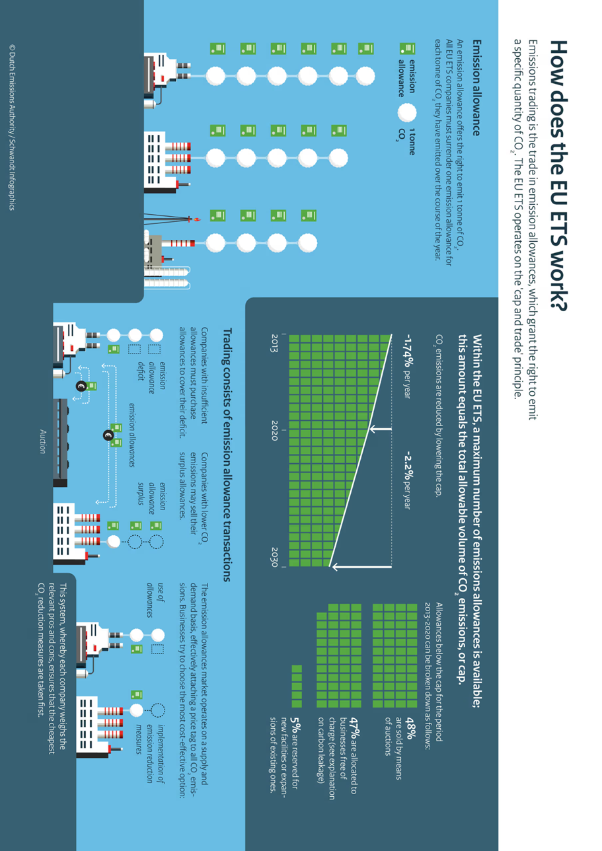
[Source: Dutch Emissions Authority (2025) | Note: Price in € per tonne of carbon dioxide

