Debate Question:
“European Union Climate Targets (2040): Is a greenhouse gas emissions reduction of 90%, realistic and fair?”

Introduction I: European Union & Greenhouse Gas Emissions 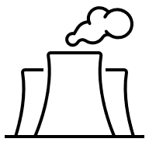
Europe is the world’s fastest-warming continent; it faces severe consequences of climate change. Rising temperatures impact public health and cause extreme rainfall in some European areas, with others hit by heatwaves and droughts.
To tackle global warming that drives climate change, the European Union (EU) has set targets for the reduction of greenhouse gas emissions, e.g., carbon dioxide. In July 2025, the European Commission proposed a target of 90-95% reduction in greenhouse gas emissions by 2040 (compared to 1990 levels). The Commission see these targets as positive for Europe’s industrial competitiveness, the creation of future-proof jobs, and strengthening member states’ energy independence.

Introduction II: Member States and Climate Credits 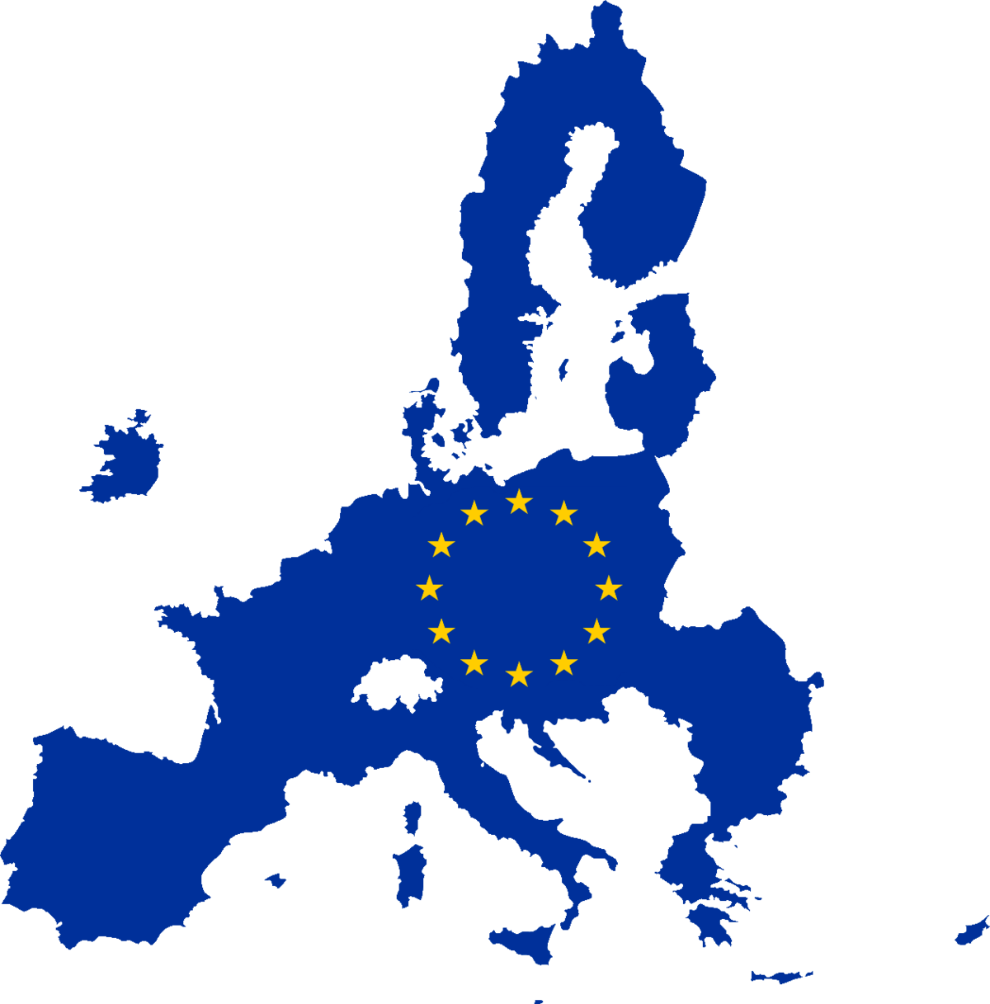
In November 2025, after 20 hours of negotiations, the 27 EU member state governments agreed on a 90% reduction in greenhouse gas emissions by 2040. They set a minimum 85% reduction target for each member state, with the possibility to use an ‘international climate credit’ for the remaining 5%.
A climate credit is a tradable certificate. It allows a member state to offset a portion of emissions by financing an emissions reduction in another country. This often involves richer European countries funding (relatively cheaper) projects to reduce emissions in developing countries outside of Europe. The European Scientific Advisory Board on Climate Change warn against using international climate credits to meet EU targets, as they undermine national efforts toward genuine decarbonisation.

Debate Instructions (for reading to students) 
We are going to debate the question: “European Union Climate Targets (2040): Is a greenhouse gas emissions reduction of 90%, realistic and fair?” The players in this debate are:
- Climate Action Network Europe
- the Danish Government
- the French Government
- the Hungarian Government
- the European Conservatives and Reformists Group
Your task is to prepare and represent the position of one of these debate players.

What do you have to do? (for reading to students) 
1. Use your Role sheet and Factsheet to prepare short points to support your position in the debate [10-15 mins on your own]
2. Then, work with others assigned to play the same role. Work on the phrasing and the examples/evidence to be used [10-15 mins with others given the same role]
3. Now, you’ll see floor markings (or chairs) marking positions in a debate circle. You and others given the same role rotate into position to speak in the debate. When you’re not in a speaking position, listen to the debate and prepare points to add information to the debate and to support your position [20 mins in debate circle]

Debate Prompts (optional aid for teachers) 
1. Will a binding target of 90% reduction in emissions by 2040 (compared to 1990 levels) strengthen or weaken the EU’s competitiveness?
- When you look at the factsheet, the EU has lower carbon dioxide emissions per person than the United States, Russia, and China. If the green transition becomes too costly for European companies as they adapt to meet targets, does the EU risk falling behind in global competitiveness, causing job losses?
- When you look at the factsheet, the EU has lower carbon dioxide emissions per person than the United States of America, Russia and China. Could it be an advantage for European competitiveness that the EU leads in the green transition. Meeting the EU’s 2040 climate targets may ensure cleaner electricity, create future-proof jobs, and strengthen the EU’s independence in generating energy?

2. Should the EU be permitted to make use of international climate credits to achieve its 2040 target? If yes, how much should be allowed?
- As outlined in the introduction, the agreement between member states allowed 5% use of international climate credits. Is a 5% limit on the use of climate credits sensible, or should the EU avoid them altogether?
- For the EU member states most severely affected by high transition costs (by changing energy sources and energy conservation), should the EU’s focus be on financial supports or the slower implementation of targets, rather than allowing the use of climate credits?

3. Should nuclear energy be considered ‘green’ under the EU’s classification system? What implications would this have for achieving the 2040 target?
- When you look at the factsheet, it shows that a large percentage of France’s electricity is generated from nuclear power. Should nuclear energy be classified as ‘green’ in EU climate agreements? If so, would it help the achievement of emission reduction targets by 2040 or would extend the dependence on fossil fuels?

Role Sheet: Climate Action Network Europe
You represent Climate Action Network Europe in this debate 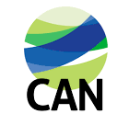
You are a civil society organisation which lobbies for (or promotes) the development of effective climate policy across Europe. You criticise the European Commission’s proposed emissions target, as not reflecting the scale of the climate crisis. You feel that a 95% reduction should be the absolute minimum target to avoid climate change consequences that are already evident in Europe and beyond.

Position Prompts 
In this debate, you (as CAN Europe) want:
- Major EU investment in renewable energy.
  - Hint: This will support long-term competitiveness by boosting job creation in innovative industries. It also boosts energy independence and security.
- The EU to NOT allow International Climate Credits .
  - Hint: Climate credits undermine member states’ climate action and undermine the EU’s credibility as a climate leader. Climate credits are more like greenwashing than part of a structured green transition.
- A move away from nuclear energy in Europe.
  - Hint: Member states’ investment in nuclear energy is a barrier to the roll-out of renewable energy and to the move away from fossil fuel use. Investment in renewable energies, such as wind and solar, is the most efficient way to meet climate goals.


Outline Of Other Debate Players
Danish   Government | French   Government | Hungarian 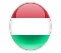  Government  EU member state. Reliant on fossil fuel imports. Considers EU climate targets unrealistic and economically damaging. |  | European Conservatives and Reformists 
EU member state. Wants ambitious climate targets and a focus on renewable energies to meet them. | EU member state. Climate ambition is limited by economic stability, including the use of nuclear energy. |  |  | Group (party) in the European Parliament. Rejects EU climate policy as an economic and political burden.

Role Sheet: Danish Government
You represent the Danish Government in this debate. 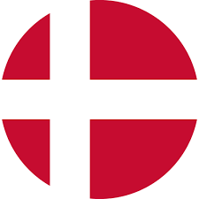
Your country has been as long-term supporter of ambitious 2040 climate targets. You emphasise the green transition as a core EU priority and you support the 90% reduction of greenhouse gas emissions by 2040. You see climate policy, competitiveness, and security as intertwined areas that need stronger European cooperation. You think that ambitious climate policies can strengthen energy security, create new green jobs, and reduce the dependence on fossil fuels imports from unstable regions.

Position Prompts
In this debate, you (as the Danish Government) want:
- A 90% reduction in greenhouse gas emissions target by 2040.
- Hint: Meeting climate goals will provide opportunities for job creation through green technologies, and investment in future-focused energy sources and industries.
- The EU to allow the use of Climate Credits by member states.
- Hint: You think that international climate credits are a way to balance climate ambition with competitiveness. From 2036 onward, you want member states to be able to avail of 5% international climate credits toward their emissions’ target.
- A focus on renewable, rather than nuclear, energy.
- Hint: Wind & solar energy should be prioritised to achieve emissions reduction.
- Hint: You do not want nuclear energy in the mix for long-term energy.

Outline Of Other Debate Players
Climate Action Network Europe | French  Government | Hungarian  Government |  | European Conservatives and Reformists
Civic society organisation. Wants the EU to have stronger climate targets. | EU member state. Climate ambition is limited by economic stability, including the use of nuclear energy. | EU member state. Reliant on fossil fuel imports. Considers EU climate targets unrealistic and economically damaging. |  | Party in the European Parliament. Rejects EU climate policy as an economic and political burden.

Role Sheet: French Government
You represent the French Government in this debate. 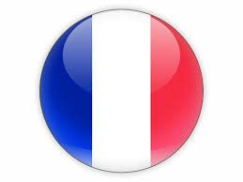
You were an important European advocate for the United Nation’s Paris Agreement (2015), that set a target of below 1.5 degrees temperature increase. You support the idea of ambitious EU climate targets for 2040.
However, you want climate targets to keep economic stability in mind. Therefore, you want international climate credits and nuclear power included in the EU’s approach to meeting climate targets.

Position Prompts
In this debate, you (as the French Government) want:
- Economic competitiveness to be considered in the green transition.
- Hint: An inflexible approach to climate targets would harm European industry. That would accentuate inequalities across member states and citizens.
- Greater scope for international climate credits.
- Hint: Climate credits help EU member states to balance climate ambition and industrial competitiveness. You want the EU to allow member states to use climate credits for up to 7% of their emissions reduction target.
- Nuclear power to be recognised as a ‘green’ energy.
- Hint: In 2021, nuclear power accounted for 68% of your electricity generation. You are the largest exporter of electricity in Europe thanks to this nuclear capacity.
- Hint: You see nuclear power as an economically stable alternative in the transition from fossil fuels. With technological advances improving efficiency and safety, you want nuclear energy included in the EU’s energy strategy.

Outline Of Other Debate Players
Climate Action Network Europe | Danish  Government | Hungarian  Government |  | European Conservatives and Reformists
Civic society organisation. Wants the EU to have stronger climate targets. | EU member state. Wants ambitious climate targets and a focus on renewable energies to meet them. | EU member state. Reliant on fossil fuel imports. Considers EU climate targets unrealistic and economically damaging. |  | Party in the European Parliament. Rejects EU climate policy as an economic and political burden.

Role Sheet: Hungarian Government
You represent the Hungarian Government in this debate. 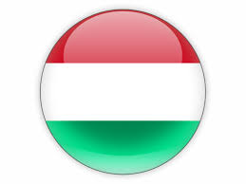
You are heavily dependent on fossil fuels and energy imports, including oil from Russia. Nearly three-quarters of your energy is fossil fuel based, and two-thirds of it is imported. You consistently oppose environmental measures that might raise energy prices on businesses and citizens. You reject the EU’s greenhouse gas emissions 90% reduction target, calling it unrealistic for member states. You frame climate policy as a matter of economic burden-sharing rather than collective ambition.

Position Prompts
In this debate, you (as the Hungarian Government) want:
- EU climate policy to NOT damage economic competitiveness.
- Hint: You think that the 2040 targets will harm the competitiveness of small and medium-sized enterprises. You think that forcing a reduction in greenhouse gases will severely impact economic development in poorer EU countries and endanger their energy security.
- Member state flexibility for the 2040 targets.
- Hint: You push for member states to be able to avail of international climate credits to a greater extent than the European Commission proposed.
- Nuclear power to be recognised as a green energy.
- Hint: You see nuclear power as important for any effort to move away from fossil fuel reliance. Nuclear power accounts for half of your electricity generation. You consider it secure, affordable, and climate-friendly.

Outline Of Other Debate Players
Climate Action Network Europe | Danish  Government | French  Government |  | European Conservatives and Reformists
Civic society organisation. Wants the EU to have stronger climate targets. | EU member state. Wants ambitious climate targets and a focus on renewable energies to meet them. | EU member state. Climate ambition is limited by economic stability, including the use of nuclear energy. |  | Party in the European Parliament. Rejects EU climate policy as an economic and political burden.

Role Sheet: European Conservatives and Reformists Group
You represent the European Conservatives and Reformists in this debate.
You are a conservative political group in the European Parliament, with 79 elected members (MEPs) from 18 EU member states. You believe that the European Union has overreached. You think that the EU should focus on increasing member states economic competitiveness and personal freedoms by lowering EU regulation (rules) and lowering EU financial obligations on member states across policy areas. Therefore, you strongly oppose the European Commission’s proposed target of 90% emissions reduction by 2040.

Position Prompts
In this debate, you (as the ECR) want:
- The EU to focus on investment rather than regulation.
- Hint: You think the 2040 climate targets are unrealistic. Before introducing more regulations (rules) and obligations, the European Commission should produce an impact assessment analysing the costs & benefits of climate targets and commitments.
- Hint: EU member states are already challenged to remain economically competitive. High energy prices could see international companies move outside of EU member states, to places with less demanding environmental targets.
- Hint: Climate ambitions should be based around investment in innovation and technological progress. The EU should not hinder member states and industries’ progress by over-regulating them. Instead, they should just focus on financing it.

Outline Of Other Debate Players
Climate Action Network Europe | Danish  Government | French  Government |  | Hungarian Government
Civic society organisation. Wants the EU to have stronger climate targets. | EU member state. Wants ambitious climate targets and a focus on renewable energies to meet them. | EU member state. Climate ambition is limited by economic stability, including the use of nuclear energy. |  | EU member state. Reliant on fossil fuel imports. Considers EU climate targets unrealistic and economically damaging.

EU Climate Targets (2040) Factsheets
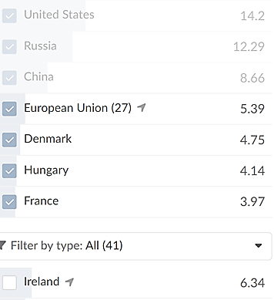
Carbon Dioxide Emissions Per Capita (2024)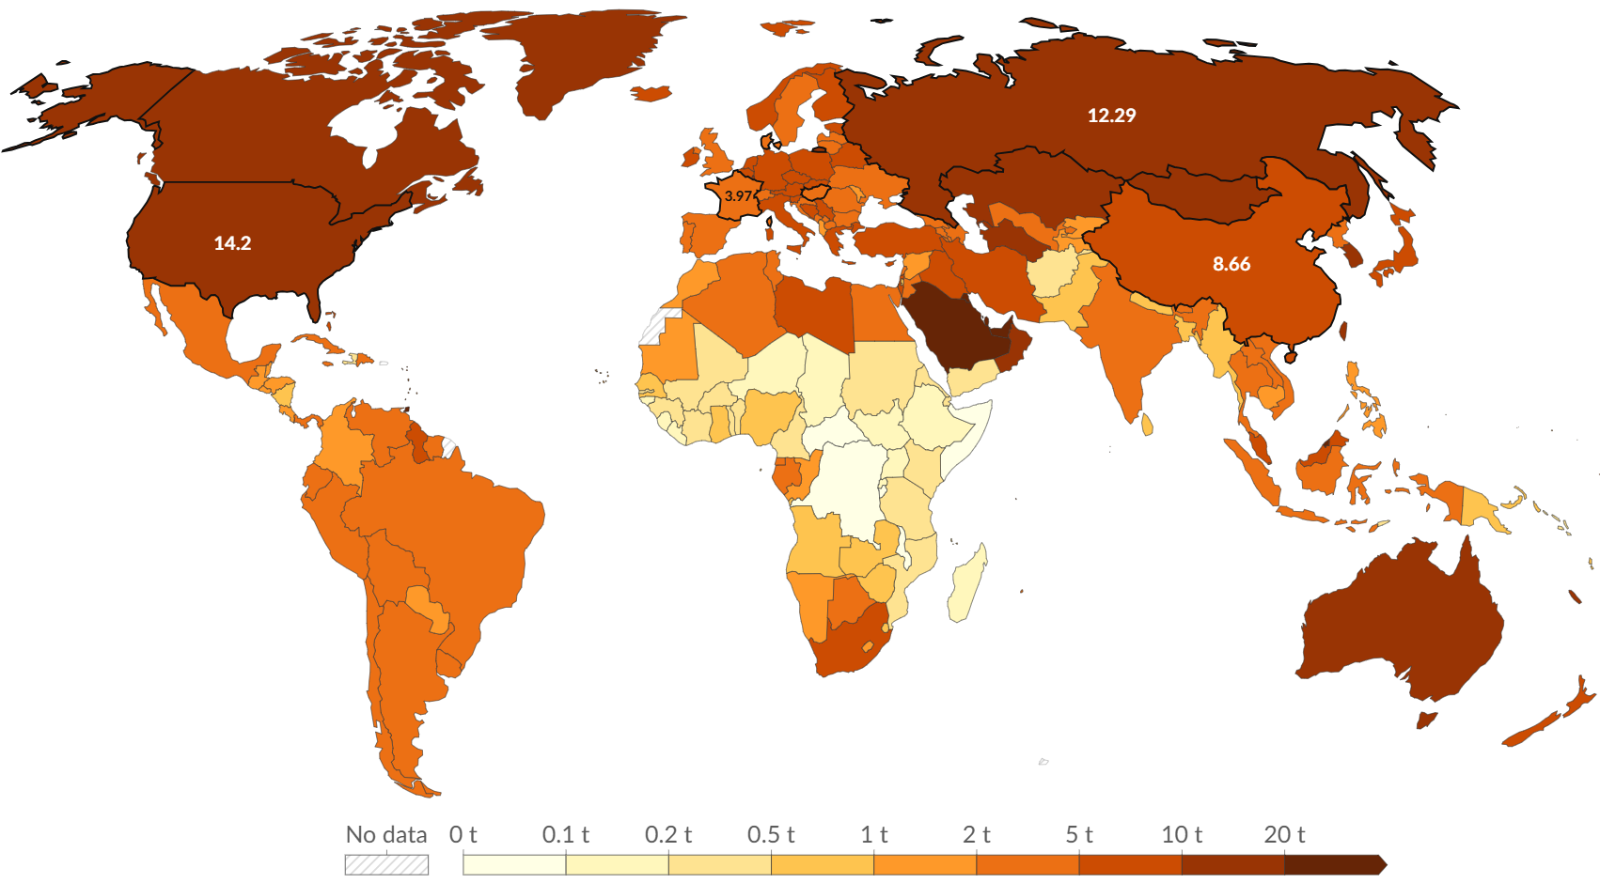
Source: Our World In Data
Note: CO₂ emissions (tonnes per person) from burning fossil fuels and industrial processes (transport, electricity, and heating)

Global Flow of Blue Carbon Credits
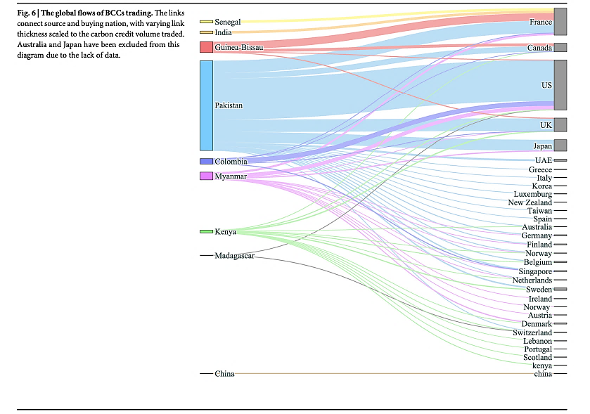

Source: Farahmand, Hilmi and Duarte (2025) [Figure 6]
Note: The coloured trading links connect source with buying nation. The thickness indicates size traded.

