Teacher Briefing



A Debate on European Union Values
The Democracy Debate

Debate Question
The question for your student debate is; “Should European Union citizens living in other EU countries be allowed to join political parties there?”. Through the debate, students explore a clash of two principles of the EU:
- EU Citizens’ Democratic Rights: EU citizens have the right to vote and stand as candidates in local and European Parliament elections in other EU member states. This allows them to participate in politics in whatever EU member state they live in.
- Member State Sovereignty: EU member states hold the power to make laws in policy areas that they have not shared with the EU.

Debate Aim
That students consider the relevance of European Union values, and the rights and explore the responsibilities of citizens and member states under EU law. The debate question comes from a court case brought by the European Commission to the Court of Justice of the EU in 2021 [European Commission v Czech Republic].
- We want you and your students to explore the ideas and issues involved through a moral, social, and political debate, rather than a legal one.
- After the debate you can present the summary of the actual court case ruling to students (page 3) as a eureka moment for reflection.

Using the Debate
You are welcome to adapt the debate design and material to meet your teaching need, classroom dynamic, or student group. See this as a debate resource rather than a straitjacket.

Teacher Briefing


Debate Format
Pre-Debate
- Days Before: Provide the Student Briefing material to students (pages 7-9).
- Optional: Show student this very short AV clip about EU values
- Debate Day: Assign 3-5 students to a group for each debate role. Visually present the Debate Instructions (page 6) to students and distribute the relevant Role Cards (page 10-17) for their role. Give them approximately 20 minutes to analyse their Role Card and prepare for their role.

Debate Design
- Room Set-up: Each role group has a table, chairs, and a table title (page 19-23).
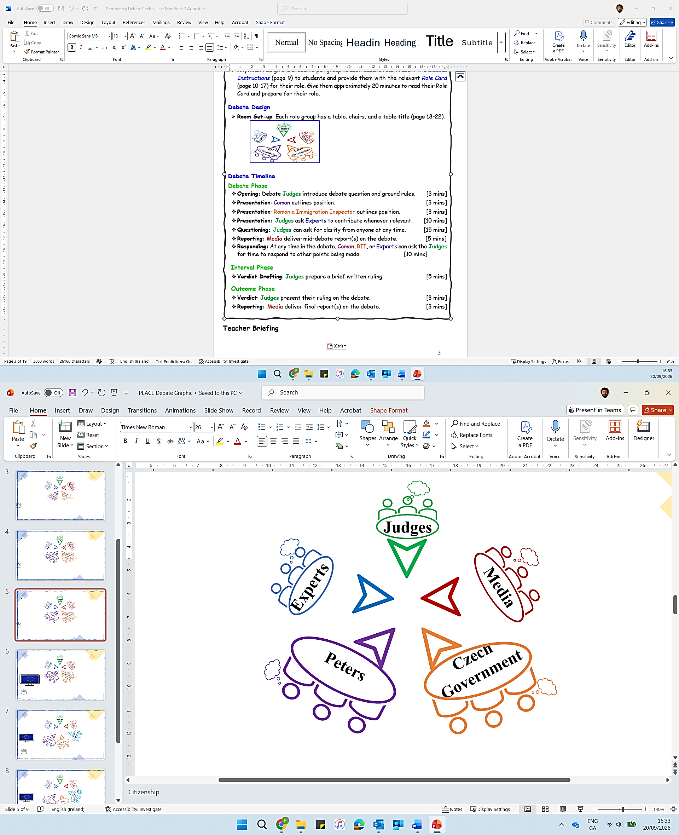
Debate Timeline
Debate Phase
- Opening: Debate Judges introduce debate question and ground rules. [3 mins]
- Presentation: Peters outlines position. [3 mins]
- Presentation: Czech Government outlines position. [3 mins]
- Presentation: Judges ask Experts to contribute whenever relevant. [10 mins]
- Questioning: Judges can ask for clarity from anyone at any time. [15 mins]
- Reporting: Media deliver mid-debate report(s) on the debate. [5 mins]
- Responding: At any time in the debate, Peters, the Czech Government, or Experts can ask the Judges for time to respond to other points being made. [10 mins]

Interval Phase
- Drafting: Judges prepare a brief written ruling. [5 mins]

Outcome Phase
- Ruling: Judges present their ruling on the debate. [3 mins]
- Reporting: Media deliver final report(s) on the debate. [3 mins]

Post-Debate
- Case Ruling: Teacher interjects to present actual case ruling (page 3). [5 mins]
- Immediately or for Homework: Students complete any Reflective or Research Activity that you choose (page 4).

Teacher Briefing




*Post-Debate* Teacher Intervention
Related Court Case
- This debate was based on a real situation. The related case, brought to the Court of Justice of the EU, was called ‘The European Commission v Czech Republic’ (2021).

**Freddie Peters is a fictional character to personalise the scenario; it was the European Commission who brought the real case**. Here are a summary of the case and the court’s ruling.

Context
- The European Commission engaged with the Czech government for 10 years from 2010 to 2020, asking them to show how Czech law met the EU obligations on electoral rights that they had agreed in 2007. Eventually the Commission brought the case to the Court of Justice of the EU in 2021.

Ruling
- Discrimination: The Court ruled that restricting party membership in Czechia to only Czech nationals is a breach of the EU law that guarantees the freedom of movement and the right of mobile EU citizens to participate in local and European Parliament elections.
- Political Participation: The Court found that for EU citizens to vote and stand effectively as candidates, they must have equal access as Czech nationals to join political parties in Czechia. Political parties express the interests of citizens and are important in a representative democracy.
- EU Democracy: The judges’ interpretation of EU law strengthened the political rights of EU citizenship. It connected the political rights of ‘standing for election’ with ‘freedom of political association’ for mobile EU citizens.
- National Identity: The judges held that ‘representative democracy’ is central to the EU’s identity, and that it comes from the shared identities of member states as representative democracies. For this reason, a member state cannot use ‘national identity’ as a grounds to undermine the EU as a ‘representative democracy’ or the democratic rights of EU citizens.
Optional Follow-up
- Show students one or both of these AV clips about:
- 1) Mobile EU Citizens Voting (ALDA)
- 2) EP President on Young People and Democracy (EUdebates)

- https://www.youtube.com/watch?v=zTaB6R30YXE

Teacher Briefing




Post-Debate Student Activities
Students can use a page or post-its to reflect on their content or skill learning. No right answers, just honesty….

Reflective Activities
Content
1. What was most interesting about the debate scenario?
2. What was most interesting about EU law?

Participation
1. What was most interesting about your role in the debate?
2. What did you learn about your debating skills or watching others debate?

Debate Impact
1. On a scale of 1 (Not at all) to 5 (Very); are you curious to find out what happened for EU citizens’ political rights after the case?
2. On a scale of 1 (Not at all) to 5 (Very); has this debate impacted your interest in EU values, principles, or EU citizens’ rights?
3. On a scale of 1 (Not at all) to 5 (Very); how engaging or fun was this debate overall?
4. What changes would you make to the debate design or content to improve it for students of your age?

Research Activities
Assign a student or a group of students to research and report back on the following:

- The outcome of a similar case between the European Commission and the Polish Government (2024).
- New EU rules, introduced in 2025, to support mobile EU citizens voting rights.
- Election turnout in your country and across the EU in the latest European Parliament election.

Teacher Briefing



Student To-dos
1. Pre-debate: Read the debate scenario and background (pages 7-8).
2. Pre-debate: Read about EU Values and Principles (page 9).
3. Pre-debate: Work in assigned group to prepare debate role. Students can use the Student Briefing material and Role Cards as resources to prepare and develop their own arguments, in their own words.
4. During debate: Prepare and present their debate points, counterpoints, or information to perform their role.
5. Post-debate: Complete any Reflective or Research Activity that you choose (page 4).


Glossary
- If you think that students do not know the following terms, these descriptions will help you in briefing them:
- EU Member States: The 27 European countries who pool decision-making power in some policy areas. This creates rights and responsibilities for their governments and their citizens under EU law.
- EU Values: Beliefs or priorities that EU member states consider to be important. The EU has 6 common values (human dignity, freedom, equality, democracy, rule of law, and respect for human rights).
- Mobile EU Citizens: Citizens of any EU member state who live in another EU member state.
- European Parliament: The EU institution that represents EU citizens’ interests. Members (MEPs) are elected for 5-year terms through elections held in each member state at the same time.

Printing (If Relevant)
You may be able to distribute debate material to students using your school’s virtual platform. However, if printing, this is a summary of advisable printing:
Days in Advance: Double-sided, 1 copy of Student Briefing (page 7-9) per student.
Days or hours in Advance: Single-sided, 1 or 2 copies of Role Cards (page 10-17).
Days or hours in Advance: Single-sided, 1 copy of table titles (page 19-23).

Debate Instructions [Teacher Presents (Visually) on Debate Day]


Preparation
You’re going to debate the question Should European Union citizens living in other EU countries be allowed to join political parties there?
I’ll assign you to a group to perform one of these roles in the debate:
- Judges
- Ms Peters
- Czech Government
- Experts
- Media
Use the Student Briefing material and the prompts on your Role Card to prepare for the debate. It is not about using big words. Present your points in your own words and prepare counterpoints to the points made by other debate players.
You may not agree with the opinions or beliefs of the role you’re playing. It’s a role-play, your job is to represent the role you’re playing, rather than your own opinion. To stand in their shoes for a little while.

Debate Timeline

Debate Phase
- Opening: Debate Judges introduce debate question and ground rules. [3 mins]
- Presentation: Peters outlines position. [3 mins]
- Presentation: Czech Government outlines position. [3 mins]
- Presentation: Judges ask Experts to contribute whenever relevant. [10 mins]
- Questioning: Judges can ask for clarity from anyone at any time. [15 mins]
- Reporting: Media deliver mid-debate report(s) on the debate. [5 mins]
- Responding: At any time in the debate, Peters, Czech Government, or Experts can ask the Judges for time to respond to other points being made. [10 mins]

Interval Phase
- Drafting: Judges prepare a brief written ruling. [5 mins]

Outcome Phase
- Ruling: Judges present their ruling on the debate. [3 mins]
- Reporting: Media deliver final report(s) on the debate. [3 mins]

Student Briefing

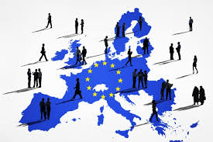
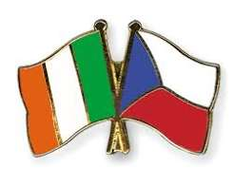

Debate Scenario
Feddie Peters is an Irish citizen who works in Czechia as a language teacher. She is very involved with community events in Prague, where she has lived for five years.
Freddie recently tried to join the local Green Party (called Strana Zelených) as she knows many party members from her community work. The party welcomed her interest, but informed her that she couldn’t join. Czech law dictates that only Czech nationals can join political parties there.
Freddie thinks that not allowing her to join a political party in Czechia is a breach of her electoral rights as a mobile EU citizen living there. In this way, she thinks that the Czech Government is breaking its responsibility as an EU member state.

What is this debate about?
The main question in this debate is; ““Should European Union citizens living in other EU countries be allowed to join political parties there?” The question involves a clash between two important ideas of the EU:
- EU Citizens’ Democratic Rights: EU citizens have the right to vote and stand as candidates in local and European Parliament elections in other EU member states. This allows them to participate in politics in whatever EU member state they live in.
- Member State Sovereignty: EU member states hold the power to make laws in policy areas that they have not shared with the EU.

Student Briefing



Debate Background: EU Law
- The EU is based on an idea of representative democracy. EU citizens are directly represented in the European Parliament.
- Every EU citizen has the right to participate in the democratic life of the EU. (Treaty on European Union)
- EU citizens have a right to move and live (‘freedom of movement’) in any other EU member state.
- Mobile EU citizens (i.e., those who live in another EU member state) have the right to vote and to stand as candidates in local and European Parliament elections in that member state. They are entitled to do so under the same conditions as nationals of that state. (EU Charter of Fundamental Rights)
- Each EU member state has the power to set its own national political conditions to protect its national identity.



Debate Background: Czech Law
- Czech citizens have the right to join political parties and political movements, so that they can participate in political life in Czechia. (Political Party Law)
- Non-Czech residents (including mobile EU citizens) living there do not have the right to join a political party.
- Mobile EU citizens who live in Czechia are allowed to vote and to be included as independent (non-party) candidates on candidate lists for local and European Parliament elections there.

Student Briefing


Member State Sovereignty
- A member state shares decision-making power with EU institutions in certain policy areas.
- In other policy areas, a member state retains full legal power to make law.

EU Citizenship
- Is automatically granted to all nationals of EU member states.
- Provides rights and opportunities, such as freedom of movement and some political rights.

Primacy of EU Law
- In policy areas where member states have given the EU competence, EU law trumps national law.
- The aim is that EU law is applied consistently across member states.

Democracy
- The EU is based on the idea of representative democracy. Citizens elect representatives to the European Parliament (MEPs).
- EU citizens have the right to vote and stand as a candidate in EP elections without discrimination.

Charter of Fundamental
Rights of the EU
- Identifies the civil, political, social, and economic rights of EU citizens and residents.

EU Principles 

These are guidelines for EU activity. They come from key EU values or ideas. They must be respected by EU institutions and member states when making decisions. Take time to read them carefully, they’ll help your debate points.

Role Card: Judges


Your Role
- You are Judges at the Court of Justice of the EU. Your role is to organise the debate and facilitate interactions. Listen to all sides neutrally and ask questions for clarity when you need. You are not on anyone’s side.
-------------------------------------------------------
Prepare
- Read the Student Briefing material (page 7-9). Use it to prepare an opening statement for the debate.
- Use the template provided to note and analyse the arguments made during the debate.
--------------------------------------------------------
Debate
- Opening: Briefly outline the debate question, and the rules of engagement for contributions and interactions between debate players.
- Facilitate: Invite debaters to present their arguments, roughly in line with the Debate Timeline in the Debate Instructions. Invite them to make counterpoints in response to points made by other debaters.
- Question: Be polite but ensure that debaters keep their points relevant to the question and issues involved.
- Invite: Experts to present information whenever relevant during the debate.
- Invite: Media groups to deliver mid-debate report.
- Ruling: Note relevant points made by Peters, the Czech Government, and Experts during the debate.
-------------------------------------------------------
Deliver
Ruling: Use the Interval Phase during the debate to consider whether Peters’ or the Czech Government’s points were more convincing, given the debate background. Using your Ruling Sheet, write a few short notes of the most convincing points made, and possible wider impacts of the debate verdict.
- Presentation: Call all debaters attention and deliver your ruling to all present, outlining the points from your Ruling Sheet.
- Closing: Invite final reports from the Media groups that conclude the debate.

Role Card: Judges
Our Decision
- State your ruling clearly. Does preventing people from joining political parties amount to denying their EU electoral rights?
- As setting national political rules is a member state power, rather than an EU power, can Czechia use national identity and sovereignty to prevent foreign nationals joining political parties?
- Give your answer, reasoning, and maybe some impacts of your decision.

What are the most convincing/relevant points in support of the Czech Government’s claim?

What are the most convincing/relevant points in support of Ms Peters’ claim?

Judges’ Ruling Sheet
- This sheet should help you in analysing the debate and forming your decision.

Role Card: Ms Peters


Your Role
- You represent Freddie Peters in the debate. You think that the Czech Government is not right to deny mobile EU citizens’ the right to join political parties in Czechia.
-------------------------------------------------------
Prepare
- Read the debate Student Briefing material. In your own words, develop moral, social, or political points to represent the EU Commission. Here are some, but be confident to develop your own:
- EU Representative Democracy: EU citizens have the right to vote and stand as candidates in local and European Parliament elections in whatever EU member state they live in. They must be able to exercise these rights under the same conditions as nationals in that state.
- Discrimination: As Czechia allows only Czech nationals to join political parties, mobile EU citizens living there cannot exercise their voting and candidacy rights under the same conditions as Czech nationals. That’s unequal treatment.
- Political Participation: Political parties play an important role in elections. Preventing party membership impacts peoples’ ability to stand for election by disadvantaging their profile, resources (finance/networks), and media access.
- Election Candidacy: Even if mobile EU citizens can stand as independent candidates in Czech elections, they are in a less favourable position than party candidates. It limits their impact on party’s policy priorities.
- State Sovereignty: The limitation of party membership in Czechia is discrimination. The Czech Government must show how granting mobile EU citizens a right to join a political party undermines its national identity.
-------------------------------------------------------
Debate
- Present: Be clear in outlining relevant points to represent Ms Peters’ position. Be confident to do this in your own words, without overly relying on prompts, big words, or a script.
- Interact: Consider the information introduced by other debate players. Be prepared to counter points that they make. Try to keep the debate background and EU principles in mind (page 9) .

Role Card: Czech Government

Your Role
- You represent the Czech Government in the debate. You think that deciding party membership rules is a member state’s power and it does not stop mobile EU citizens’ right to vote or stand in European Parliament elections.
-------------------------------------------------------
Prepare
- Read the debate Student Briefing material. In your own words, develop moral, social, or political points to represent the Czech Government. Here are some, but be confident to develop your own:
- Representative Democracy: You allow mobile EU citizens to vote and stand as candidates in local elections and European Parliament elections. Membership of political parties is a separate issue and is not covered by EU law.
- Discrimination: EU law around discrimination relate to the exercise of the right to vote and stand for election, not to party membership.
- Political Identity: Rules on political party operations at national level are the exclusive power of each member state. The EU allows member states to set nationality as a condition to vote in national parliament elections. This protects member states’ political systems and respects their national identity. It is logical that EU law can be interpreted to allow member states to limit the ability of foreign nationals to participate in other national political platforms, such as political parties.
- Election Candidacy: Czech allows mobile EU citizens to stand as independent (non-party) candidates on political party candidate lists. Independent candidates are often included on such lists and sometimes rank highly on those lists.
- Political Participation: Ms Peters only presumes that independent candidates are in a less favourable position than political party candidates. A candidate’s election success depends on opinions, personality, and policy, rather than party membership.
-------------------------------------------------------
Debate
- Present: Be clear in outlining relevant points to represent the Czech Government’s position. Be confident to do this in your own words, without overly relying on prompts, big words, or a script.
- Interact: Consider the information introduced by other debate players. Be prepared to counter the points that they make. Try to keep the debate background and EU principles in mind (page 9) .

Role Card: Experts


Your Role
- You are independent experts who provide information to enhance the debate. You are neutral, you do not represent either side. Your role is to explain a key concept or context to help the judges understand the debate.
--------------------------------------------------------
Prepare
- Read the debate Student Briefing material to be aware of the background.
- Divide the roles below within your group. If you like, work as sub-groups rather than individually. Develop related points in your own words.
- Politics Professor: Outline that mobile EU citizens’ right to vote and stand in local and European Parliament elections ensures that they can play an active political role in the member state they live in. The electoral rights of EU citizenship are important to build democratic participation in the Union.
- Political Geographer: Outline that there are about 18 million mobile EU citizens. The scale of mobile EU citizens in a member state ranges from 1% (Lithuania) up to 33% (Luxembourg). It is 3% in Czechia but is more than 5% in most EU states.
- Czech Political Scientist: Outline that in European Parliament elections from 2004-2019 in Czechia, 30% of candidates on political party candidate lists were non-party (independent) candidates. In the 2004 election, a German (mobile citizen) was elected in Czechia to the European Parliament. In local elections in Czechia, a majority of candidates are not political party members.
- Polish Government Representative: Outline that mobile EU citizens cannot join political parties in Poland either. This does not stop them from voting or standing (as independent candidates) in local or European Parliament elections. They have less access to public radio and television than party candidates, but they have access to online (social) media. In Polish politics, some candidates get more public attention exactly because they are not Polish.
- Election Observer: Outline that in European Parliament elections from 2004-2019, the vast majority of candidates were members of political parties, and the vast majority of successful candidates were members of political parties at member state level.
--------------------------------------------------------
Debate
- Present: Be clear and brief in your contributions, with a neutral tone.
- Interaction: The Judges will invite you. But if a point made in the debate relates to your expertise, ask the Judges for an opportunity to clarify.

Role Card: Media


Your Role
- You are reporters for news organisations covering the debate. Your teenage audience is not familiar with the EU. Your reports need to make the debate issues meaningful for them. Bring a bit of drama or excitement to the debate.
--------------------------------------------------------
Prepare
- Divide into two news groups. Media organisations focus 1) informing in a neutral or formal way or 2) dramatising by using controversial angles and soundbites. Each media group can decide whether your report stye will be ‘Informing’ or ‘Dramatising’.
- You can also decide whether your reports are for Online (TikTok, Insta, X, etc) or Broadcast (TV or Radio) media.
- Think about and prepare relevant props (fake micro-phone, backdrop, sound effects, or imagery) for the type of report medium you select.
- Use the Student Briefing material to select angles that to focus on in your reports. Within your group, divide tasks to ensure relevant information is captured, and the design and presentation of the report(s) is prepared.
- Use the mid-debate and final report Preparation Templates to prepare.
--------------------------------------------------------
Debate
- Observe: Note relevant points, issues, and debate exchanges.
- Engage: At any time, you can ask other debate players for a comment or quotation to inform your reports.
--------------------------------------------------------
Deliver
- Mid-Debate Report: When called by the Judges, each media group delivers a short (2-3mins) and snappy update on the debate to that point. Be creative and add life to the debate for an external audience. Include relevant props depending on your type of report and start with a catchy headline.
- Final Report: When called by the Judges, each media group presents a short (2-3mins) and snappy final report on the debate. Try to keep your Informing or Dramatising style in mind. Be creative to engage or entertain your audience.


Role Card: Media

Debater Quotes / Comments to include:

Hook/Angles to bring your ‘Informing’ or ‘Dramatising’ style:

Props to Animate Report Presentation:

Other Notes:

Possible Headlines:

Main Debate Points/Issues/Events to include:

Report Style: Informing or Dramatising? ___________________

Report Type: TikTok, Insta,TV, Radio, X, or other? __________________

Preparation Template for Mid-Debate Report

Role Card: Media

Debater Quotes / Comments to include:

Hook/Angles to bring your ‘Informing’ or ‘Dramatising’ style:

Props to Animate Report Presentation:

Other Notes:

Possible Headlines:

Main Debate Points/Issues/Events to include:

Report Style: Informing or Dramatising? ___________________

Report Type: TikTok, Insta,TV, Radio, X, or other? __________________

Preparation Template for Final Report

Judges

Peters

Czech
Government

Experts

Media

