Debate Question:
“Should the European Union (EU) stop supporting meat production to make its Common Agricultural Policy greener?”

Introduction I: Common Agricultural Policy 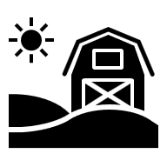
When founded in the 1960s, the EU Common Agricultural Policy (CAP) aim was to increase farm output in member states, for a stable supply of affordable food. In 2024, agricultural output from EU member states was valued at €532 billion, with €234 billion of that output exported.
In recent decades, the CAP aims have widened to include the sustainable management of natural resources and lowering greenhouse gas emissions. It wants to do this while protecting farmers’ livelihoods and promoting agri-food production. CAP funding and payments guide agricultural activity toward goals agreed by member states at EU level. CAP spending accounted for 28% of the overall EU budget in 2024. Negotiations between member states, interest groups, and EU institutions, are underway for the next CAP agreement (2028-2034).

Introduction II: Environmental Policy 
The European Union is an important player in environmental policy. Laws agreed by member states at EU level influence production and consumption levels inside and outside its borders. In 2019, EU institutions and member states agreed ambitious environmental goals as part of the European Green Deal. The deal targets environmentally sustainable production and consumption across sectors. Making agricultural production more environmentally efficient and sustainable isa key EU environmental priority.
Questions are being asked about what agricultural measures are needed to ensure that the EU meets its own environmental targets. Is a move from an animal-based to plant-based diet necessary? If so, what measures are needed to ensure such a transition maintains economic competitiveness, and supports the livelihood of individuals and communities involved in agri-food production?

Debate Instructions (for reading to students) 
We are going to debate the question: “Should the European Union stop supporting meat production to make its Common Agricultural Policy greener?” The players in this debate are:
- the European Commission
- the Danish Government
- the Irish Government
- the League of European Agri-plant Food-producers (LEAF)
- the Meat and Livestock Associations in Europe (MEAL).
Your task is to prepare and represent the position of one of these debate players.

What do you have to do? (for reading to students) 
1. Use your Role sheet and Factsheet to prepare short points to support your position in the debate [10-15 mins on your own]
2. Then, work with others assigned to play the same role. Work on the phrasing and the examples/evidence to be used [10-15 mins with others given the same role]
3. Now, you’ll see floor markings (or chairs) marking positions in a debate circle. You and others given the same role rotate into position to speak in the debate. When you’re not in a speaking position, listen to the debate and prepare points to add information to the debate and to support your position [20 mins in debate circle]

Debate Prompts (optional aid for teachers) 
1. Is a move from animal-based to plant-based diets necessary in the EU?
- What are the goals of EU agricultural policy and environmental policy?
- How significant is animal-based agriculture for greenhouse gas emissions?
2. How can the EU encourage change in production and consumption?
- How is animal-based agriculture important for EU citizens’ food and livelihoods?
- How does the EU influence the behaviour of food producers and consumers?
3. What measures are needed to make sure that food supply, economic competitiveness, and agricultural/rural economies are protected?
- For an EU member state, what are the economic costs and risks of changing from animal-based to plant-based diets?
- For an EU member state, what are the food supply risks involved in changing from an animal-based to a plant-based diet?
- If removing supports from meat production, what measures are needed to avoid these economic or food supply risks?

Role Sheet: European Commission
You represent the European Commission in this debate. 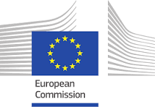
You initiate and monitor EU law. You think the EU should be a world leader in tackling climate change. Through policy proposals and financial supports, you encourage member states, producers, and consumers, toward sustainable practices to meet the goals and targets of the European Green Deal. You want to balance efficient use of natural resources and emissions reductions, with maintaining members’ agri-sectors.

Position Prompts
In this debate, you (as the European Commission) want: 
- EU greenhouse gas emissions reduced to 55% by 2030 and 90% by 2040.
  - Hint: Look at the progress made in Greenhous Gas Emissions in the Factsheet.
- Member states and agricultural sectors to reform to tackle climate change, protect natural resources, and enhance biodiversity.
  - Hint: Look at agriculture’s impact on Greenhouse Gas Emissions in the Factsheet.
- Other players to appreciate the resources (funds, schemes, measures) available to agri-producers to ensure a stable green transition.
  - Hint: Look at the Environmentally Sustainable CAP info in Further Information.

Further Information (titles hyperlinked or use QR codes) 
EU Meat Production | Concerns Around CAP | Environmentally Sustainable CAP
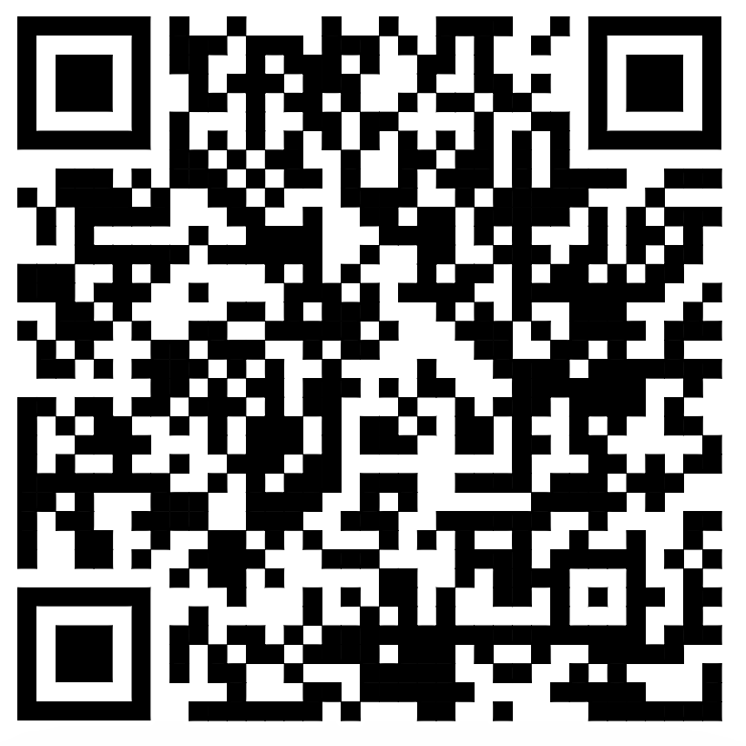 | 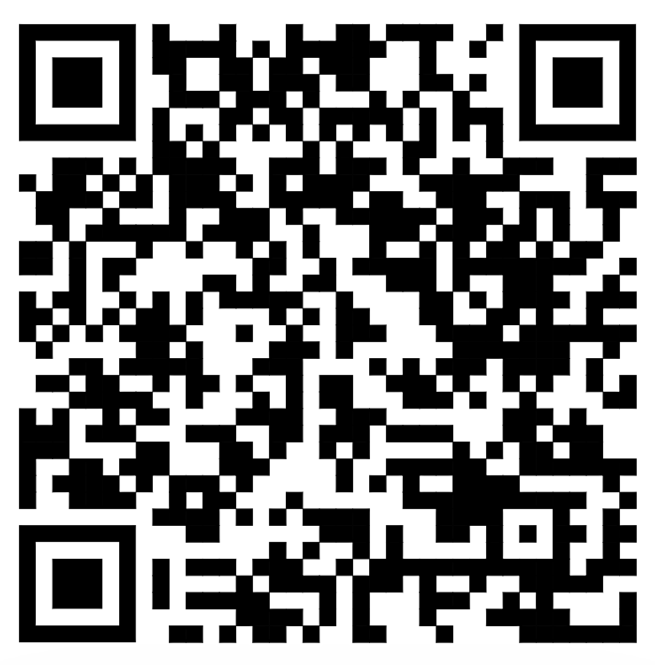 | 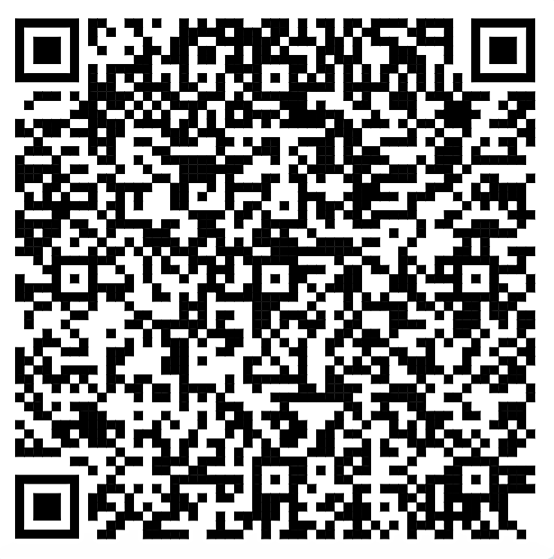
Source: EU Agri Dept | Source: Euractiv | Source: EU Agri Dept

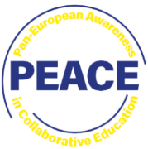
Outline Of Other Debate Players
Danish Government | Irish  Government | LEAF | MEAL 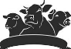
EU Member state. Wants to move toward a plant-based diet. Has proposed a meat-based carbon tax. | EU member state. Hesitant on speed of green transition. Has powerful agri-groups and a grass-based livestock sector. | Organisation of food producers, nutritionists & researchers. Calls for a plant-based transition. | Meat & livestock association. Thinks meat production can be sustainable with innovation & financial support.

Role Sheet: Danish Government
You represent the Danish Government in this debate.
You want the EU and member states to deliver on climate challenges by actions, not just words. You want stronger enforcement of EU agriculture & environmental policies. You think accelerating the green transition ensures competitive agri-food sectors, driven by innovative production. You think that innovation in the Danish agri-sector shows the potential for others to embrace change.

Position Prompts
In this debate, you (as the Danish Government) want:
- A faster green transition to ensure climate action targets are met and the EU’s agri-food sector remains competitive.
- Hint: Look at the poor progress made in Greenhouse Gas Emissions in the Factsheet.
- An embrace of innovation and biotechnology by food producers, with a shift from meat-based to plant-based diets.
- Hint: Look at the Plant-based Plan video in Further Information.
- The introduction of a carbon tax on livestock emissions in the EU.
- Hint: Look at the Tax Livestock Emissions video in Further Information.

Further Information (titles hyperlinked or use QR codes) 
Plant-based Plan | Tax Livestock Emissions
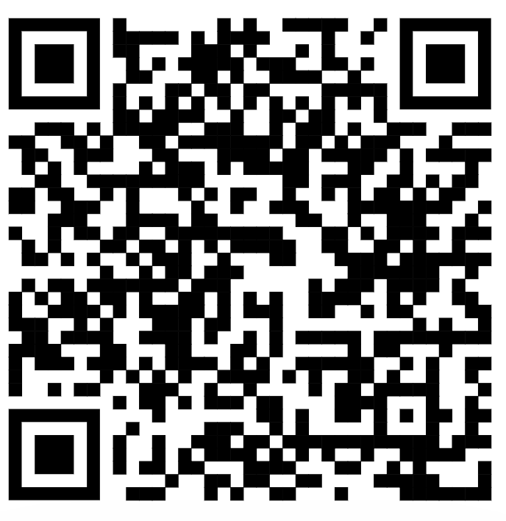 | 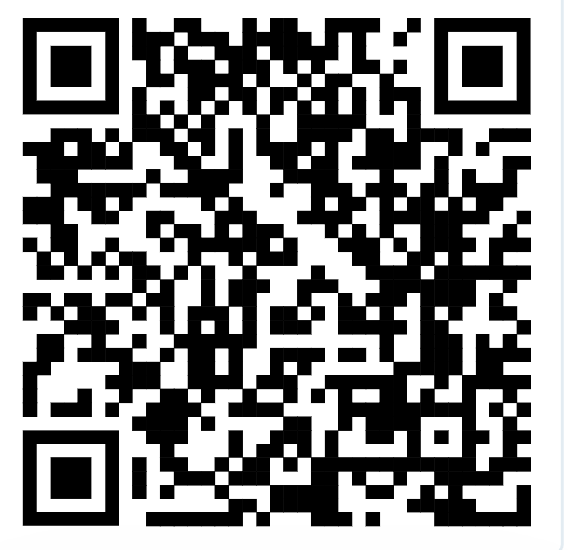
Source: Financial Times | Source: Euronews

Outline of Other Debate Players
EU  Commission | Irish  Government | LEAF | MEAL
EU institution. Encourages a transition to sustainable practices through policy proposals and financial supports. | EU member state. Hesitant on speed of green transition. Has powerful agri-groups and a grass-based livestock sector. | Organisation of food producers, nutritionists & researchers. Calls for a plant-based transition. | Meat & livestock association. Thinks meat production can be sustainable with innovation and financial support.

Role Sheet: Irish Government
You represent the Irish Government in this debate.
You are reactive to meat production and processing interest groups. You emphasise the importance of livestock production for trade, exports, and rural community income. You argue that facilitating dairy and meat production, in places like Ireland, where the climate is conducive to grass-based production, is a more efficient use of resources and better for animal welfare, and food security.

Position Prompts
In this debate, you (as the Irish Government) want:
- To protect family farm incomes and rural economies in any green transition.
- Hint: Look at the Climate Change video in Further Information.
- Grass-based meat and dairy production to be protected given its relative advantage for food security and animal welfare.
- Hint: Look at the EU Agricultural Output in the Factsheet.
- EU farmers’ higher production and environmental standards to be protected, particularly in the trade deal with South American countries (Mercosur).
- Hint: Look at the Farmer Protest video in Further Information.

Further Information (titles hyperlinked or use QR codes) 
Climate Change | CAP Reforms | Farmer Protest
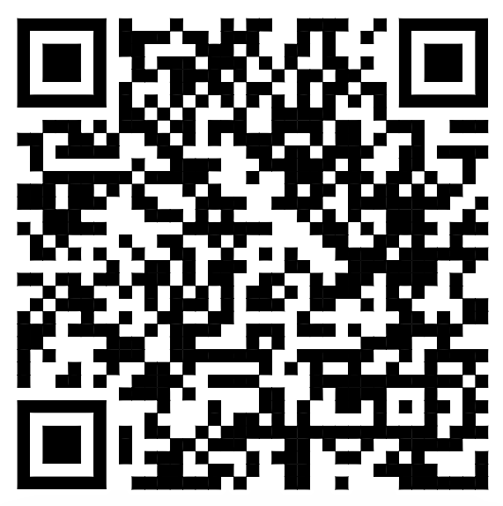 | 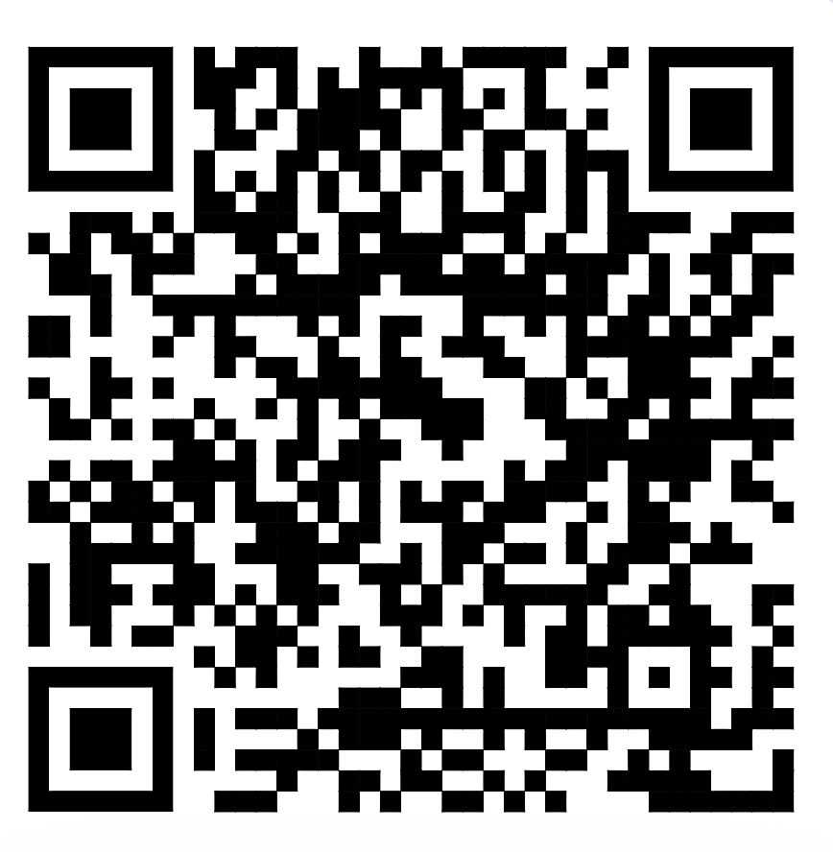 | 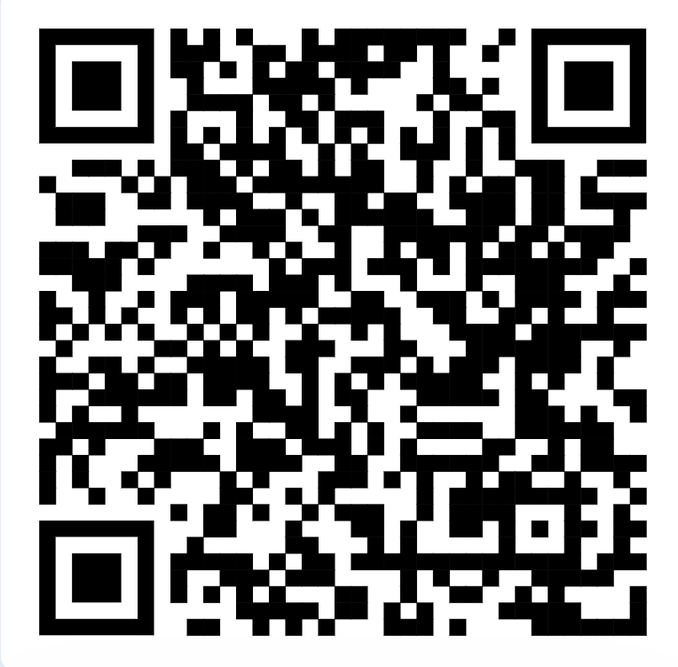
Source: Agriland | Source: Farmer’s Journal | Source: WION

Outline Of Other Debate Players
EU  Commission | Danish Government | LEAF | MEAL
EU institution. Encourages a transition to sustainable practices through policy proposals and financial supports. | EU Member state. Wants to move toward a plant-based diet. Has proposed a meat-based carbon tax. | Organisation of food producers, nutritionists & researchers. Calls for a plant-based transition. | Meat & livestock association. Thinks meat production can be sustainable with innovation & financial support.

Role Sheet: League of European Agri-plant Food-producers (LEAF)

You represent the League of European Agri-plant Food-producers (LEAF) in this debate.
You are very concerned by the threat of climate change and biodiversity loss. You put plant-based foods at the centre of the transition to more sustainable food systems. You advocate for a move toward vegetables, grains, pulses, nuts, fungi, and algae. You believe there should be a rebalancing of EU farm supports away from animal-based products and toward sustainable alternatives. 

Position Prompts
In this debate, you (as LEAF) want:
- The EU to incentivise sustainable practices in food production and processing.
- Hint: Look at the poor progress in the Factsheet.
- More EU funding of research and innovation on plant-based alternatives to animal-based products.
- Hint: Look at the Plant-based Transition video in Further Information.
- Plant-based manufacturers to be able to promote products to consumers using existing terminology, e.g., the use of veggie ‘burger’ and oat ‘milk’.
- Hint: Look at the Plant-based Promotion video in Further Information.

Further Information (titles hyperlinked or use QR codes) 
Plant-based Transition |  | A Climate Diet | Plant-based Promotion
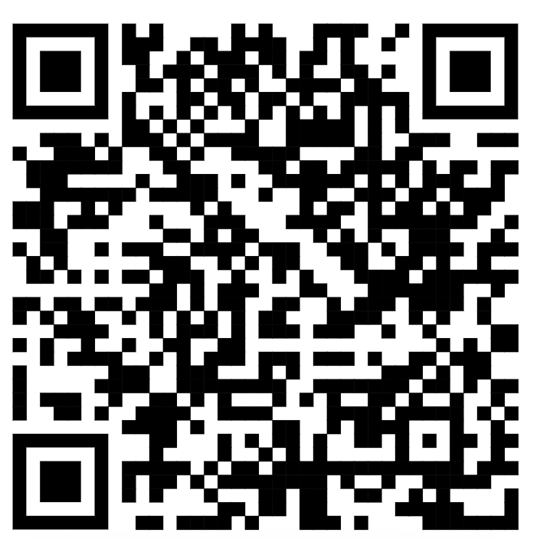 | 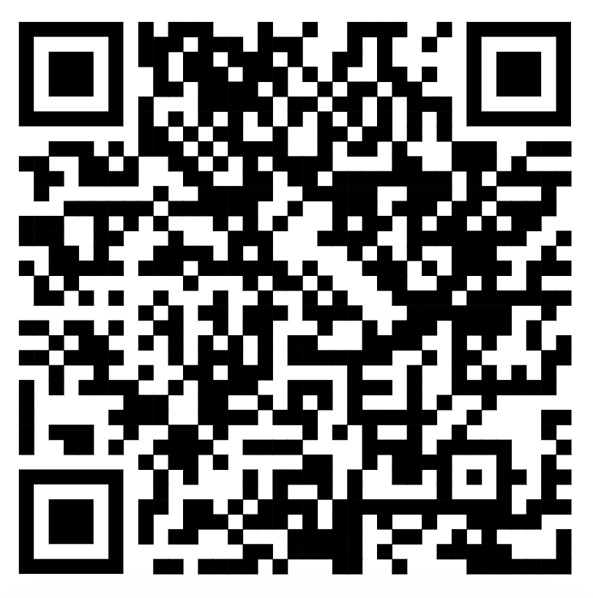 |  | 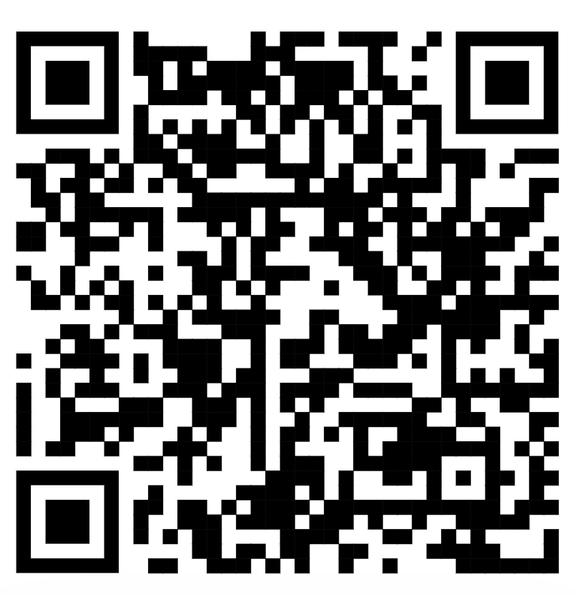
Source: EU Horizon | Source: Euronews |  | Source: DW News

Outline Of Other Debate Players
EU  Commission | Danish Government | Irish  Government | MEAL
EU institution. Encourages a transition to sustainable practices through policy proposals and financial supports. | EU Member state . Wants to move toward a plant-based diet. Has proposed a meat-based carbon tax. | EU member state. Hesitant on speed of green transition. Has powerful agri-groups and a grass-based livestock sector. | Meat & livestock association. Thinks meat production can be sustainable with innovation & financial support.

Role Sheet: Meat and Livestock Associations in Europe (MEAL)
You represent the Meat and Livestock Associations in Europe (MEAL) in this debate.
You think that animal-based farming provides an irreplaceable source of food, income, & culture for European citizens & consumers. Animal-based foods provide vital nutrients, with 34% of the world’s protein derived from meat, milk, and eggs. You think that Farmers’ livelihoods are essential for secure food supply. Without farmers, sustainability cannot be achieved. You advocate for better-raised animals rather than fewer animals at all costs. 

Position Prompts
In this debate, you (as MEAL) want:
- Agricultural innovations that lower the ecological footprint of livestock farming (genetics, feed and nutrition, digital technology) to be more accessible, and financially supported, for smaller and family farms.
- Hint: Look at the Food Additive chart in the Factsheet.
- Rules on livestock farming to be outcome-oriented rather than uniform, to respect the economic and geographic context of production at local level.
- Hint: Look at the Feeding Europe video in Further Information.
- The superior quality of EU livestock output (environmental standards & food safety) recognised, including in the trade deal with South American countries.
- Hint: Look at Agricultural Output in Factsheet and Mercosur in Further Information.

Further Information (titles hyperlinked or use QR codes) 
EU Meat | Feeding Europe | Mercosur
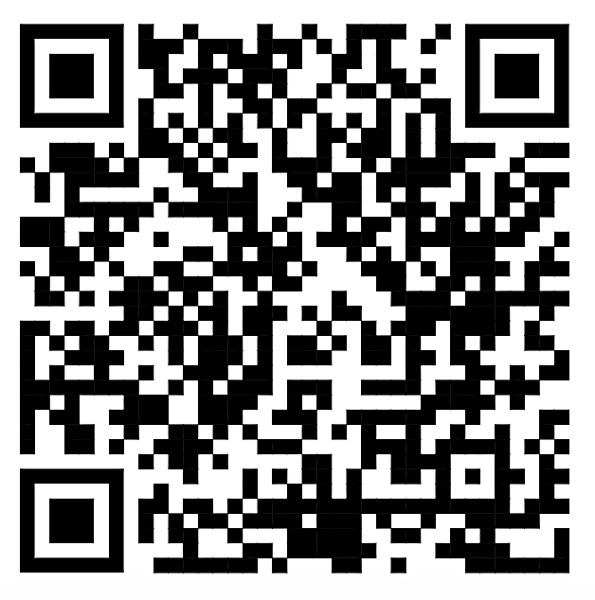 | 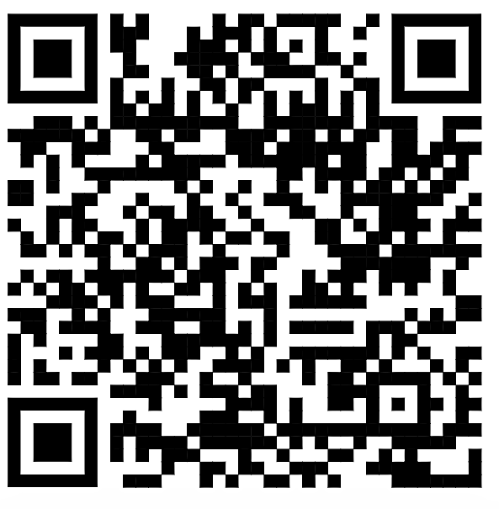 | 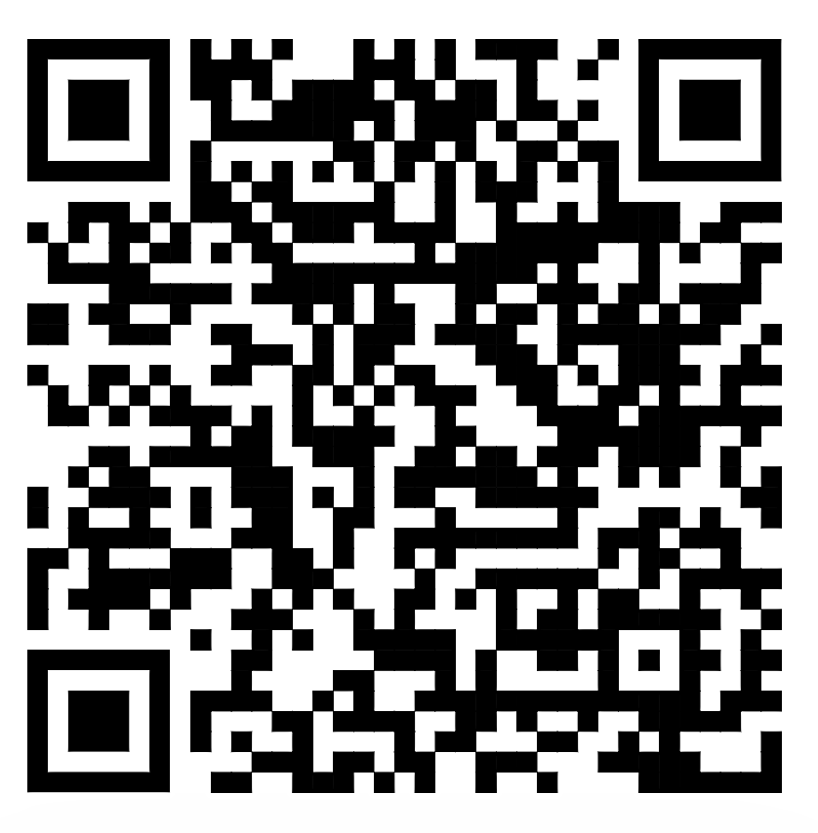
Source: EU Agri Dept. | Source: Euronews | Source: France24

Common Agricultural Policy Debate Factsheets

EU Agricultural Output (2024)
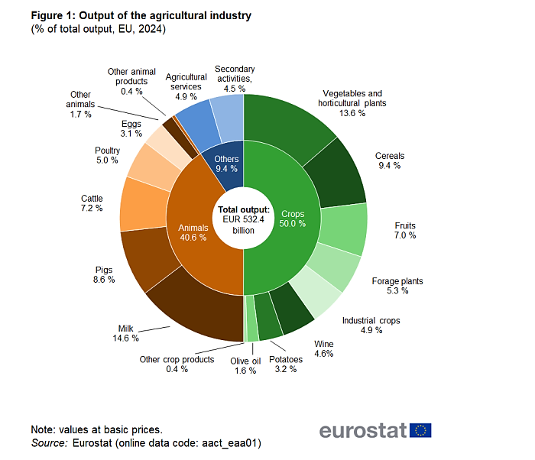
Source: Eurostat (2025) | Note: % output per sector
---------------------------------------------------------------------------------------------------------

Livestock Population in Millions (2020)
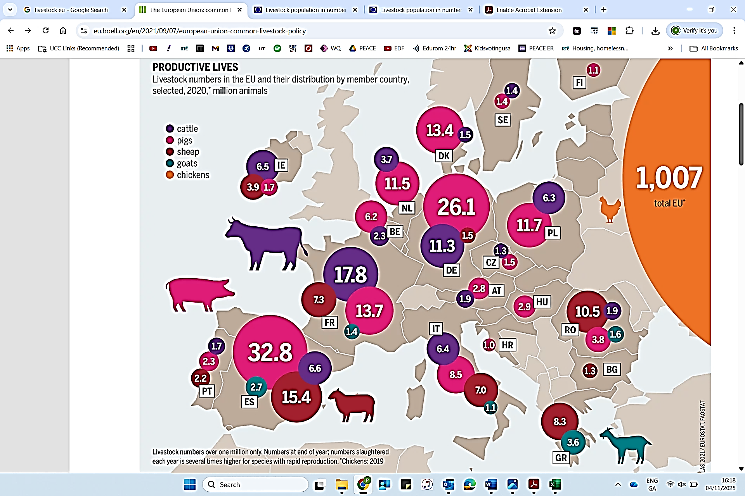
Source:Stiftung & Grethe (2021) | Note: EU member State (2020)
EU Livestock Population Trend 2010-2021
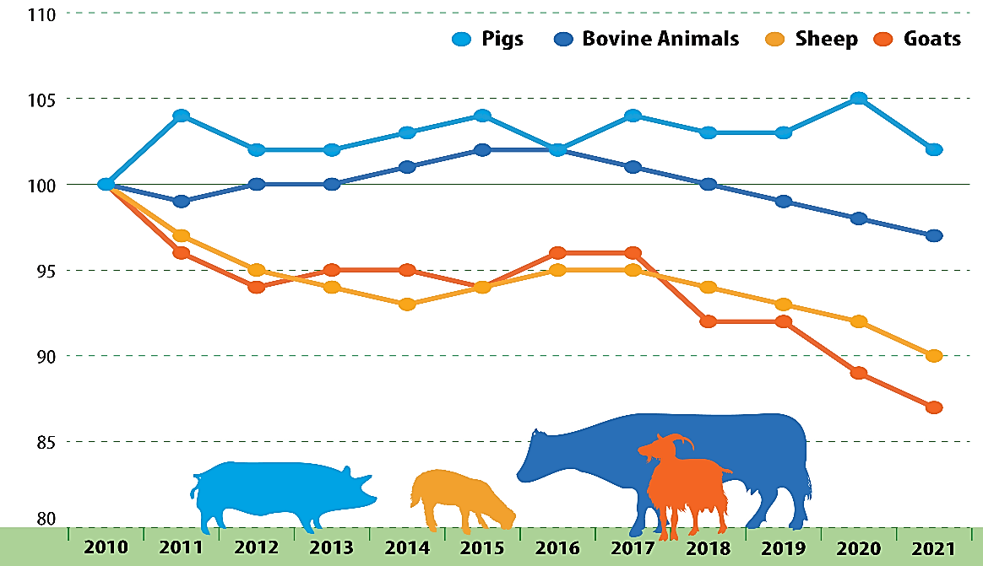
Source: Eurostat (2025) | Note: % based on 2010 as base
-------------------------------------------------------------------------------------------------

Global Greenhouse Gas Emissions from Food Production
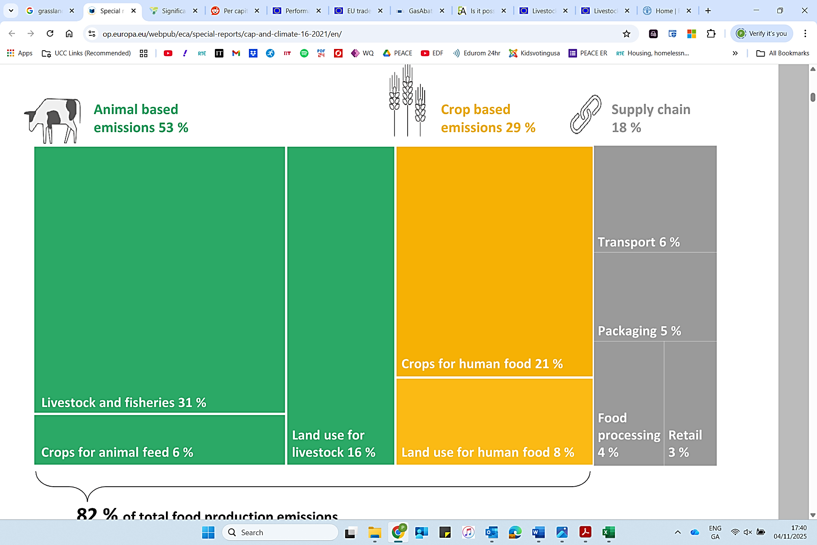
Source: ECA, Poore & Nemecek (2018)
Note: Per Million Ton Co₂ (2018)
Estimated Reduction/Increase in Greenhouse Gas Emissions
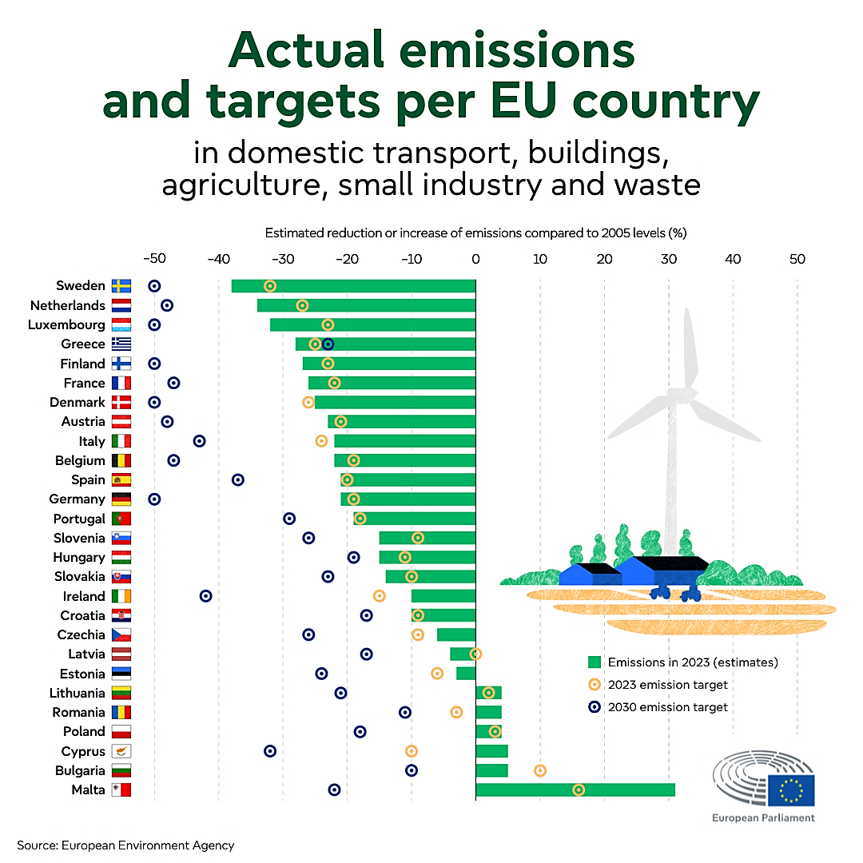
Source: European Environmental Agency (2024)
Note: % per EU Member State comparing 2023 to 2005
-----------------------------------------------------------------------------------------------------

Greenhouse Gas Emissions in the EU
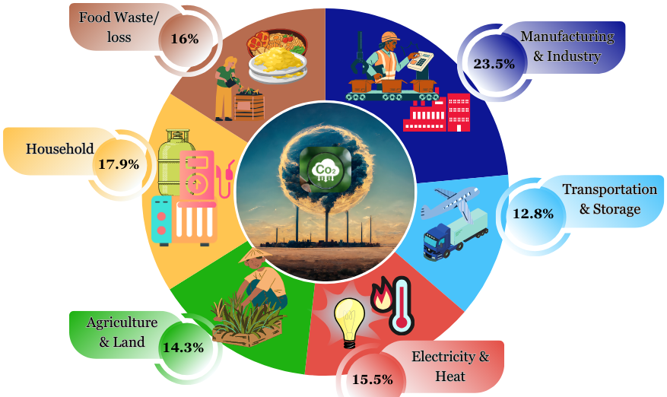
Source: BioLaMer & Eurostat (2024) | Note: By sector (2023)
Global Livestock Emissions by Region
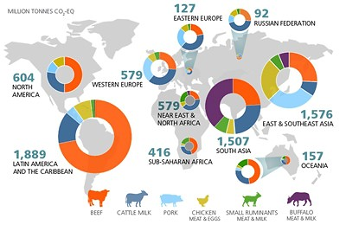
Source: UN Food and Agriculture Organization (2021)
Note: Per Million Ton Co₂ Equivalent
-----------------------------------------------------------------------------------------------------

Global Emissions Decrease Potential Through Food Additives
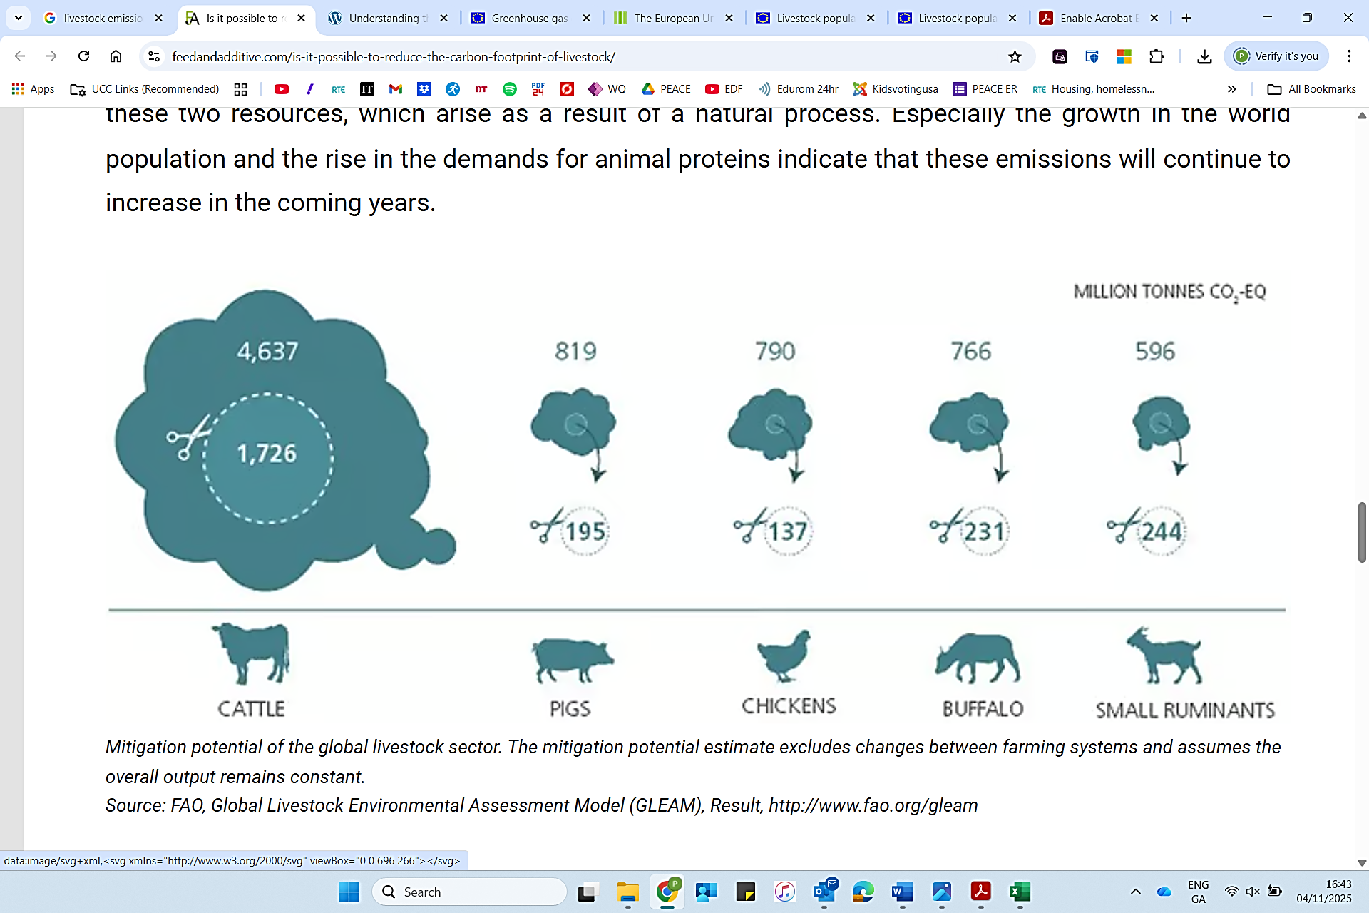
Source: UN Food and Agriculture Organization
Note: Per Million Ton Co₂ Equivalent (2021)

