Debate Question:
“Should the European Union increase the scope of its carbon border system to better fight climate change?”

Introduction I: EU Emissions Trading System (ETS) 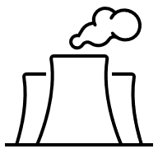
Air pollution and greenhouse gases harm our planet and health. Pollution in Europe has caused more extreme weather, rising sea levels, and damage to nature. To tackle this, the European Union (EU) has a goal to reach carbon neutrality by 2050. To encourage companies to reduce carbon emissions, the EU introduced an Emissions Trading System (ETS). This limits the amount of carbon dioxide that a company can emit. If a company produces less than its limit, the spare allowance can be sold to another company. If it produces more than its limit, it must buy an allowance for same. In this way, a company is financially rewarded for being cleaner and punished if it exceeds its limit.
A challenge to the system is that some companies base part of their production chain outside of the EU, where climate policies are less demanding. Therefore, carbon-intensive products circulate in the EU market and undermine the competitiveness of EU-based products. This is known as carbon leakage and undermines the effectiveness of EU climate action.

Introduction II: Carbon Border Adjustment Mechanism 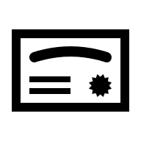
To address carbon leakage, a Carbon Border Adjustment Mechanism (CBAM) was created. An importing company must buy a CBAM certificate for some goods produced outside of the EU. The cost of a certificate mirrors the price of the equivalent carbon allowance under the Emissions Trading System (ETS). The mechanism attempts to level competition for EU & non-EU producers. It tries to create a comparable cost for the carbon involved in producing a product for sale in the EU.
The mechanism is being phased in gradually, starting with emissions-intensive sectors, with a high risk of carbon leakage such as iron, steel, aluminium, fertilizers, electricity, and hydrogen. The CBAM may be extended to other products, depending on climate policy negotiations. This extension is controversial. Some worry it will become another bureaucratic burden for European industries that are already decarbonizing. Others see it as a hidden tariff against which trading countries might impose their own tariff on EU exports in retaliation.

Debate Instructions (for reading to students) 
We are going to debate the question: “Should the European Union increase the scope of its carbon border system to better fight climate change?” The players in this debate are:
- the Germany Government
- the Polish Government
- EuroSteel
- the Climate Defence Network Europe
- the Turkish Government
Your task is to prepare and represent the position of one of these debate players.

What do you have to do? (for reading to students) 
1. Use your Role sheet and Factsheet to prepare short points to support your position in the debate [10-15 mins on your own]
2. Then, work with others assigned to play the same role. Work on the phrasing and the examples/evidence to be used [10-15 mins with others given the same role]
3. Now, you’ll see floor markings (or chairs) marking positions in a debate circle. You and others given the same role rotate into position to speak in the debate. When you’re not in a speaking position, listen to the debate and prepare points to add information to the debate and to support your position [20 mins in debate circle]

Debate Prompts (optional aid for teachers) 
1. Should the Carbon Border Adjustment Mechanism be extended to cover more products, such as chemicals, hydrogen, or plastics?

2. Does the Carbon Border Adjustment Mechanism unfairly punish developing countries, or does it push them to adopt cleaner technologies?

3. Can the Carbon Border Adjustment Mechanism help create green jobs in Europe, or will it risk job losses in traditional industries?

4. Should the EU prioritise global climate responsibility even if extending the Carbon Border Adjustment Mechanism creates tensions with its trading partners?

Role Sheet: German Government
You represent the German Government in this debate. 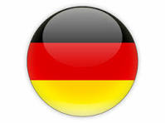
You generally support the Carbon Border Adjustment Mechanism (CBAM), as a tool to keep fairness between companies. Without CBAM, foreign companies could sell cheaper products in the EU without paying for the damage their emissions cause. You think CBAM is about more than protecting our companies; it sends a message that if a company from outside the EU wants to trade, it must take climate action seriously and raise standards accordingly.

Position Prompts
In this debate, you (as the German Government) want: 
- Fair competition for your industries.
  - Hint: You want to ensure that German companies, such as steel and chemical producers, are not disadvantaged compared to companies outside the EU with weaker climate rules.
- Strong climate action in Europe and beyond.
  - Hint: You want importers to pay for their carbon emissions to ensure that climate action is a core part of trade and other countries are encouraged to raise their standards.
- Protecting jobs and the economy.
  - Hint: Your industries provide many jobs. CBAM helps to keep manufacturing companies in Germany while still moving toward a climate-friendly future.

Further Information (titles hyperlinked or use QR codes) 
Carbon Border Adjustment Mechanism  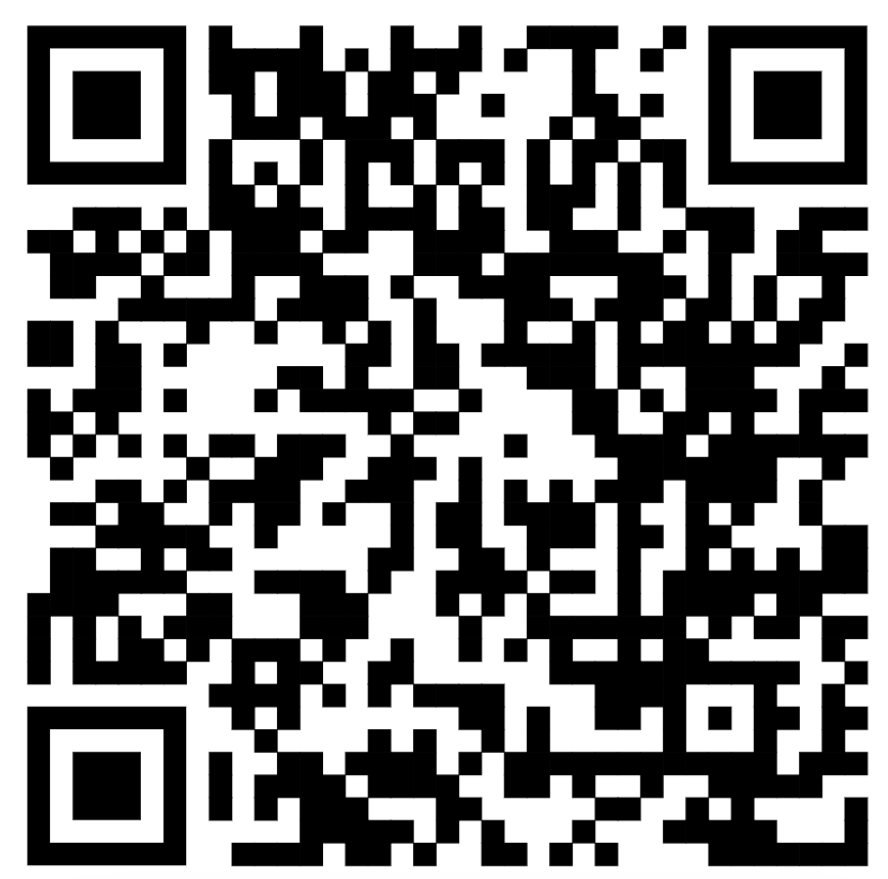 | Carbon Leakage  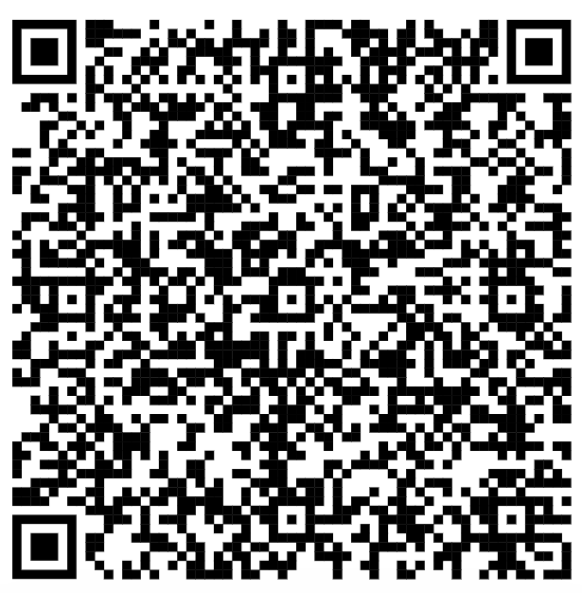
Source: Dansk Industri | Source: Energiewende


Outline Of Other Debate Players
Polish 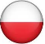  Government | EuroSteel  | Climate Defence Network Europe | Turkish   Government
EU member state. You fear that CBAM will raise prices and damage economy and trade. | A multinational company You want support for innovation rather than financial and administrative burdens. | A civic society organisation. You think CBAM is vital to ensure climate action and raising standards in and outside the EU. |  | A trading country with the EU. You think CBAM punishes developing economies unfairly.

Role Sheet: Polish Government
You represent the Polish Government in this debate.
You criticise the Carbon Border Adjustment Mechanism (CBAM). While you agree with the EU’s climate goals, CBAM is not the right tool to achieve them. Extending CBAM will increase production costs for companies & prices for consumers. Many of your industries (steel, cement, & energy) depend heavily on coal and are already under pressure from high EU climate costs. You think that putting extra EU charges on imports will see trading partners retaliate with tariffs on European exports, risking economy and jobs.

Position Prompts
In this debate, you (as the Polish Government) want:
- Affordable energy and products.
- Hint: You want to save citizens & industries from higher prices that CBAM could cause.
- Fair treatment for member states.
- Hint: Countries like Poland, rely more on coal and are still catching up economically. You should not face the same onerous climate financial burdens as richer EU member states.
- Strong EU trade relations.
- Hint: You want to avoid conflicts with trading partners from outside the EU. Tariff retaliation on trade could cost jobs and harm your economy.

Further Information (titles hyperlinked or use QR codes) 
Carbon Border Adjustment Mechanism | Poland & CBAM | CBAM Issues
 | 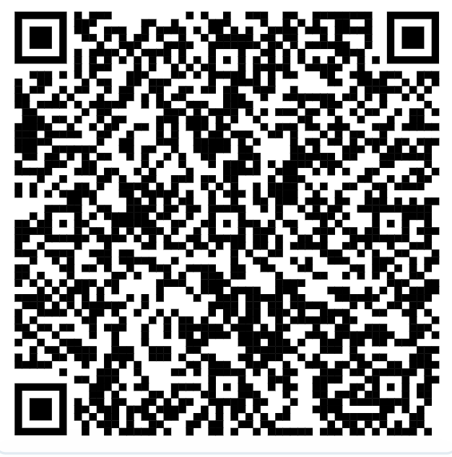 | 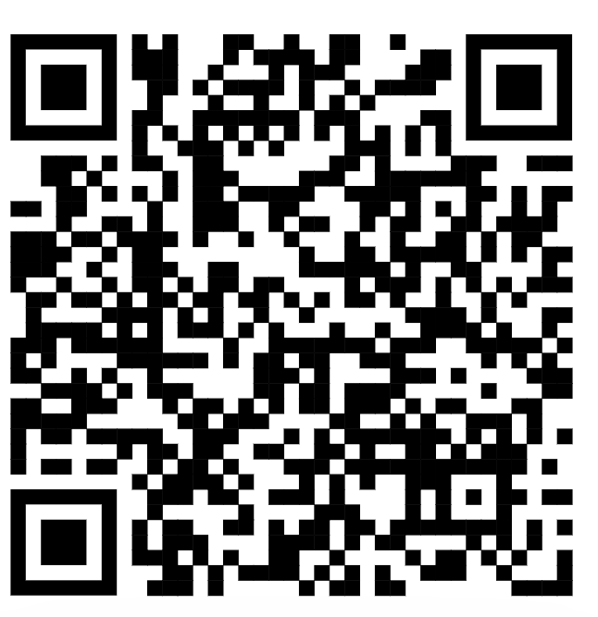
Source: Dansk Industri | Source: Euractive | Source: Orgalim

Outline Of Other Debate Players
German Government | EuroSteel | Climate Defence Network Europe | Turkish  Government
EU member state. You support the expansion of CBAM for climate action without damaging competition. | A multinational company You want support for innovation rather than financial and administrative burdens. | A civic society organisation. You think CBAM is vital to ensure climate action and raising standards in and outside the EU. |  | A trading country with the EU. You think CBAM punishes developing economies unfairly.

Role Sheet: EuroSteel
You represent EuroSteel in this debate.
As a large company, you appreciated the need to fight climate change. You’re very concerned about how the Carbon Border Adjustment Mechanism (CBAM) is designed. You want predictable & fair rules. If it is too strict or complicated, it will hurt European companies. You fear that extra financial or administrative costs, through CBAM, will make it harder to sell steel in Europe and beyond. You want support measures and longer transitional periods so that you can invest in low-carbon technologies without risking economic stability.

Position Prompts
In this debate, you (as the EuroSteel) want:
- Fair competition globally.
- Hint: You want to make sure that steel produced in the EU can compete with imported steel from countries with weaker climate rules, without losing its market share.
- Predictable and practical rules.
- Hint: CBAM should not be overly complicated or bureaucratic. You need to focus on reducing emissions instead of struggling with administration and paperwork.
- Support for decarbonization.
- Hint: You want policies that help you to invest in cleaner technologies while keeping jobs and production in Europe stable.

Further Information (titles hyperlinked or use QR codes) 
Carbon Border Adjustment Mechanism | CBAM Bureaucracy | CBAM Issues
 | 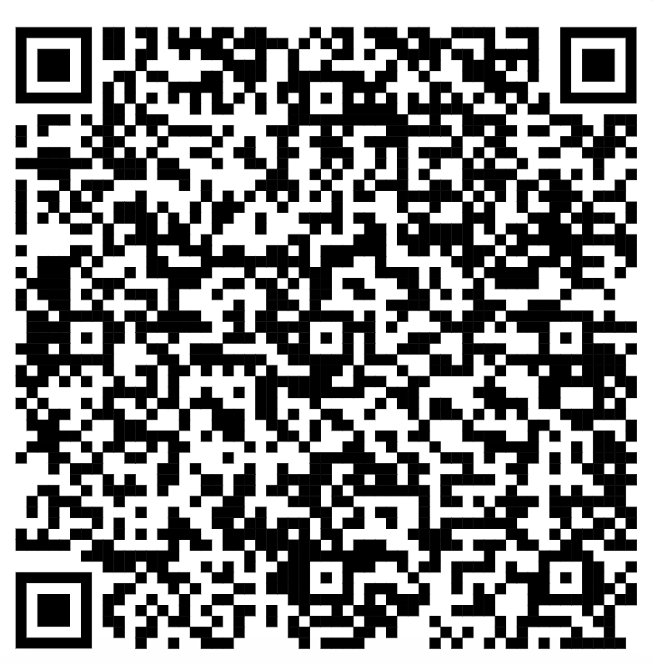
Source: Dansk Industri | Source: NOERR | Source: Orgalim

Outline Of Other Debate Players
German Government | Polish  Government | Climate Defence Network Europe | Turkish  Government
EU member state. You support the expansion of CBAM for climate action without damaging competition. | EU member state. You fear that CBAM will raise prices and damage economy and trade. | A civic society organisation. You think CBAM is vital to ensure climate action and raising standards in and outside the EU. |  | A trading country with the EU. You think CBAM punishes developing economies unfairly.

Role Sheet: Climate Defence Network Europe
You represent the Climate Defence Network Europe in this debate.
You fully support the Carbon Border Adjustment Mechanism (CBAM). It’s an important instrument to make sure that companies take responsibility for their carbon emissions. CBAM ensures that everyone pays for the carbon they produce, so competition is based on efficiency and innovation. It decreases the risk of carbon leakage and ensures that EU and non-EU producers face the same climate costs. CBAM encourages other countries to strengthen their climate policies.

Position Prompts
In this debate, you (as Climate Defence Network Europe) want:
- Strong climate protection.
- Hint: CBAM will significantly reduce global CO₂ emissions, it’s not just about protecting European companies.
- Fairness for everyone.
- Hint: All companies, inside and outside the EU, should pay the same price for the carbon they produce, so that no one benefits from polluting more.
- Global climate leadership.
- Hint: The EU should lead by example and encourage other countries to adopt stricter climate policies, making climate action a shared global responsibility.

Further Information (titles hyperlinked or use QR codes) 
Carbon Border Adjustment Mechanism | Need for CBAM | CBAM Impact
 | 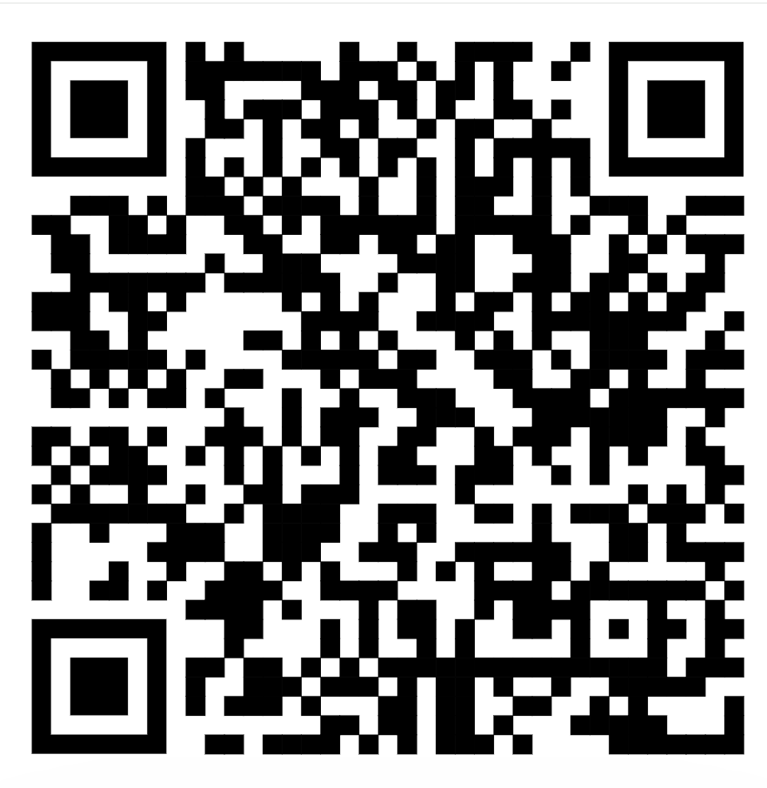 | 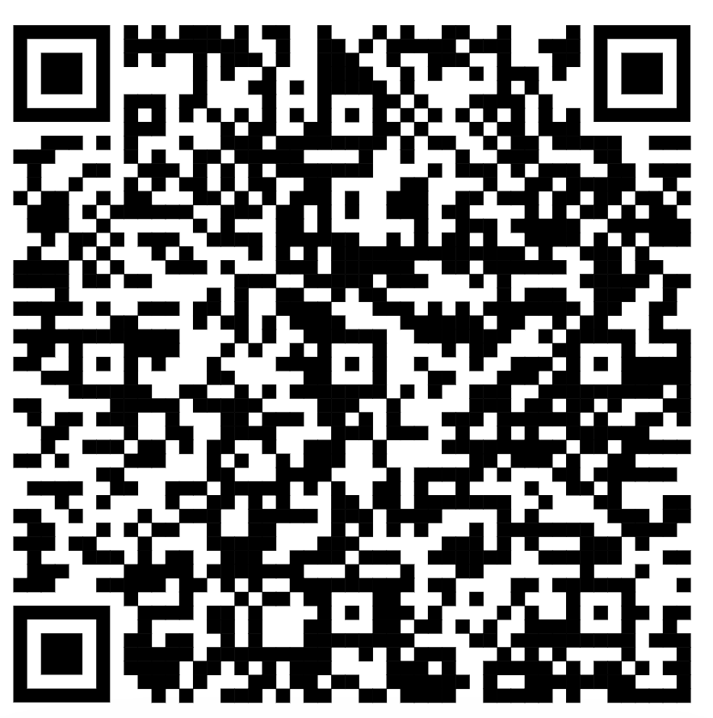
Source: Dansk Industri | Source: Climate Market Watch | Source: Wood Mackenzie

Outline Of Other Debate Players
German Government | Polish  Government | EuroSteel | Turkish  Government
EU member state. You support the expansion of CBAM for climate action without damaging competition. | EU member state. You fear that CBAM will raise prices and damage economy and trade. | A multinational company You want support for innovation rather than financial and administrative burdens. |  | A trading country with the EU. You think CBAM punishes developing economies unfairly.

Role Sheet: Turkish Government
You represent the Turkish Government in this debate.
You have a strong trading relationship with the EU, especially in steel, cement, and aluminium. You fear that the Carbon Border Adjustment Mechanism (CBAM) will make your exports to the EU more expensive. Many Turkish companies depend on fossil fuel energy, making it harder to compete with European producers who have been investing in cleaner technologies for years. CBAM is unfair and protectionist. Wealthy EU regions have benefited from polluting for decades and are now shifting the costs of the green transition onto developing economies.

Position Prompts
In this debate, you (as the Turkish Government) want:
- EU support to reduce emissions rather than punishment.
- Hint: The EU should finance technological change to help the transition to cleaner production. Climate change is a global problem, it needs cooperation, not punishment.
- Strong trade to support change in traditional industries.
- Hint: You want protection against the risk of job losses and reduced competitiveness in key industries like steel, cement, and aluminium.
- Richer European member states to act fairly.
- Hint: CBAM should not undermine fair trade or harm relations with developing & emerging economies. Truly fair climate policy should be based on partnership & shared responsibility. Give countries outside the EU a chance to transition.

Further Information (titles hyperlinked or use QR codes) 
Carbon Border Adjustment Mechanism | CBAM Issues
Source: Dansk Industri | Source: Orgalim

Outline Of Other Debate Players
German Government | Polish  Government | EuroSteel |  | Climate Defence  Network Europe
EU member state. You support the expansion of CBAM for climate action without damaging competition. | EU member state. You fear that CBAM will raise prices and damage economy and trade. | A multinational company You want support for innovation rather than financial and administrative burdens. | A civic society organisation. You think CBAM is vital to ensure climate action and raising standards in and outside the EU.

Carbon Border Adjustment Mechanism Factsheet
Explainer
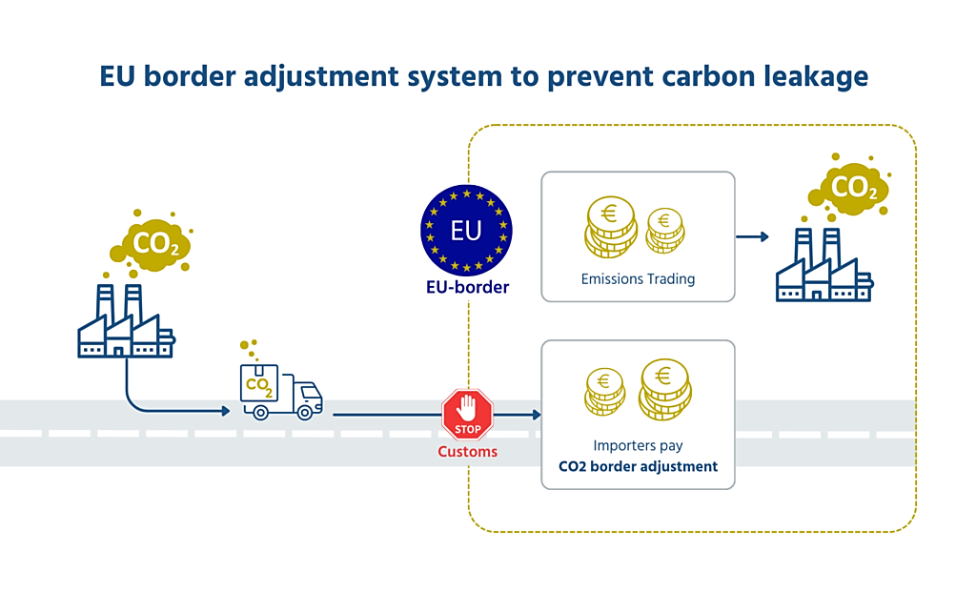
----------------------------------------------------------------------------------------------
Carbon Dioxide Emissions Per Country (2023)
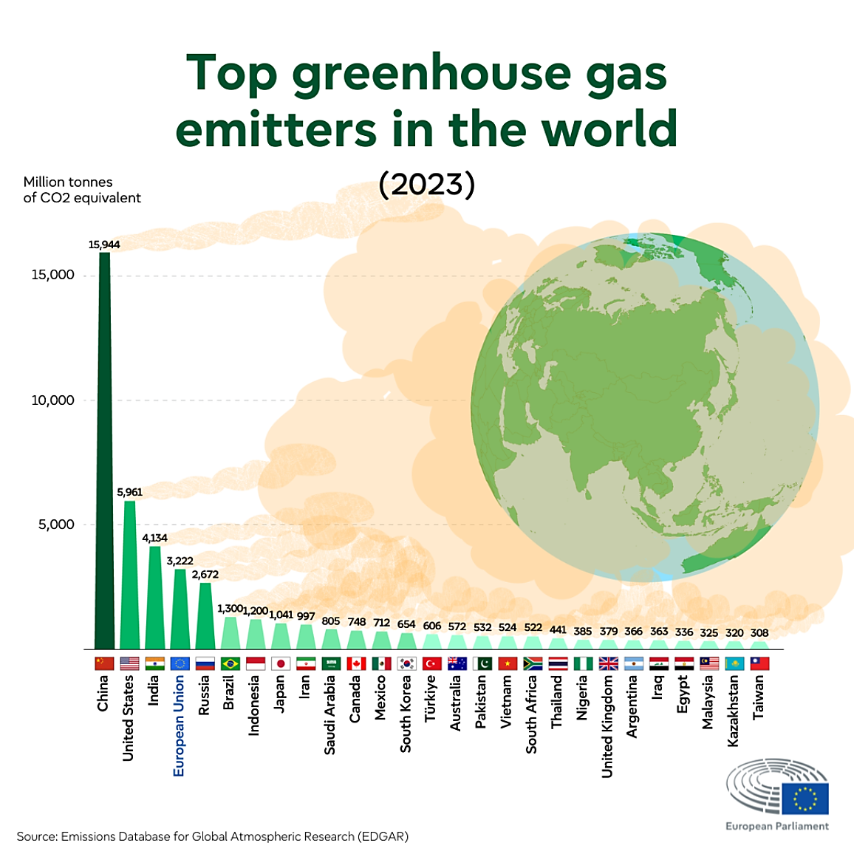
Source: Emissions Database for Global Atmospheric Research
Note: Measured in carbon dioxide million tonnes.
Carbon Dioxide Emissions from Energy Use in EU (2022)
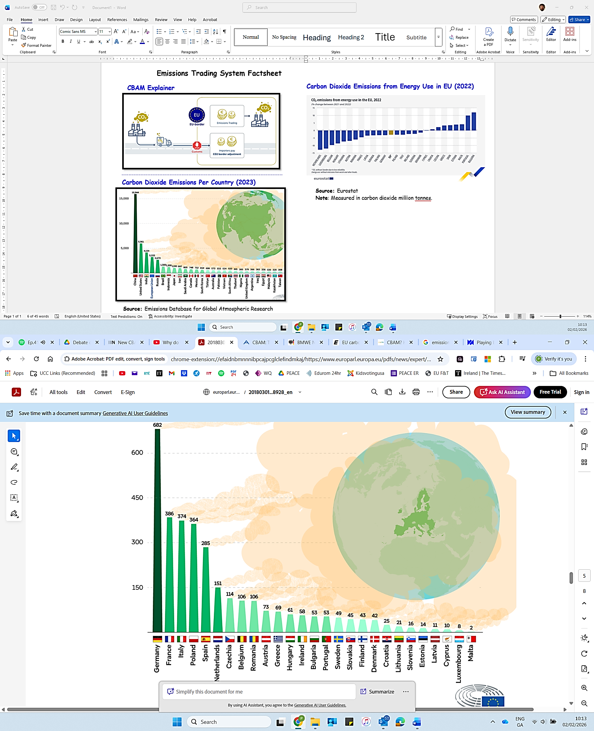
Source: Emissions Database for Global Atmospheric Research
Note: Measured in carbon dioxide million tons.

----------------------------------------------------------------------------------------------

Countries Reactions to CBAM (2024)
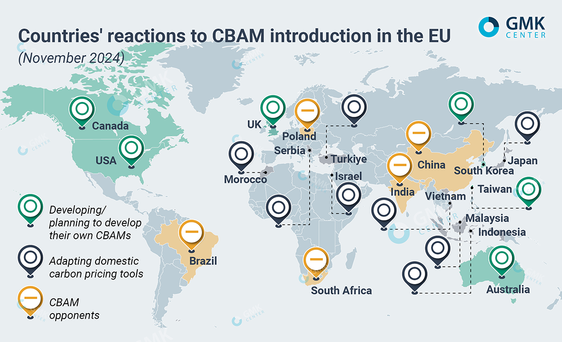
Source: GMK Center

