Debate Question:
“Is the European Union’s (EU) protection of biodiversity through its Nature Restoration Law acceptable?”
Introduction I: Biodiversity 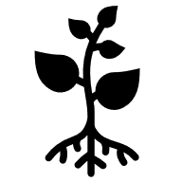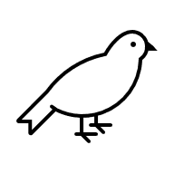
The EU is an important player in environmental policy. Laws agreed by member states (countries) at EU level shape human impacts on nature in Europe. Biodiversity refers to the variety of plants and animals in an area. The EU’s Biodiversity Strategy (2030) aims to protect nature and restore biodiversity.
The strategy aims to: 1) increase protected areas on land and sea, 2) create a nature restoration law, and 3) support biodiversity by funding schemes and monitoring progress. As part of the strategy, the Nature Restoration Regulation (law) was passed by EU institutions and member states in 2024. The law was hotly debated by civil society and interest groups, with much negotiation among member state governments, and Members of the European Parliament.

Introduction II: Nature Restoration Law 
The law contains targets for habitat and species restoration, with indicators to track progress in member states. The law aims for biodiversity improvements in:
- Wetlands, forests, grasslands, rivers and lakes, scrub, rock areas, and dunes
- The population of pollinating insects: e.g., grassland butterflies
- Forest ecosystems: e.g., bird populations and the stock of organic carbon
- Agricultural ecosystems: e.g., organic carbon in soil and high-diversity features
- Marine ecosystems: e.g., sediment bottoms and marine species habitats
- Urban ecosystems: e.g., green space and tree cover
Targets for the use of chemical pesticides, the management of forests and agricultural land, nitrate/phosphate levels in rivers and lakes, and marine species’ conservation are controversial. Civil society and sectoral interest groups think that the targets are either too weak to have positive impact or are too severe on agricultural activity. They disagree about the targets set, the extent to which they are binding, the time given to meet them, and the indicators used.
Each EU member state is preparing a Nature Restoration Plan on how it will meet targets. As they prepare these plans, it is time to consider; Are the targets in the EU’s Nature Restoration Law adequate? What are the potential effects on human activity and biodiversity? What measures (finance, time, or flexibility) are needed to ensure those affected can sustainably change behaviour?

Debate Instructions (for reading to students) 
We are going to debate the question: “Is the EU’s protection of biodiversity through its Nature Restoration Law acceptable?” The players in this debate are:
- the European Commission
- the Network for Environment, Wildlife, and Biodiversity in Europe (NEWBIE)
- the Organisation for Farming and Rural Community Survival (FORCS)
- the League of Organic and Agroecology Farmers (LOAF)
- the Polish Government
Your task is to prepare and represent the position of one of these debate players.

What do you have to do? (for reading to students) 
1. Use your Role sheet and Factsheet to prepare short points to support your position in the debate [10-15 mins on your own]
2. Then, work with others assigned to play the same role. Work on the phrasing and the examples/evidence to be used [10-15 mins with others given the same role]
3. Now, you’ll see floor markings (or chairs) marking positions in a debate circle. You and others given the same role rotate into position to speak in the debate. When you’re not in a speaking position, listen to the debate and prepare points to add information to the debate and to support your position [20 mins in debate circle]

Debate Prompts (optional aid for teachers) 
1. Are the targets in the EU’s Nature Restoration Law adequate?
- What are the targets of the NRL?
- What challenges are they supposed to address?
2. What are their potential effects on human activity?
- What human activities will they affect?
- Are those effects necessary or justifiable?
3. What measures and supports (finance, time, or flexibility) are needed to ensure that those affected can sustainably adjust their behaviour?
- What is required to ensure that those who need to change practices can and will do so?
- What are the risks involved in trying to reach the targets?
- What measures are needed to avoid those risks?

Role Sheet: European Commission
You represent the European Commission in this debate. 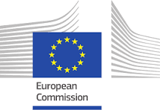
You initiate and monitor EU law. You believe the EU should be a world leader in protecting nature. With weather and climate-related extremes costing €162 bn in the EU between 2021 and 2023, you want to counter the threats of climate change, food insecurity and disease outbreaks through nature restoration.
35% of current EU budget spending is dedicated to reaching goals of the EU Green Deal, and nearly 10% is allocated to biodiversity objectives. Through policy proposals and financial supports, you guide member states and sectoral actors to meet the goals of the EU’s biodiversity strategy.

Position Prompts 
In this debate, you (as the European Commission) want:
- Member state Plans to meet the Nature Restoration Law targets for 2030.
  - Hint: Look at Protected Areas video in Further Information and Targets in Factsheet.
- Member states to implement agricultural reforms that enhance biodiversity and protect species under existing legislation on habitats.
- Hint: Look at the Habitats video in Further Information.
- Other players to realise the resources (finance, schemes, advice) and flexibility available to support biodiversity enhancing practices.
  - Hint: Look at the EU Budget Contribution to Green Deal in Factsheet

Further Information (titles hyperlinked or use QR codes) 
Protected Areas | Habitats
 | 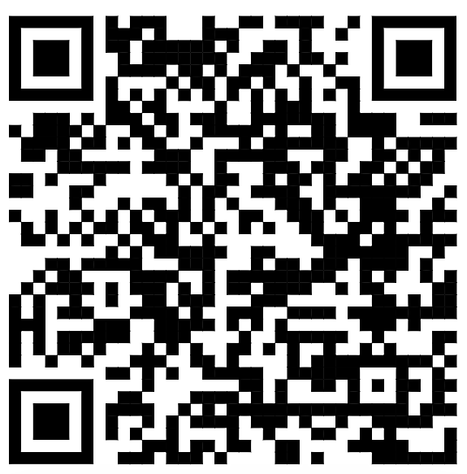
Source: EU Environment Dept | Source: EU Environment Dept

Outline of Other Debate Players
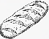  League of O & A Farmers  (LOAF) |   Network for EWB in Europe  (NEWBIE) |   Organisation for  F & RC Survival  (FORCS) | Polish 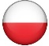  Government
Organisation of green-minded farmers. Wants farmers to embrace change, and the EU to support it. | Organisation of researchers and citizens. Wants stronger measures to restore biodiversity. | Organisation of agri-producers & agrarians. Warns that agriculture needs to be viable for nature restoration. | EU member state. Wants financial guarantees for agri. & forestry sectors. Wants more time to make & implement plan.

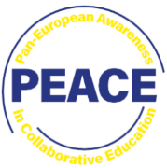
Role Sheet: Network for Environment, Wildlife, and Biodiversity in Europe
You represent the Network for Environment, Wildlife, and Biodiversity in Europe in this debate.
You want the EU and members to realise that restoring degraded ecosystems is not only a moral duty; it’s economically important. Human health, food security, & water supply depend on clean rivers and thriving pollinators. Healthy ecosystems fight climate change; healthy forests & agricultural land are emissions’ sponges.
You feel it’s crucial that EU institutions deliver a wake-up call to member states by setting effective targets which meet the current biodiversity challenge, and then ensure that they are enforced strongly.

Position Prompts
In this debate, you (as NEWBIE) want:
- The EU to set binding targets that match the scale of the problem rather than bend to the interests of agri-food producers.
- Hint: Look at Contested Interests and Biodiversity Fail videos in Further Information.
- EU institutions to punish laggard member states who dilute or delay action.
- Hint: Look at the Budget video in Further Information and Indicators in the Factsheet.

Further Information (titles hyperlinked or use QR codes) 
Contested Interests | Biodiversity Fail |  | Budget
 |  |  | 
Source: DW News |  | Source: Euronews | Source: @newscvg

Outline of Other Debate Players
EU  Commission | Organisation for  F & RC Survival  (FORCS) | League of O & A Farmers  (LOAF) | Polish  Government
EU institution. Encourages practices that protect nature through policy proposals and financial supports. | Organisation of agri-producers & agrarians. Warns that agriculture needs to be viable for nature restoration. | Organisation of green-minded farmers. Wants farmers to embrace change, and the EU to support it. | EU member state. Wants financial guarantees for agri. & forestry sectors. Wants more time to make & implement plan.

Role Sheet: Organisation for Farming and Rural Community Survival
You represent the Organisation for Farming and Rural Community Survival in this debate.
You think green over-regulation must be curbed. Family farms & rural economies are being regulated out of business by unrealistic targets. This has been driven by anti-farming groups rather than the practicalities of food supply. Nature restoration must include sustaining living for those carrying out the most change.
You argue that the biodiversity crisis is experienced first-hand by farmers & rural communities who are primary keepers of land and rivers and know impacts.

is politically reactive to the meat production and processing sectors. It emphasises the importance of livestock production for trade, exports, and contribution to the income of rural communities. It is considering a ‘temperature neutrality’ rather than ‘net zero approach to the 2050 emissions targets. The Irish Government argues that facilitating dairy and meat production, in places like Ireland, where the climate is conducive to pasture-based production is better for resource efficiency, animal welfare, and food security.

Position Prompts
In this debate, you (as FORCS) want:
- Flexibility in targets and timelines to recognise the local geographic and economic contexts of agri-food producers.
- Hint: Look at the EU Protests video in Further Information.
- Farm incomes & rural economies protected for sustainable nature restoration.
- Hint: Look at Derogation video in Further Information and Outputs in the Factsheet.
- The higher environmental standards of EU farming output to be recognised in the trade deal between the EU and South American countries (Mercosur).
- Hint: Look at Mercosur video in Further Information and EU Livestock in the Factsheet.

Further Information (titles hyperlinked or use QR codes) 
EU Protests | Derogation |  | Mercosur
 |  |  | 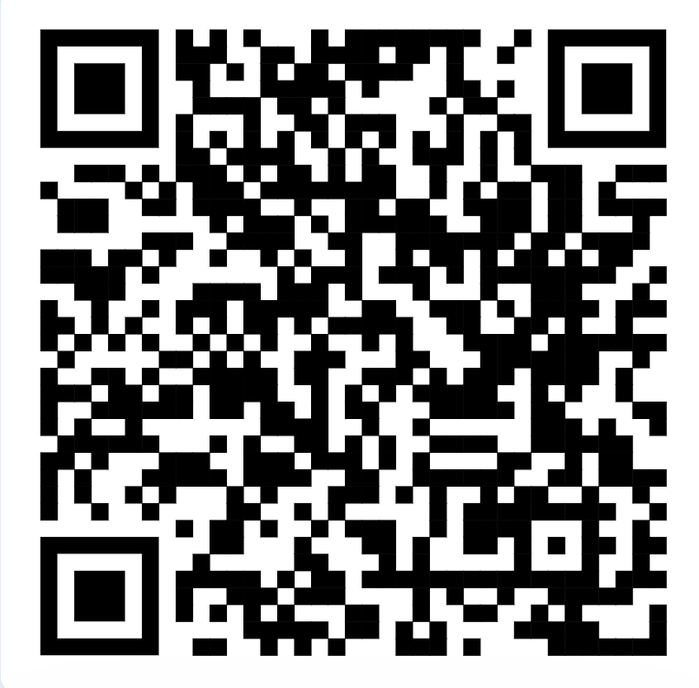
Source: DW News |  | Source: Agriland | Source: WION

Outline of Other Debate Players
EU  Commission | Network for EWB in Europe  (NEWBIE) | League of O & A Farmers  (LOAF) | Polish  Government
EU institution. Encourages practices that protect nature through policy proposals and financial supports. | Organisation of researchers and citizens. Wants stronger measures to restore biodiversity. | Organisation of green-minded farmers. Wants farmers to embrace change, and the EU to support it. | EU member state. Wants financial guarantees for agri. & forestry sectors. Wants more time to make & implement plan.

Role Sheet: League of Organic and Agroecology Farmers

You represent the League of Organic and Agroecology Farmers in this debate. 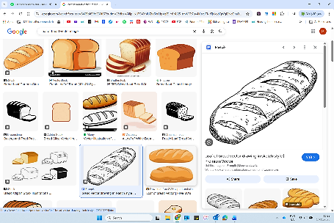
You are concerned by the threat of climate change and biodiversity loss. Europe, as the fastest-warming continent, faces unprecedented impacts from intertwined nature and climate crises. Drought, flooding, & disease all impact agri-producers.
Farming for nature is a good investment for the farmer, with enhanced production & animal health, reduced costs & pest outbreaks. You want farming centred on the husbandry of nature; farmers as key players restoring soils, plants & species.

Position Prompts
In this debate, you (as LOAF) want:
- The EU to support farmers to restore nature by incentivising agroecological schemes, soil restoration and rewilding. Metrics of nature restoration included when calculating EU farm-support payments
- Hint: Look at Nature Farming video in Further Information and Output in the Factsheet.
- The EU to support and incentivise spin-off economic opportunities in social farming and eco-farming.
- Farmers and the EU to invest in research, innovation, and networks for organic and agroecological practices such as multispecies swards and cropping.
- Hint: Look at Funding Biodiversity video in Further Information and Budget Contribution to Green Deal and Area Under Organic Farming in the Factsheet.

Further Information (titles hyperlinked or use QR codes) 
Nature Farming | Funding Biodiversity
 | 
Source: Farming for Nature | Source: Farming for Nature

Outline of Other Debate Players
EU  Commission | Network for EWB in Europe  (NEWBIE) | Organisation for  F & RC Survival  (FORCS) | Polish 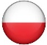  Government
EU institution. Encourages practices that protect nature through policy proposals and financial supports. | Organisation of researchers and citizens. Wants stronger measures to restore biodiversity. | Organisation of agri-producers & agrarians. Warns that agriculture needs to be viable for nature restoration. | EU member state. Wants financial guarantees for agri. & forestry sectors. Wants more time to make & implement plan.

Role Sheet: Polish Government
You represent the Polish Government in this debate. 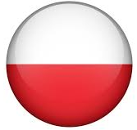
You are concerned that the Restoration Law creates obligations and burdens on farming and forestry sectors without guarantees of compensatory finance. Agricultural is a very important part of your rural economy and community, with a strong farming interest group. Your wood-processing sector is one of the biggest in Europe. At a time when defence and economic stability are important, due to the Russian government’s expansive threats, you want stronger guarantees of funding and more time to adjust.

Position Prompts
In this debate, you (as the Polish Government) want:
- Stronger guarantees on the finance available to farming and forestry sectors in return for obligations to change practice.
- Hint: See Poland Reaction video in Further Information.
- More time to prepare and implement a Nature Restoration plan.
- Hint: See Farmer Protest video in Further Information.
- Land rewetting in Poland’s defensive East Shield project to be included in nature restoration targets and funding.
- Hint: See Poland Reaction video in Further Information.

Further Information (titles hyperlinked or use QR codes) 
Farmer Protest | Poland Reaction (see 30mins-35mins)
 | 
Source: TVP World | Source: TVP World

Outline of Other Debate Players
EU  Commission | Network for EWB in Europe  (NEWBIE) | Org for F & RC  Survival (FORCS) | League of O & A Farmers  (LOAF)
EU institution. Encourages practices that protect nature through policy proposals and financial supports. | Organisation of researchers and citizens. Wants stronger measures to restore biodiversity. | Organisation of agri-producers & agrarians. Warns that agriculture needs to be viable for nature restoration. | Organisation of green-minded farmers. Wants farmers to embrace change, and the EU to support it. Wants more time to make & implement plan.

Biodiversity Debate Factsheets
EU Nature Restoration Regulation Targets (2024)
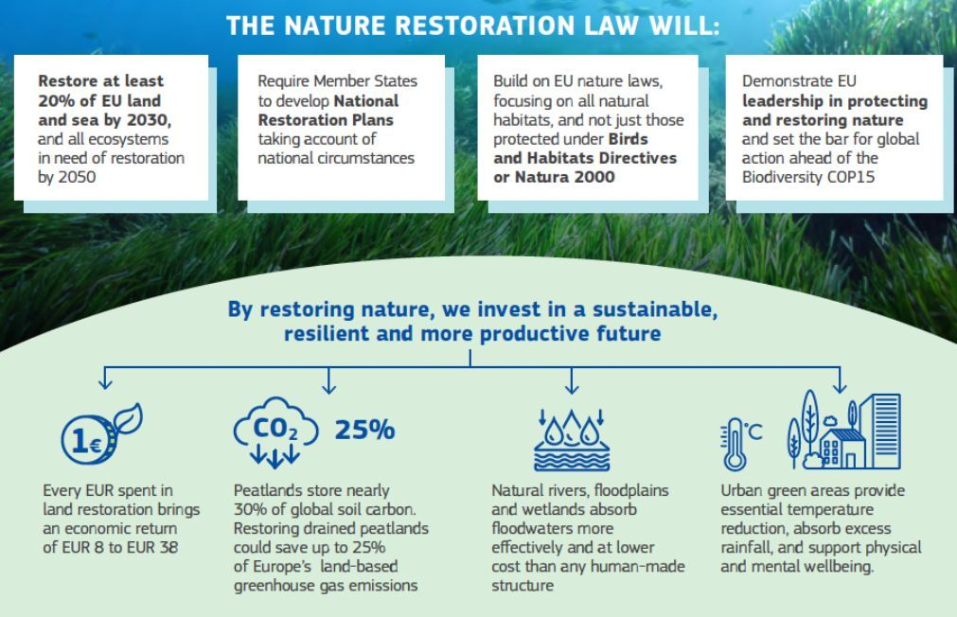
Source: Institute for Sustainable Development (2025)
------------------------------------------------------------------------------------------------------
EU Common Bird Population by Type of Species 1990-2023
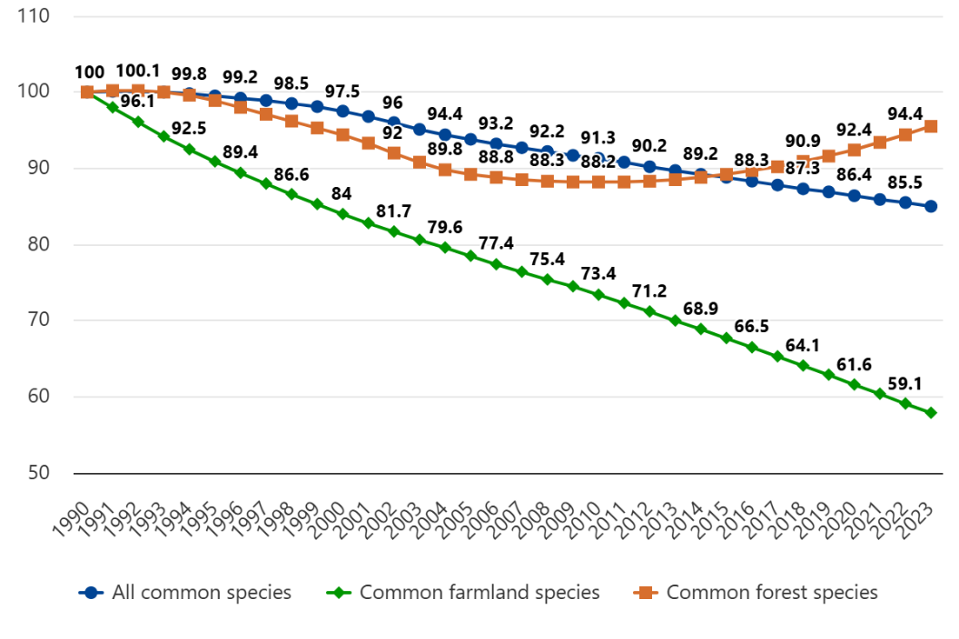
Source: Eurostat (2025) | Note: % with 1990 population as base
Status of Species under EU Assessment (2013-2018)
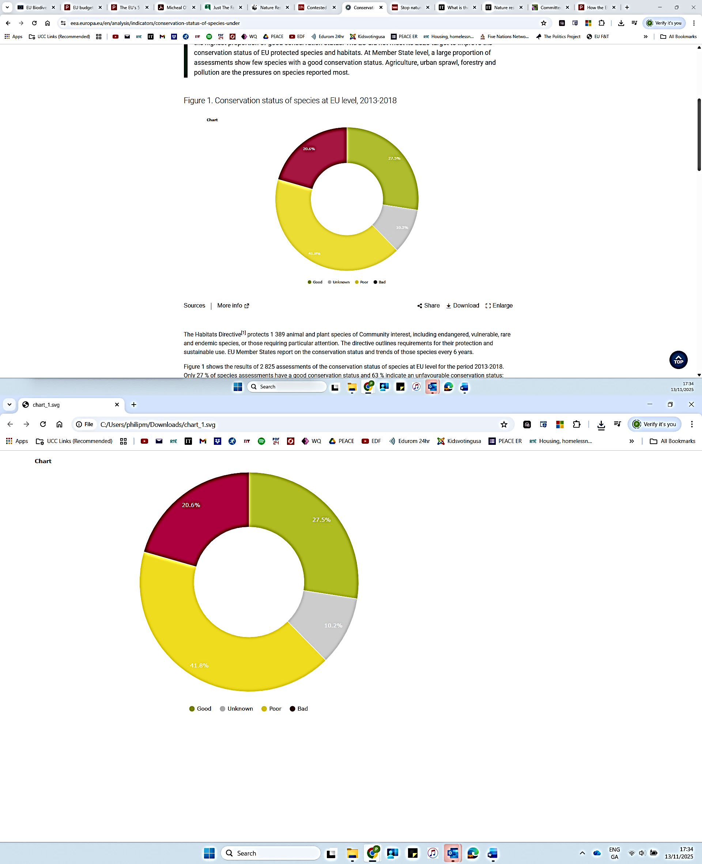

Source: European Environmental Agency (2021)
Note: % of assessment outcomes
-----------------------------------------------------------------------------------------
EU Grassland Butterfly Population 1991-2023
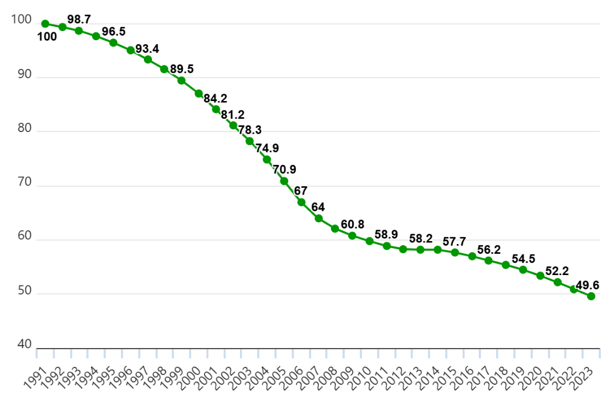
Source: Eurostat (2025) | Note: % with 1991 population as base
Agricultural Area under High-Diversity Features (2024)
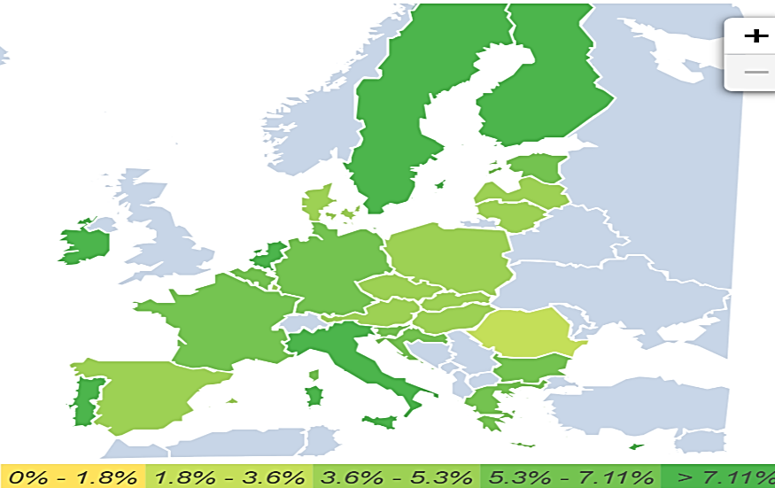
EU27: 5.6%
Source: Joint Research Centre (2025)
Note: per EU member state (2020)
-----------------------------------------------------------------------------------------------

Agricultural Area under Organic Farming
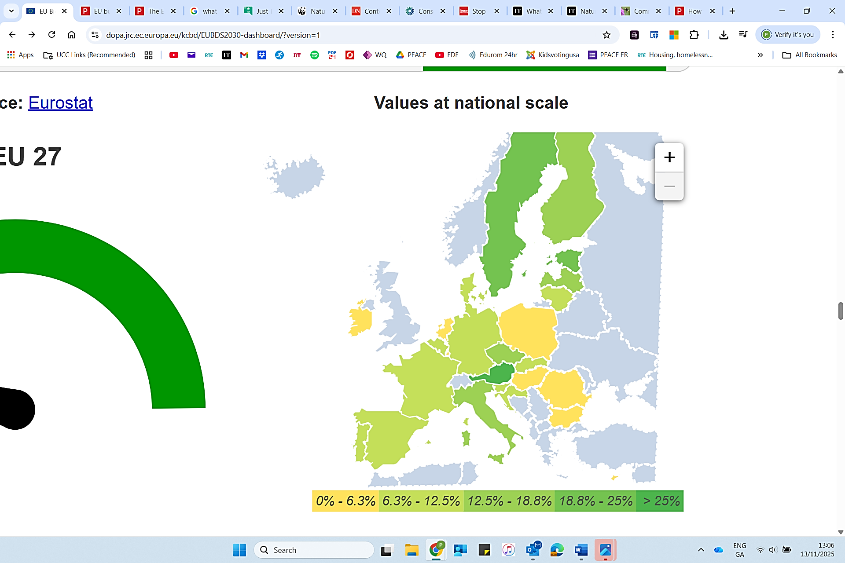
EU27: 9.1%
Source: Eurostat (2025) |Note: % per EU member state
Trees Planted as part of 3 Billion Trees Pledge
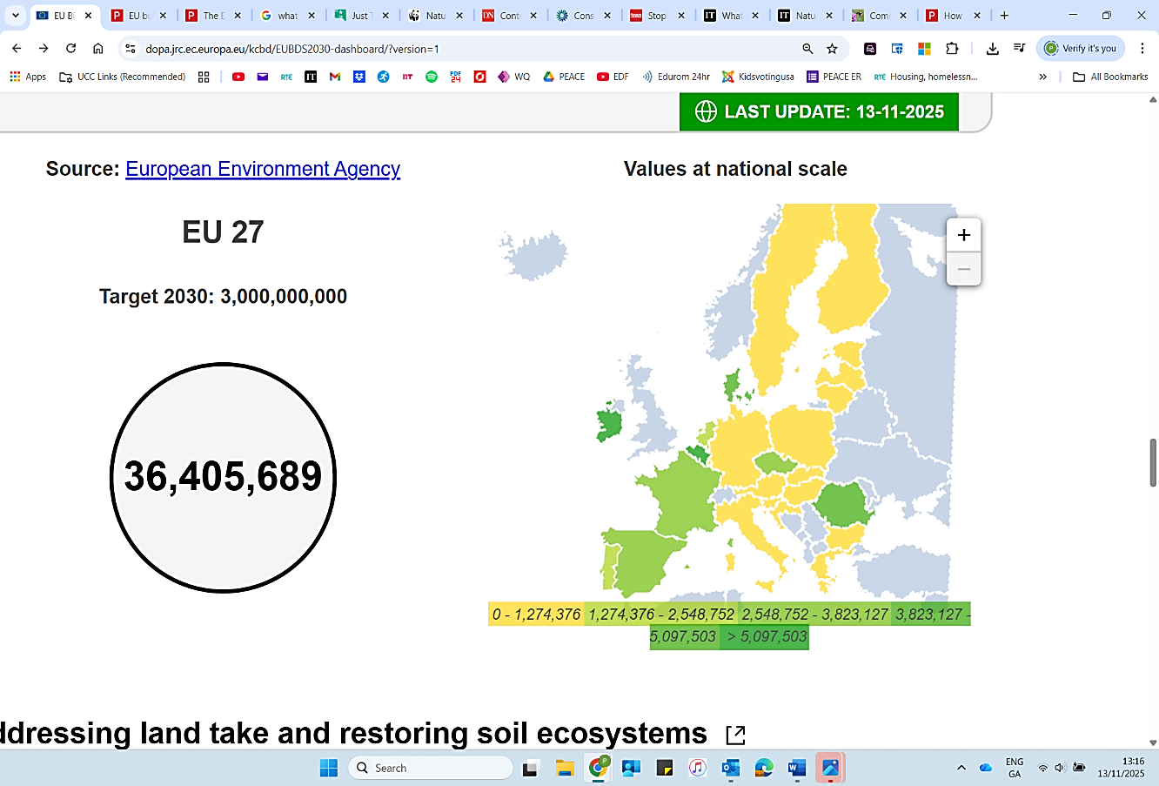
Source: European Environmental Agency (2025)
Note: Per EU Member State
----------------------------------------------------------------------------------------------

Change in Nitrate Levels in Groundwater (2023)
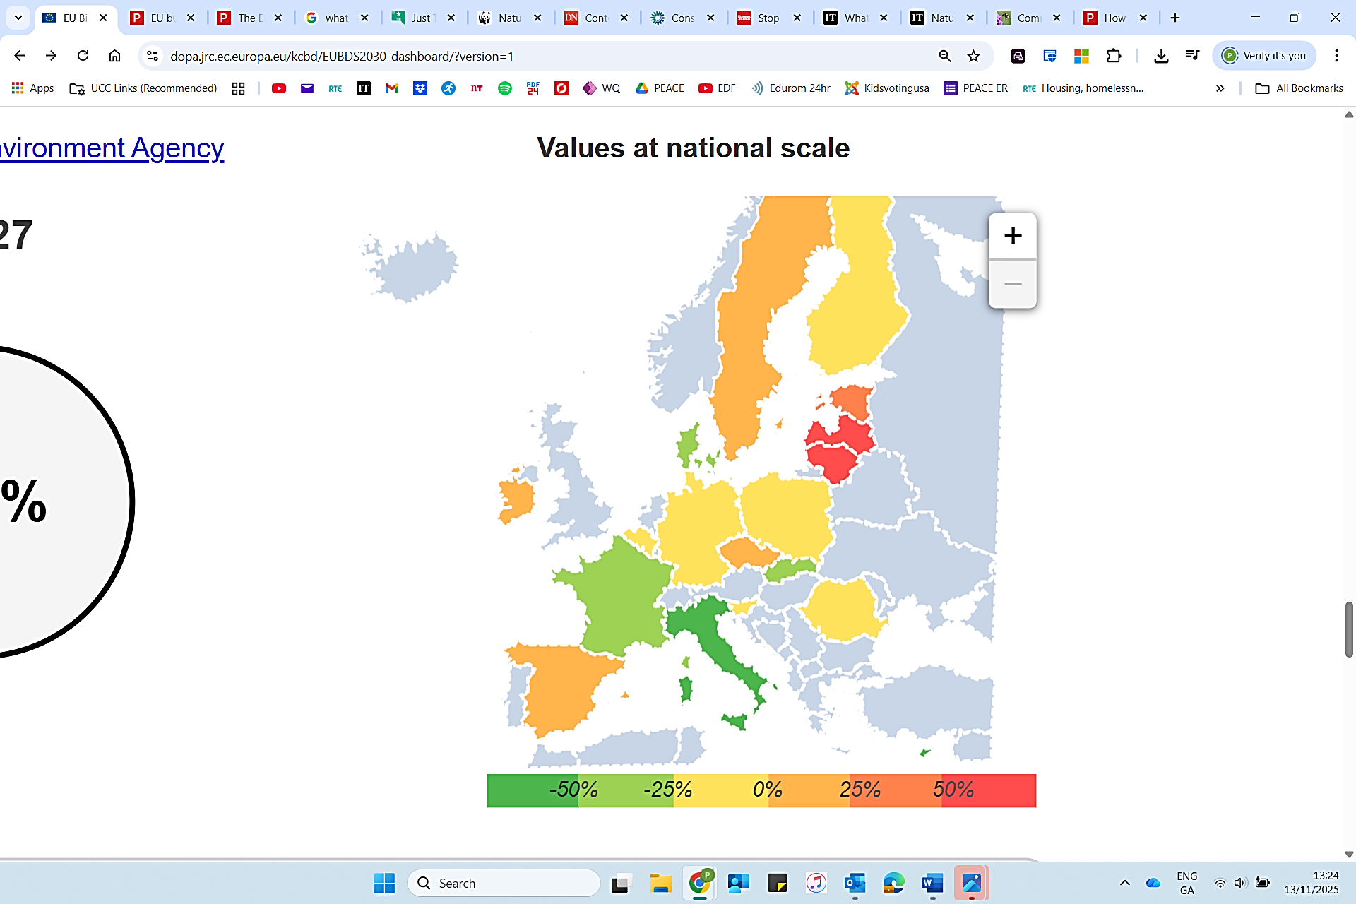
EU27: -8.7%

Source: European Environmental Agency (2024)
Note: % per EU member state, compared to year 2000
EU Agricultural Output (2024)
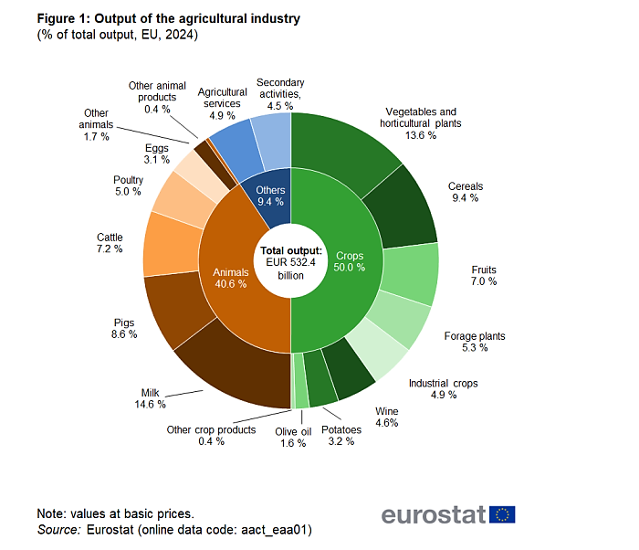
Source: Eurostat (2025) | Note: % per sector

-------------------------------------------------------------------------------------------------

EU Livestock Population Trend 2010-2021
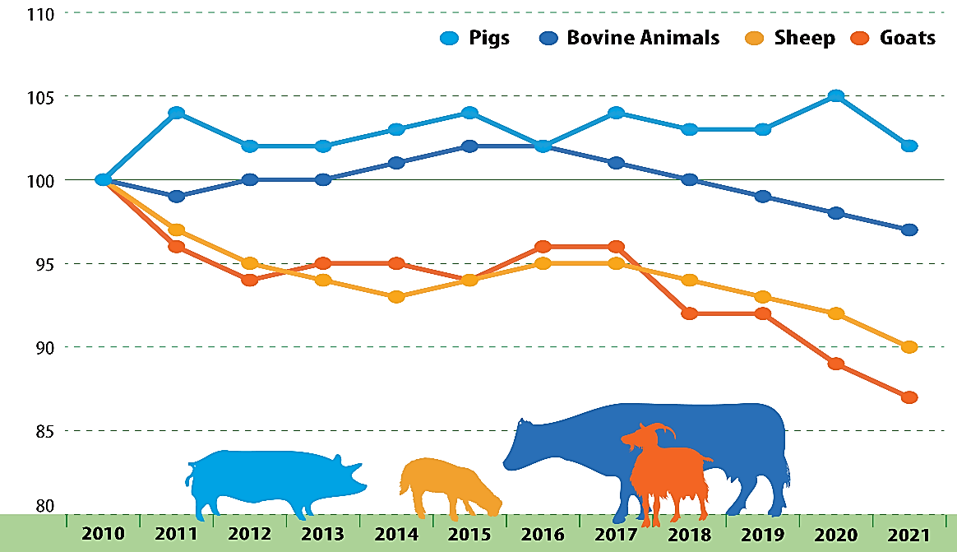
Source: Eurostat (2025) |Note: % with 2010 as base

EU Budget Contribution to Green Deal (2021-2027)
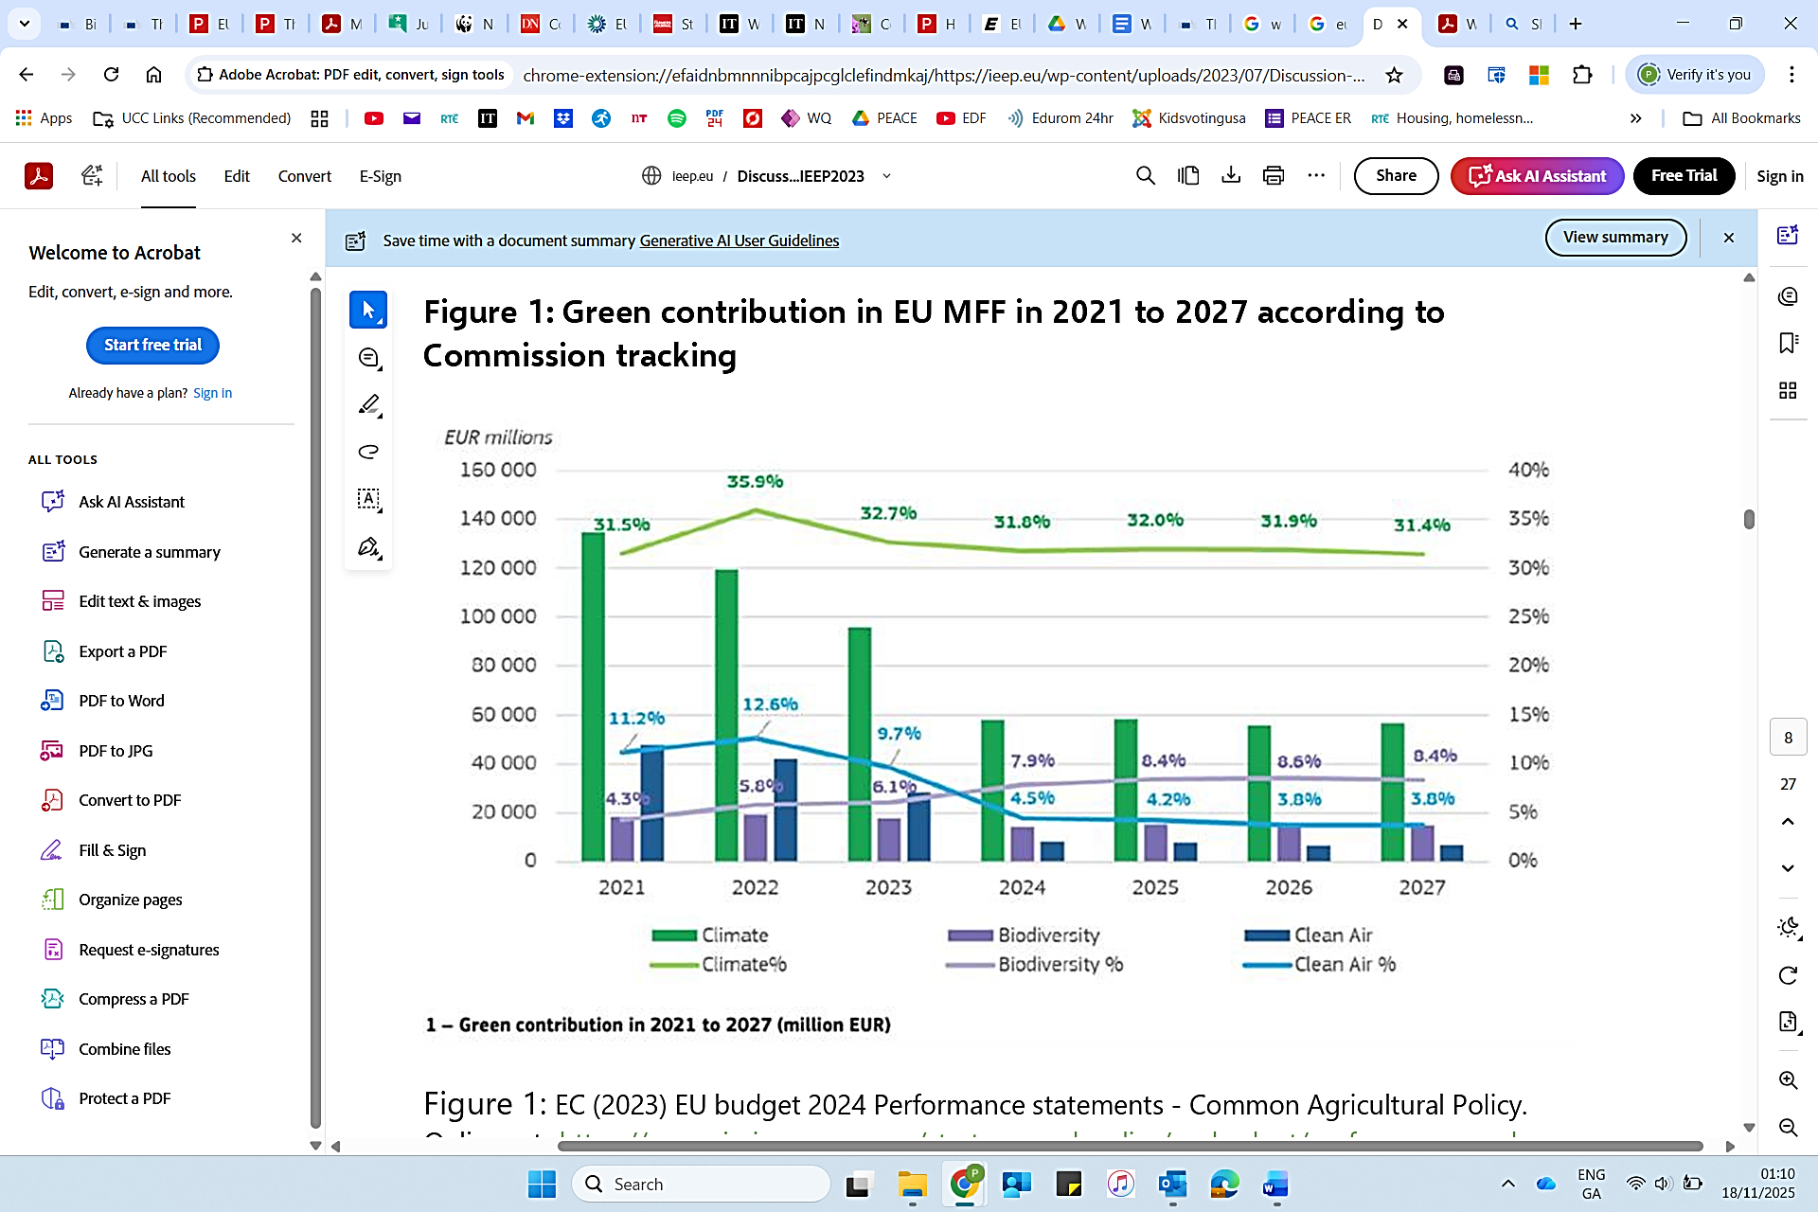
Source: Institution for European Environmental Policy (2023)
Note: % per sector, in € millions

