Ireland in the EU – 50 years on (1973-2023)
Dr Emmanuelle Schön-Quinlivan
Jean Monnet Chair in Active European Citizenship, UCC

When Taoiseach Jack Lynch and Foreign Affairs Minister Patrick Hillery TD signed Ireland’s accession to the European Communities, they probably did not foresee the incredible trajectory this membership would generate for a small, poor, rather self-sufficient country. Whether from an economic, social, cultural, or political point of view, the membership of the European Economic Communities transformed Ireland. In 50 years, Ireland has become a net contributor to the European budget, an example of the level of economic growth and prosperity European funding can generate, and an esteemed partner in negotiations at the European table. How did this happen?
In January 1972, becoming a member of the European Communities (EC) was done with optimism and hope. The picture of Ireland in the 1970s was very different from that of 2023. Ireland had a population of 2.9 million According to the CSO, life expectancy for men was under 70 and for women under 73. Irish per capita income was 64% that of the European Communities average. 55% of Irish exports went to the UK. This was the first enlargement of the club since its creation. Despite some regions of existing member states being poor, Ireland was the first wholly poor state to join. The EC acknowledged in the accession treaty Ireland’s economic under-development and over the years, Ireland has been instrumental in developing Cohesion Funds to bring up the standard of living in poorer member states.
In May 1972, the accession referendum campaign was dominated by the Yes led by the Fianna Fáil government. Fine Gael and some influential interest groups such as the Irish Farmers’ Association supported a commitment to freedom of movement of goods, services, capital, and people. On the opposite side of the argument, Labour, Sinn Fein, and some trade unions were worried for the survival of industries in an open competitive market and campaigned for the ‘No’. The fishing industry in particular was opposed to joining the EC. Until the early 1970s, fisheries were included in the Common Agricultural Policy. However, a specific Common Fisheries Policy (CFP) was pieced together just before the first enlargement in 1972. The original 6 member states (France, Germany, Italy, Belgium, Netherlands, and Luxembourg) had limited fishing waters and the potential new states (Ireland, UK, Denmark) had rich fishing waters. At the heart of the CFP, signed off on the eve of the first enlargement, was among other things the equal access provision – all member states could fish in the fishing waters of the other member states. During Ireland’s accession talks, this was the most problematic issue with fears of overfishing of coastal areas and the death of local fishing communities (something Minister Patrick Hillery, as chief accession negotiator was acutely aware of as a TD of Clare). Ireland got certain transition arrangements for 10 years such as Community fishermen could only go a certain distance inside Irish waters. This arrangement was corrected later on but it explains the fishing community’s resistance and also echoes the heightened sensitivity of fishery issues during the Brexit negotiations.
In contrast, the farming community could see the benefits of membership through increased prices via the Common Agricultural Policy and access to a common market. Overall, the electorate believed in the potential of access to other European markets for industrial and economic growth as well as job creation. As a result, on 10 May 1972, with a 70.88% level of participation, 83.1% of Irish voters resolutely committed to entering the EC. At a time of strong party loyalties, this positive result came as no surprise since the two major Irish political parties supported a ‘Yes’ vote. This led to the first constitutional amendment approved by Irish voters via referendum.
Economically, by 1 January 1993, the common market transformed into a Single Market with the removal of technical, legal and bureaucratic barriers to freedom of movement and trade. In 1972 the Irish economy was largely agriculturally based and highly reliant on exports to the UK. EU membership granted farmers access to the more profitable Single Market and helped Ireland develop a more diverse, knowledge-based economy with industries like pharmaceuticals, computer hardware and software and financial services contributing to strong GDP growth. The benefits of the Single Market to Ireland are estimated to be in excess of €30 billion annually, with access to 26 markets and 430 million people.
Beyond the economic benefits that Ireland could anticipate from joining the EEC, social, political and cultural benefits ensued. From a social point of view, in 1973 Irish women were discriminated against significantly in the workplace. It was accepted practice that men were paid more for undertaking the same task. ‘Equal pay for equal work’ came slowly to 1970s Ireland. There was also a marriage bar in place whereby women in public service jobs had to resign upon marriage; a restriction which was removed as a direct consequence of EEC membership since this bar was in contradiction with European values and would have led Ireland to be taken to the European Court of Justice if it had not rescinded it. As Dr Nyhan Grey highlights (2023), ‘using the legal basis provided by treaties, member states including Ireland have adopted thirteen directives on gender equality since 1975. These directives have ensured, among other things, equal treatment concerning access to work, training, promotions and working conditions, as well as guaranteed rights to parental leave and the protection of pregnant workers and breastfeeding mothers.’

Politically, Ireland found itself in a tense situation with the outbreak of the Troubles in Northern Ireland in 1969. This was a concern for the founding six member states considering Ireland’s application. Issues of peace and cooperation became central. Just eight days after Ireland signed the Treaty of Accession to the European Communities ‘Bloody Sunday’ happened and made media headlines across the world. Key political actors such as John Hume perceived the neutral framework of the EU as a suitable context in which to foster interests and gain additional political and economic support. Throughout tumultuous times the European Parliament often provided this neutral political platform for Northern Ireland nationalists and unionists to meet. Through various iterations of European Cohesion policy, starting with the International Fund for Ireland and continuing from 1995 with the PEACE programmes, the European Parliament has also continuously supported the funding of peace, reconciliation, and economic cooperation and stability in Northern Ireland and the six bordering counties.

From a cultural point of view, Ireland has since medieval times engaged from a scholarly point of view with the rest of the continent of Europe. It had set up Irish Colleges in France, Belgium, or Italy. This connection to the continent continued after Ireland joined the European Union through the programme of third level exchanges called Erasmus. A former Irish Commissioner, Peter Sutherland, was one of the brains behind the Erasmus programme which has seen over 65,000 students and staff engage with other European education institutions. On 1 January 2022, the Irish language became a fully working language of the EU, placing it on an equal footing with the other 23 languages in which all official European documents are translated.
Even though the membership of the EEC and then the EU has brought undeniable benefits to Ireland, it was done at a cost such as a turbulent first decade when some manufacturing industries hit the ground, like Dunlop/Ford in Cork, because of the free movement of goods. Three challenges remain nowadays, regarding taxation, defence, and influence at EU level.
Ireland, along with all EU Member States, is free to choose its own tax systems but some co-ordination is necessary to ensure citizens and businesses fully benefit from the Single Market. Ireland’s corporate tax rate is amongst the lowest in Europe, and it can only be changed by the Irish Government. However, the global tax landscape is changing, and reforms are needed to address challenges arising from the digitalisation of the international economy. There is a multilateral approach through the OECD/G20 Inclusive Framework on Base Erosion and Profit Shifting in the pipeline which will help inform both Ireland’s and the European Union’s future approach to corporate tax.
From a defence point of view, the war in Ukraine has fostered further discussions on Ireland’s position on European Security and Defence Policy regarding participation in European Permanent Structured Cooperation (PESCO) projects, the triple lock on its neutrality, or the European Strategic Compass. In July 2022, Minister for Foreign Affairs and Minister for Defence, Simon Coveney TD welcomed the approval by the Dáil of his proposal for the Defence Forces to join four new European Permanent Structured Cooperation (PESCO) projects. Nonetheless defence and security issues remain sensitive in Ireland. It remains to be seen how the conversation on potential European strategic autonomy will progress with Irish people.
Finally, Ireland is facing a “demographic cliff” in its representation among the staff of the EU’s institutions, as many senior and long-serving Irish officials will retire over the coming years. While Ireland is adequately represented at present, and indeed Irish people have served in the institutions at the most senior levels in the past, Ireland is now significantly under-represented at entry and mid-management levels across the Institutions. It is strategically important that Irish people continue to shape EU policies at all levels. Irish officials working in the EU can help to shape and implement EU policies that work for Ireland. They know Ireland’s culture, its system, and its priorities. They are useful contact points for Irish government officials on EU matters and can give early warning to the Irish system on significant upcoming policy or legislative decisions that could have an impact on Ireland. Levels of Irish representation are projected to fall dramatically over the next decade.
At a domestic level, Eoin Drea (2023) has argued that, despite the highest levels of support for the European Union of all member states, Ireland has remained quite Anglo-American in its cultural and socio-economic development. It continued to be extremely reliant on the English-speaking world, having refused for several years to develop teaching of continental languages at primary level. It is only in 2021 that the Language Sampler Module was introduced and trialled in 100 schools. Furthermore, Irish students’ participation in the Erasmus programme, an EU-wide study abroad programme, has traditionally been among the lowest in the EU, largely due to a lack of linguistic skills. In 2023, for the first time, the demand has been extremely strong rising to 8,700 compared with 5,400 in 2020/2021. Overall, Irish students are still more tempted to get a J1 visa or take a gap year in Australia or New Zealand than to go for an internship in Warsaw or Madrid.
In conclusion
It is difficult to imagine an Ireland without the EU or indeed an EU without Ireland. We might paraphrase Seamus Heaney to describe the impact of the EU in Ireland as ‘a series of ripples widening out from an original center’. This membership has been significant in supporting social, political, and economic changes in Ireland. We nonetheless need to nurture it and make sure that we are happy with how it is developing. As President of the European Parliament Metsola said during her visit to Ireland in 2023: ‘Ireland is Europe and Europe is Ireland’. This involves maturing the debate beyond pro or anti-EU to shape the policies we want. Interdependence and solidarity are at the heart of the European Union. Let’s see how Ireland and the EU will shape each other in the next 50 years.
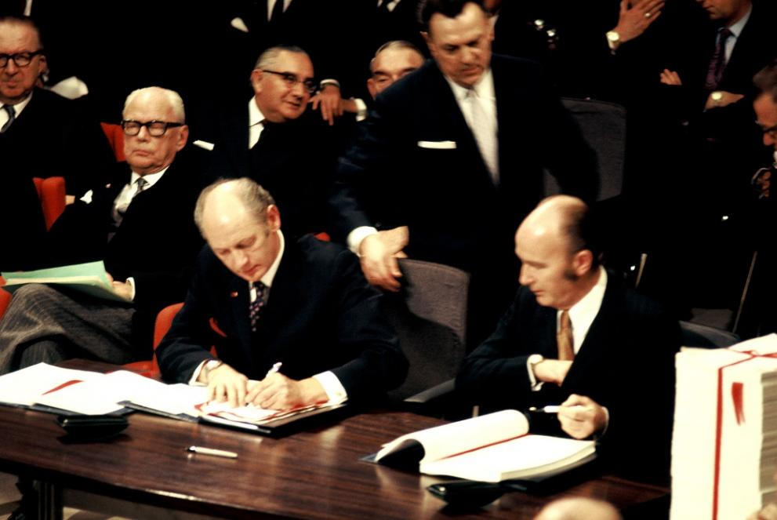
Singing of the Treaties of Rome, creating the EEC and Euratom, 25 March 1957 (European Commission Audiovisual Service).

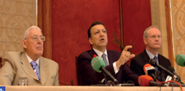

Sources:
Nyhan Grey, M. (2023) Into Europe: Ireland and the EU 1973-2023, Department of Foreign Affairs, National Archives, Royal Irish Academy.
Drea, E. (2023) ‘Time to end our wink and nod, buffet-style approach to European affairs’, Irish Times

