Conflict Resolution:  There is a conflict between two neighboring countries over resources. The EU has been asked to intervene and promote peaceful resolution. What policy will you implement?   | Refugee Crisis:  A neighboring country is facing a refugee crisis, and the EU has been asked to provide humanitarian aid and assistance.  What policy will you implement?  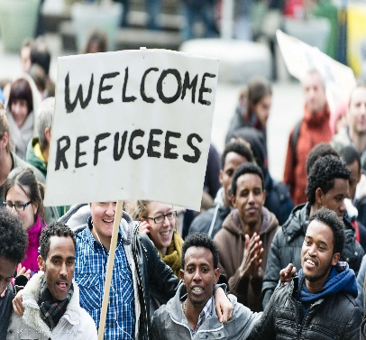 | Cybersecurity Threat:  A cyber-attack has taken place on a neighboring country, and the EU has been asked to help mitigate the threat.  What policy will you implement?  
Human Rights Violations:  A neighboring country has been accused of human rights violations, and the EU has been asked to take action to hold them accountable.  What policy will you implement?  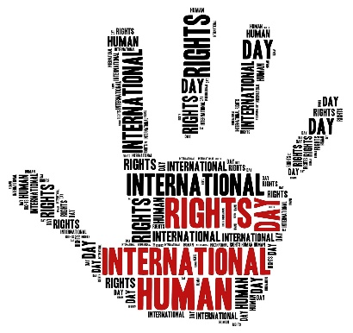 | Economic Recovery:  A neighboring country is facing an economic crisis, and the EU has been asked to provide assistance to promote recovery.  What policy will you implement?   | Global Health Crisis:  A global health crisis has emerged, and the EU has been asked to take action to promote public health and safety.  What policy will you implement?  
Gender Equality:  A neighboring country has significant gender inequality issues, and the EU has been asked to promote gender equality and women's rights. What policy will you implement?   | Environmental Protection:  A neighboring country is facing significant environmental degradation and pollution issues, and the EU has been asked to help promote environmental protection. What policy will you implement?   | Climate Change:  The EU has been asked to take a leading role in addressing climate change by implementing policies to reduce greenhouse gas emissions. What policy will you implement?  
Digital Divide:  There is a significant digital divide between different regions of the EU, and the EU has been asked to promote digital inclusion and accessibility. What policy will you implement?   | Regional Conflict:  A regional conflict has erupted in a neighboring country, and the EU has been asked to help mediate a peaceful resolution. What policy will you implement?   | Migrant Crisis:  A neighboring country is facing a significant influx of migrants, and the EU has been asked to help provide humanitarian aid and support. What policy will you implement?  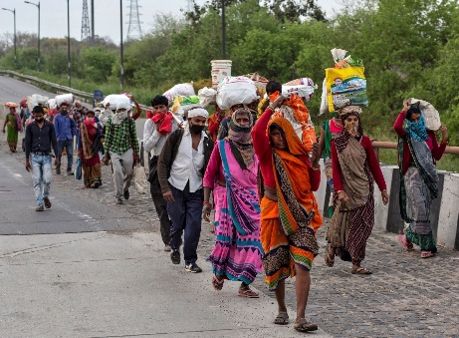

European Social Fund:  The European Social Fund provides financial assistance to EU member states for social programs and initiatives.   | European Investment Bank:  The European Investment Bank provides financial assistance for infrastructure and development projects within the EU.   | European Union Civil Protection Mechanism:  The EU Civil Protection Mechanism aids and provides coordination for disaster response and emergency situations.  
European Union Cultural Program:  The EU Cultural Program promotes cultural exchange and preservation within the EU and with partner countries.  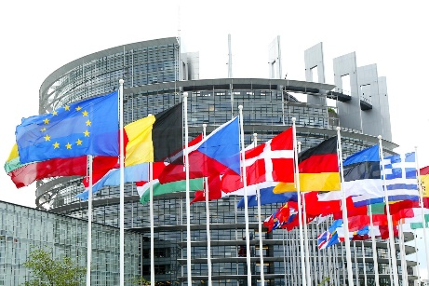 | Common Security and Defense Policy:  The Common Security and Defense Policy provides a framework for EU member states to coordinate defense and security issues.  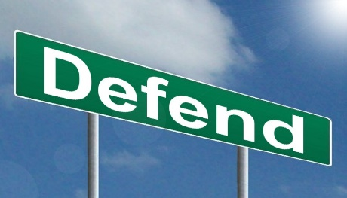 | European Union Agency for Fundamental Rights:  The EU Agency for Fundamental Rights promotes and protects human rights in the EU  
European Development Fund:  The European Development Fund provides financial assistance to countries outside the EU for development projects.   | Erasmus+ Program:  The Erasmus+ program promotes student exchange and mobility within the EU and with partner countries.   | European Arrest Warrant:  The European Arrest Warrant streamlines the process of extraditing criminals between EU member states.  
European Union Agency for Law Enforcement Cooperation:  The EU Agency for Law Enforcement Cooperation  - promotes and coordinates law enforcement  - judicial cooperation within the EU.   | European Green Deal: The European Green Deal is an EU-wide policy initiative to promote sustainable development and achieve climate neutrality by 2050.  This card represents a focus on promoting:  - green technologies  - reducing carbon emissions  - protecting biodiversity.   | European Neighbourhood Policy:  This is a framework for cooperation between the EU and its neighbours, with the goal of promoting stability, security and prosperity.  This card represents a focus on promoting:  - democratic reforms  - economic development  - regional cooperation with neighboring countries.  

EU co-op Quest
In this fun card game, players take on the role of European Union representatives who are tasked with promoting international cooperation, justice, and human rights.
Players will face various challenges and obstacles as they work to achieve their goals and score points.
Gameplay:
- Players start with a hand of cards that represent different EU policies, initiatives, and programs related to international cooperation, justice, and human rights.
- On each turn, a player draws a challenge card that presents a scenario where the EU could intervene to promote cooperation, justice, or human rights. The player must then choose a policy card from their hand that they think would be the best solution to the challenge.
- After playing their policy card, the player rolls some dice to determine if their solution is successful. If they roll a high enough number, their solution is successful, and they score points. If they roll a low number, their solution fails, and they lose points.
- The game continues with players taking turns drawing challenge cards and playing policy cards until a certain point threshold is reached or a set number of rounds are played.
- The player with the highest score at the end of the game wins and is declared the most successful EU representative in promoting international cooperation, justice, and human rights.
Game Components:
- Challenge cards (with different scenarios where the EU could promote cooperation, justice, or human rights)
- Policy cards (representing EU policies, initiatives, and programs related to the learning outcome)
- Dice (to determine success or failure of solutions)
- Scoring track (to keep track of player scores)
Learning Outcome:
This game helps players to understand and evaluate the role of the European Union in promoting international cooperation, justice, and human rights. By simulating real-world scenarios and presenting players with different policy options, the game encourages critical thinking and decision-making skills. Additionally, the game can also promote teamwork and collaboration as players work together to achieve common goals.

